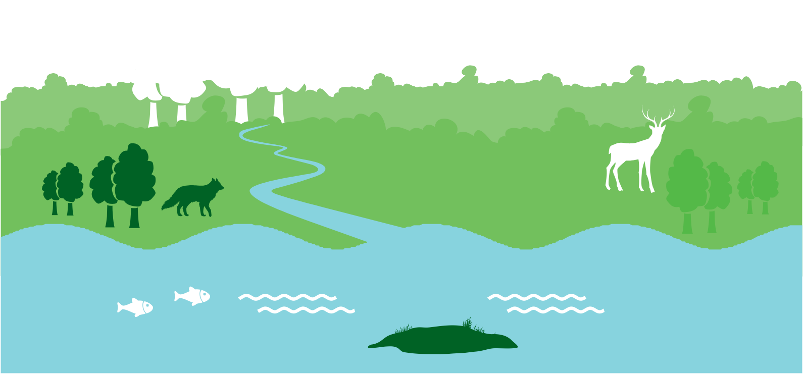

Chapter 9 - Natural Heritage

CHAPTER 9
Proposed Amendment CH 9.1
 | Section | Page
Draft CDP 2017 – 2023 | 9.1 Background | Throughout chapter

Insert reference to Wildlife Acts 1976 to 2012 within the chapter, as required.

CHAPTER 9
Proposed Amendment CH 9.2
 | Section | Page
Draft CDP 2017 – 2023 | 9.1 Background | 299

Insert new Objective NH:
Support the implementation of the Fingal Heritage Plan in relation to the promotion and protection of Fingal’s Natural Heritage.

CHAPTER 9
Proposed Amendment CH 9.3
 | Section | Page
Draft CDP 2017 – 2023 | 9.2 Biodiversity | 300

Insert new Objective NH:
Consider developing a Natural Heritage Trail or Trails to support raising awareness about these natural assets amongst the public.

CHAPTER 9
Proposed Amendment CH 9.4
 | Section | Page
Draft CDP 2017 – 2023 | 9.2 Biodiversity | 304

Insert Codling Fault Zone marine SAC into Table BD01: Protected Areas of International and National Importance with an asterix that states:
This area is not mapped on Green Infrastructure 2, Sheet 15 owing to the 24 km distance from shore but can be reviewed in SI 99 of 2016, 24 February 2016, as a map is attached. See www.npws.ie.

CHAPTER 9
Proposed Amendment CH 9.5
 | Section | Page
Draft CDP 2017 – 2023 | 9.4 Landscape | 318

Include the following text:
Dublin Bay Biosphere Reserve
Biosphere Reserves are places where nature and people connect. They are areas which are internationally recognised for their biological diversity yet also actively managed to promote a positive relationship between people and nature.
The Dublin Bay Biosphere Reserve is a special designation awarded by the United Nations Educational, Scientific and Cultural Organisation (UNESCO). It is part of a global network of 651 Biosphere Reserves in 120 countries. In 2015 UNESCO expanded the North Bull Island Biosphere designation to include Dublin Bay, reflecting its significant environmental, economic, cultural and tourism importance. The Biosphere now extends to over 300 km2, with over 300,000 people living within the newly enlarged Biosphere. The Biosphere designation does not add or detract from the regulatory framework already in place for the Bay but is designed to assist stakeholders in finding sustainable solutions to the management of the Bay which ensure good outcomes for both people and nature.

CHAPTER 9
Amendment CH 9.6
 | Section | Page
Draft CDP 2017 – 2023 | 9.4 Landscape | 318

Insert new Objective NH:
Consider Baldoyle jointly with Portmarnock for a Special Amenity Order.

CHAPTER 9
Proposed Amendment CH 9.7
 | Section | Page
Draft CDP 2017 – 2023 | 9.4 Landscape | 318

Insert an updated Dublin Bay Biosphere Reserve Map, dated 2016.

CHAPTER 9
Proposed Amendment CH 9.8
 | Section | Page
Draft CDP 2017 – 2023 | 9.5 The Coast | 320

Include an additional paragraph:
The natural assets of the coastline including beaches are important economic assets particularly for tourism. They are also valuable amenity resources with significant recreational importance and public health benefits.

CHAPTER 9
Proposed Amendment CH 9.9
 | Section | Page
Draft CDP 2017 – 2023 | 9.5 The Coast | 323

Amend Objective NH61:
Plan and develop the Fingal Coastal Way from north of Balbriggan to Kilbarrack taking full account of the need to protect the natural and cultural heritage of the coast and the need to avoid significant adverse impacts on European Sites, other protected areas and species protected by law.

CHAPTER 9
Proposed Amendment CH 9.10
 | Section | Page
Draft CDP 2017 – 2023 | 9.5 The Coast | 323

Amend Objective NH64:
Protect beaches, access to beaches and designated bathing areas as valuable local amenities and as a tourism resource and support the maintenance, protection and improvement of access to them.

