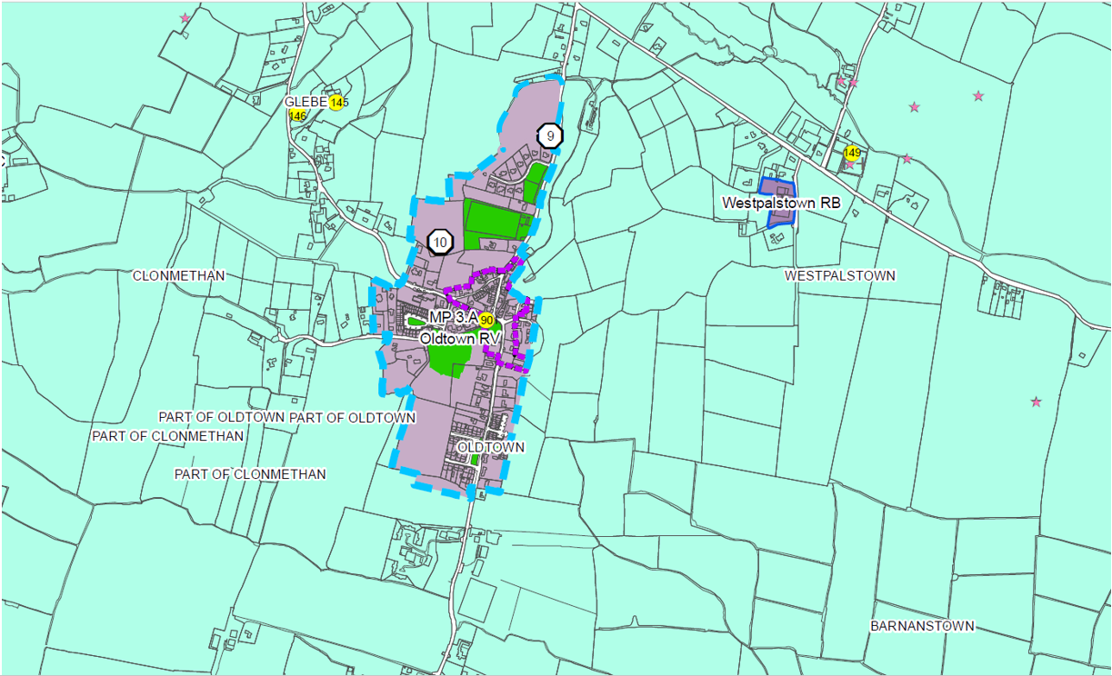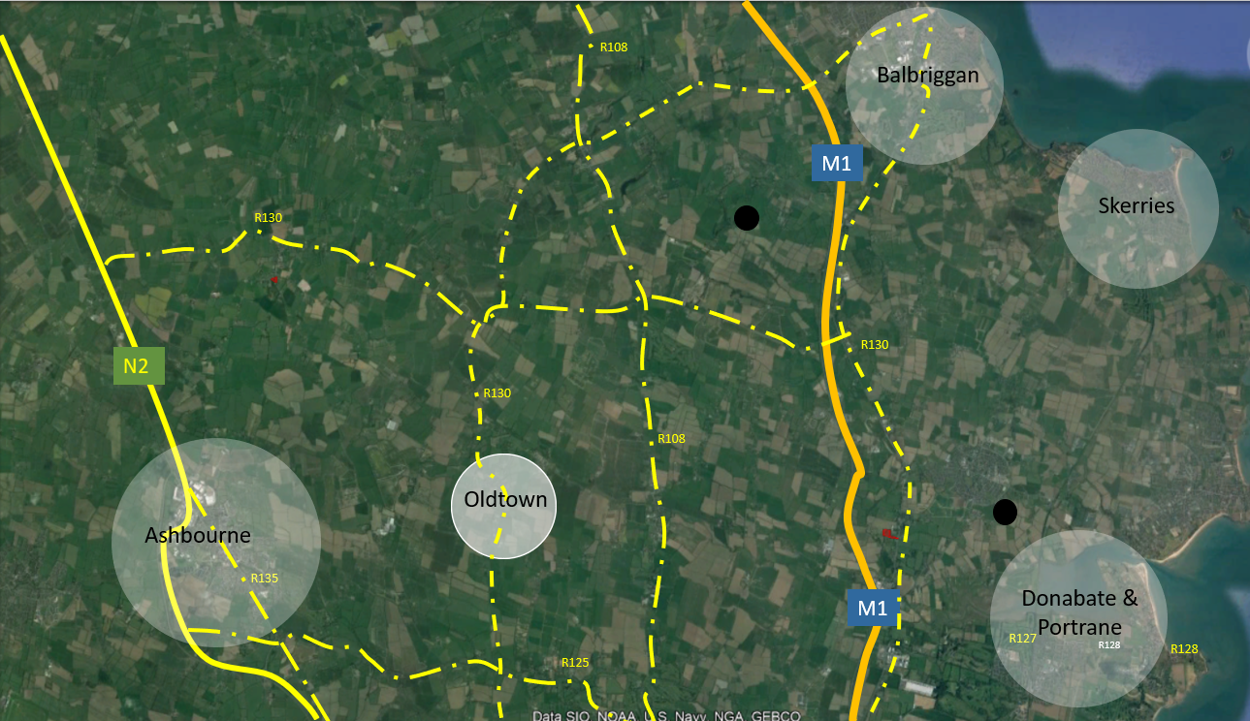
DRAFT DEVELOPMENT PLAN SUBMISSION
DRAFT FINGAL DEVELOPMENT PLAN 2023-2029 (STAGE III PROPOSED MATERIAL ALTERATIONS)
Material Alteration PA CH 13.1: Revisions to Residential Care Home / Retirement Homes and Sheltered Accommodation
December 2022

EXECUTIVE SUMMARY
This submission is made by Downey Planning and is submitted to Fingal County Council in the context of the Draft Fingal County Development Plan 2023-2029, which is currently on a public call for submissions in relation to the proposed Material Alterations. In this context, this submission specifically relates to:
“PA CH 13.1: Section 13.5 Zoning Objectives, Vision and Use Classes, page 452
Insert caveat 19 ‘For Public Operators Only’ to the following uses in the Permitted in Principle category of the CI-Community Infrastructure zoning objective, ‘Residential Care Home/Retirement Home’ and ‘Sheltered Accommodation’.”
Our concerns are in regard to the proposed material alteration PA CH 13.1 to the Draft Fingal County Development Plan 2023 – 2029. This material alteration proposes that residential care home/retirement homes & sheltered accommodation on “CI” Community Infrastructure Zoned Land can be delivered by ‘public operators only’. Our concerns in respect of this policy are summarised as follows:
- Ireland is experiencing population growth and an ageing population with 7,500 new residential care beds required by 2026.
- Fingal County Council currently has 2 no. public care home facilities.
- Residential care homes across Ireland are almost exclusively being delivered by private operators.
- The care home sector has experienced considerable strain particularly as a result of the COVID-19 pandemic and all operators are required to meet national targets.
- In order to meet ongoing demand for care beds, both public and private delivery is required and restricting delivery to public operators only is contrary to national planning policy

We believe that restricting the delivery of residential care home/retirement homes & sheltered accommodation on ‘CI – Community Infrastructure’ zoned lands to ‘Public Operator Only’ restricts the potential for further development and is contrary to the sustainable planning and development on lands within Fingal. We hope Fingal County Council take the above concerns into consideration prior to the adoption of the proposed material alteration within the Draft Fingal County Development Plan 2023 – 2029.

TABLE OF CONTENTS

1.0 INTRODUCTION 4
2.0 LEGISLATIVE BASIS 4
3.0 DRAFT DEVELOPMENT PLAN: MATERIAL ALTERATIONS 5
4.0 JUSTIFICATION FOR SUBMISSION 5
5.0 CONCLUSION 7

© Downey 2022
Downey Planning Document Control
 | Name | Date | Version
Prepared by | Sean Slevin (Graduate Planner) | 6/12/2022 | V_01_DRAFT
Approved by | Catherine Norris (Associate Planner) | 22/12/2022 | V_03_FINAL

INTRODUCTION
Downey, Chartered Town Planners, 29 Merrion Square, D02 RW64, have prepared this submission to the Draft Fingal County Development Plan 2023-2029. This submission is made in relation to the Stage 3: Material Alterations of the Draft Fingal Development Plan 2023 – 2029, specifically Proposed Material Alteration PA CH 13.1. This written submission is made in response to an invitation for comments from interested parties by Fingal County Council. This submission is being made within the specified timeframe for submissions (22 December 2022, as extended from 9 December 2022 due to the submission of the Errata document to the Material Alterations) as set out on the Draft Development Plan’s website.

LEGISLATIVE BASIS
Section 9 of the Planning and Development Act, 2000 (as amended) provides that, subject to the requirements set out in Sections 9, 10, 11 and 12 of the Act, a planning authority must adopt a new Development Plan every six years. The recommendations for the content of a Development Plan are set out within Section 10 of the Planning and Development Act, 2000 (as amended) and must include a strategy for the proper planning and sustainable development of the area of the Development Plan and shall consist of a written statement and a plan or plans indicating the development objectives for the area in question. The process for the preparation of the Draft Development Plan is contained within Section 11 of the Planning and Development Act, 2000 (as amended), and the consultation process of the Draft Development Plan is contained within section 12 of the Planning and Development Act, 2000 (as amended), which states:
“12 - (7) (a) In case the proposed amendment would, if made, be a material alteration of the draft concerned, the planning authority shall, not later than 3 weeks after the passing of a resolution under subsection (6), publish notice of the proposed amendment in at least one newspaper circulating in its area.
(b) A notice under paragraph (a) shall state that—
(i) a copy of the proposed amendment of the draft development plan may be inspected at a stated place and at stated times during a stated period of not less than 4 weeks (and the copy shall be kept available for inspection accordingly), and
(ii) written submissions or observations with respect to the proposed amendment of the draft made to the planning authority within the stated period shall be taken into consideration before the making of any amendment.
(8) (a) Not later than 8 weeks after giving notice under subsection (7), the manager of a planning authority shall prepare a report on any submissions or observations received under that subsection and submit the report to the members of the authority for their consideration.

DRAFT DEVELOPMENT PLAN: MATERIAL ALTERATIONS
DOWNEY make this submission in relation to the proposed alteration PA CH 13.5 of the Draft Development Plan in regard to the restriction of development on lands zoned “CI” – Community Infrastructure’. The material alteration to the Draft Fingal Development Plan 2023 – 2029, under the recommendation of the chief executive, is cited as follows:
“PA CH 13.1: Section 13.5 Zoning Objectives, Vision and Use Classes, page 452
Insert caveat 19 ‘For Public Operators Only’ to the following uses in the Permitted in Principle category of the “CI - Community Infrastructure” zoning objective, ‘Residential Care Home/Retirement Home’ and ‘Sheltered Accommodation’.”
By adding the proposed caveat 19, this material alteration restricts development on “CI” Community Infrastructure zoned lands to public operators only in the delivery of residential care homes/retirement homes and sheltered accommodation.
DOWNEY are of the opinion that this restriction on the zoning objective of “CI” – Community Infrastructure is not justified and would materially impact the delivery of these facilities which is contrary to national planning policy. The proposed reasoning for this material alteration provided by the Chief Executive is outlined in the Material Alterations Stage 3 Document as follows:
“The submission highlighting both the private and public nature of housing provision and as it specifically relates to accommodation for the elderly is welcomed. After further consideration, it is considered there is merit in the context of the CI zoning objective and vision as set out above which provides for the provision of community infrastructure and services, to apply caveat 19 ‘For Public Operators Only’ to the following uses in the Permitted in Principle category of the CI zoning objective including, ‘Residential Care Home/Retirement Home’ and ‘Sheltered Accommodation’. This is to ensure the provision of accommodation types for the elderly in accordance with the spirit of the zoning objective and vision and on a public level within CI zoned lands.”
For the reasons set out in this statement, this material alteration should be removed.

JUSTIFICATION FOR SUBMISSION
DOWNEY, wish to provide several reasons why the proposed Material Alteration to the Draft Development Plan 2023 – 2029 should be removed. Within this submission, we have used ‘residential nursing homes’ as our primary example of residential care but are mindful that ‘residential care’ is very broad term and covers a wide range of types of care such as mental health, disability, health, age, and hospice care facilities. The proposed material alteration restriction on “CI” – Community Infrastructure lands has the potential to affect a wide range of different residential care facilities including their ability to develop on these lands. Within this context, while this submission focuses on residential care homes it should be noted this policy, if brought into effect, would be felt by a broader range of residential care.

4.1 Aging Demographics: Need for Residential Care Home Facilities
The establishment of Census 2022 preliminary findings show that there was an increase of 7.7% females and 7.5% males within Ireland since 2016, at a population of 5,123,536 million personas. Fingal saw an increase of 11% in its population, with an increase of 33,198 persons. The first full subset of results of the census 2022 data will be released in April 2023.
Alongside the increase in the size of the population, there is a shift towards an ageing population due to a range of factors including people living longer – a trend which is set to increase in the future. This will result in an even more increase in demand for health and age-related care facilities, which are already under considerable strain for supply issues.
To meet the needs of an ageing population, 7,500 new residential care beds are required across Ireland by 2026 to facilitate the demand that is arising as a result of the shift in population demographics. In order to meet this demand, the provision of both private and public residential care will be a necessity.
DOWNEY have concerns about the ability of Fingal County Council to meet the needs of their ageing population in the event that delivery is restricted to public operators only.
4.2 Delivery of Residential Care Homes
Within Fingal, statistics show that 2 no. public residential nursing care centres exist (Lusk Community Unit & Clarehaven Nursing Home) on the approved ‘HSE public nursing homes cost of care’ documentation as of January 2022.
Looking at the national picture, across the country, nursing homes are operated by a mixture of private and voluntary bodies, and the HSE. Private entities are by far the largest providers in the sector, managing 8 no. out of 10 no. beds nationally (80%). This is due to a range of factors, but the most significant one is the lack of public sector investment in the residential care sector. There is a significant disparity between the provision of private and public residential care homes. Public residential care homes (c. approximately 6,000 no.) are at a significantly lower number than private residential care homes (c. approximately 25,000 no.) across the country.
A further consideration is recent trends in the sector. The Covid-19 pandemic had a significant impact on residential care home delivery. A change that was adopted by the HIQA (The Health Information and Quality Authority) an independent authority established to drive high-quality and safe care for people, was the adoption of new policies, including the National Standards for Residential Care Settings for Older People in Ireland, that resulted in the reduction of communal shared spaces that posed as a risk to the spread of infection.
In 2021, HIQA introduced a regulation introduced giving rise to the requirement for every resident to be entitled to en-suite facilities (at a minimum a toilet & hand basin) that was to be adopted by December 2021. Smaller residential care centres (but also large residential care centres that did not provide en-suite facilities and had large communal wash facilities) were under significant strain as a result of both the Covid-19 pandemic and complying with the regulations. We have seen the closure of residential care centres as a result. As of 2022, up to 450 nursing home beds have been lost due to 16 care facility closures, resulting in further strain on the sector.
DOWNEY have concerns that very few residential care homes will now be delivered on “CI” zoned lands in the event that this policy is implemented adding additional strain to a sector already struggling to meet the demand for older persons’ accommodation, making it difficult to meet Fingal’s targets in terms of the meeting the needs of an ageing population. In a time when the market faces a lot of uncertainty due to changing circumstances that are occurring as a result of significant events such as Covid-19 requiring the updating of health policies, altering the design of potential residential care schemes, imposing restrictions that divide private and public development locations is an approach that is of concern.
4.3 Private care delivery
One of the factors purportedly inhibiting the delivery of public care homes is that private residential care home delivery has been found to be cheaper than public nursing residential care. Statistics show that on average if people do not qualify under the threshold to be covered by public care, it costs an average of €624 higher in 2019 to facilitate the running of a public facility. Statistics show that on average, public residential care costs €1,616 while private costs €992. The evidence shows that public care is significantly more costly to operate, and this could have a potential impact on the future of the development of further residential care facilities by public bodies and the ability for these to be developed and operated across the county.
On this basis, DOWNEY have concerns that very limited residential care homes will be delivered on “CI” zoned lands in the event that this policy is implemented, making it difficult to meet Fingal’s targets in terms of meeting the needs of an ageing population.
The supply of beds is under considerable strain. By restricting the development of CI – Community Infrastructure zoned lands to ‘Public Operators Only’, could slow down the delivery of much-needed residential care rooms as the numbers are reducing as a result of complying with health policies. Some residential care beds may be lost to the system as smaller homes struggle to survive from a combination of rising costs and the 2016 Standards being enforced by the HIQA.

CONCLUSION
Downey, Chartered Town Planners, 29 Merrion Square, D02 RW64, have prepared this submission to the Draft Fingal County Development Plan 2023-2029. This submission is made in relation to the proposed Material Alteration PA CH 13.1: Section 13.5.
Our concerns are in regard to the proposed material alteration to the Draft Fingal County Development Plan 2023 – 2029, in which it is being proposed to alter the provision of residential care homes to be public operators only. Our concerns can be summarised under the following:
- Ireland is experiencing population growth and an ageing population with 7,500 new residential care beds required by 2026.
- Fingal County Council currently has 2 no. public care home facilities.
- Residential care homes across Ireland are almost exclusively being delivered by private operators.
- The care home sector has experienced considerable strain, particularly as a result of the COVID-19 pandemic and all operators are required to meet national targets.
- In order to meet the ongoing demand for care beds, both public and private delivery is required and restricting delivery to public operators only is contrary to national planning policy
Downey trust that you will consider the grounds of this submission when preparing the Fingal County Development Plan 2023 – 2029. We respectfully submit that the proposed material alteration PA CH 13.1: Section 13.5 should be revised to remove this restriction and are of the opinion that it is an unfounded restriction on development and would harm the planning and sustainable development of Fingal.

Population Ageing and the Public Finances in Ireland Report
HIQA Report on impact of Covid-19 on Residential Care Homes, which provides numbers of beds
CBRE Report on Provision of Residential Care Homes
Irish Times, “More than 450 nursing home beds lost due to care facility closures this year”.
Government of Ireland: A Value for Money Review of Nursing Home Care Costs

