Part 8 Rejuvenation and upgrade of Wellview Park
and public realm at Wellview Green and Terrace

Ecological Impact Assessment Report

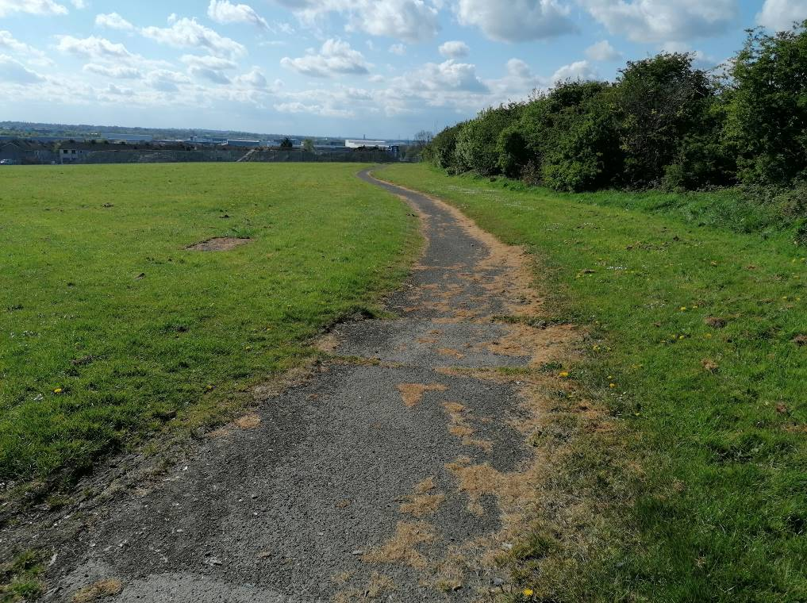

FINAL REPORT

22nd March 2022



Faith Wilson Ecological Consultant B.Sc. (Hons) CEnv MCIEEM
Kestrel Ridge, Tigroney West, Avoca, Co. Wicklow

Part 8 Rejuvenation and upgrade of Wellview Park
and public realm at Wellview Green and Terrace

Ecological Impact Assessment Report

Table of Contents

1. INTRODUCTION 4
1.1 Background 4
1.2 Project Brief 4
1.2 Relevant Ecological Legislation 6
1.2.1 Nature Conservation Designations 6
1.2.2 Bats 6
1.2.3 Badgers 7
1.2.4 Otter 8
1.2.5 Invasive Species 8
1.2.6 Fisheries 10
1.3 Project Description 10
2. METHODOLOGY 11
2.1 Project Background 11
2.2 Legislation, Policy and Guidelines 11
2.3 Desk Study & Consultation 12
2.4 Field Surveys 13
3. RESULTS 17
3.1 Nature Conservation Designations 17
3.2 Rare, Scarce and Threatened Flora 18
3.3 Previous Ecological Surveys 18
3.4 Changing Land Use 19
3.5 Habitats 22
3.6 Invasive Species 29
3.7 Bats 29
3.8 Other Mammals 31
3.9 Amphibians 32
3.12 Birds 32
3.13 Fisheries and Watercourses 32
4. ASSESSMENT OF ECOLOGICAL SIGNIFICANCE 33
4.1 Church Fields Lands 33
4.2 Wellview Park 33
5. DESIGN RECOMMENDATIONS 34
6. ECOLOGICAL IMPACTS – WELLVIEW PARK 36
7. MITIGATION MEASURES 38
7.1 Mitigation by Avoidance 38
7.2 Sediment Control 38
7.3 Contractor Briefing 39
7.4 Protection Measures for Birds 39
7.5 Measures for Birds 39
7.6 Protection Measures for Bats 39
7.7 Measures for Bats - Erection of Bat Boxes 41
7.8 Biosecurity 41
7.9 Planting Proposals 42
7.10 Grassland Management/Creation 42
7.11 Invasive Species 42
7.12 Tree Survey 43
7.13 Ecological Clerk of Works 43
7.14 Screening for Appropriate Assessment 43
7.15 Park Habitat Management Plan 43
7.16 Wetland/Pond Creation 43
8. PREDICTED IMPACT OF THE PROPOSED DEVELOPMENT 44
9. CONCLUSION 45
10. REFERENCES 46

Part 8 Rejuvenation and upgrade of Wellview Park
and public realm at Wellview Green and Terrace

Ecological Impact Assessment Report

INTRODUCTION

1.1 Background
This report has been prepared by Faith Wilson (an independent ecological consultant and licensed bat specialist).

Dermot Foley Landscape Architects were appointed by Fingal County Council to complete a five-stage design process for the delivery of an 11-hectare public park, commissioned by Fingal County Council, at Church Fields, Dublin 15 and this report feeds into that design process.

Faith was appointed by Dermot Foley Landscape Architects to advise on the ecological sensitivities of the lands at Church Fields, Dublin 15, to inform the design of their development as a public space and to provide an ecological impact assessment on the final design.

This ecological impact assessment is submitted as part of a Part 8 planning application to Fingal County Council for a site of c.5.5 hectares. The documentation pertains to the Part 8 Rejuvenation and upgrade of Wellview Park and public realm at Wellview Green and Terrace within the Church Fields Lands. The documentation should be read in conjunction with other complementary documentation related specifically to the proposed linear park, as submitted by Dermot Foley Landscape Architects, Punch Consulting Engineers, Fallon Design, BMA Planning, Archaeology Plan and The Tree File. Wellview Park is one of a number of open spaces included in the Church Fields Lands. Wellview Park links into the previously approved Church Fields Eastern Linear Park. It is intended that the proposed linear park will ultimately to be extended to form a larger contiguous park of c. 11.8 hectares, stretching from Church Road in the east to the Pinkeen River in the west.

1.2 Project Brief
The Church Fields Lands are located one kilometre north of the village of Mulhuddart. The Church Fields Lands are the subject of a master-planning exercise for the provision of housing, part of which includes the delivery of a series of parks which form part of a proposed residential development.

The location of the Church Fields Lands is shown on Figure 1.1 below. The current green open nature of the lands is evident in the aerial imagery for the area as shown on Figure 1.2 below.

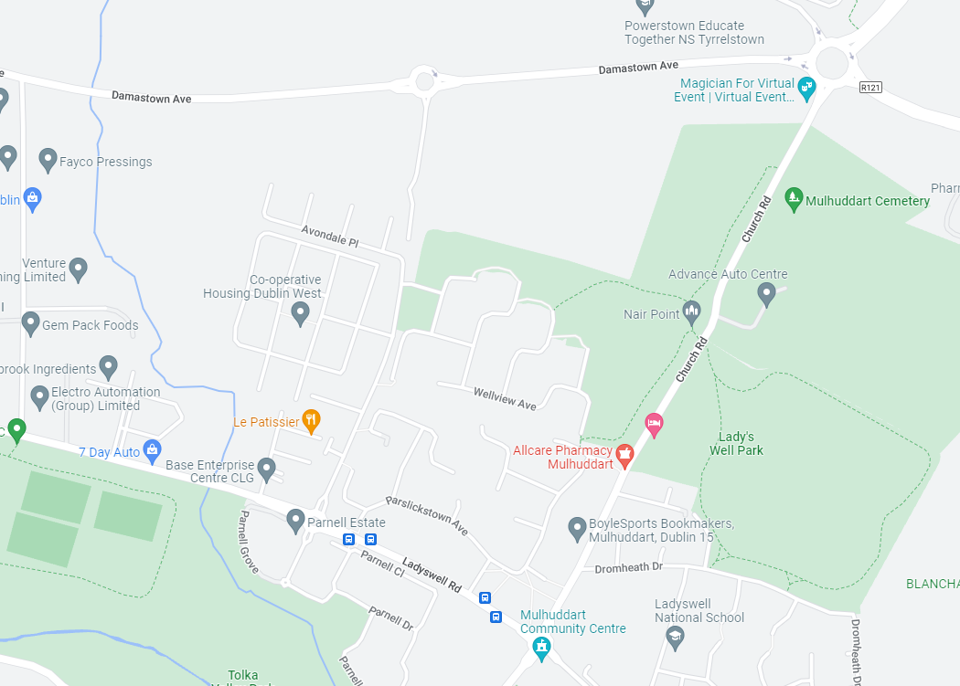
Figure 1.1 The Church Fields Lands north of Mulhuddart.

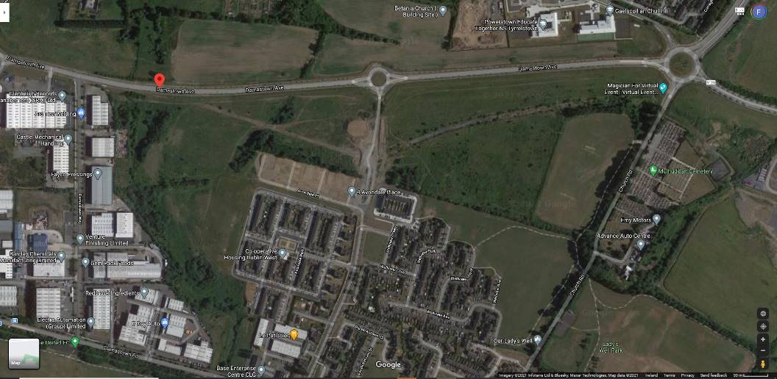
Figure 1.2 The location of Wellview Park (indicated by the red arrow). Source: Google Maps.

1.2 Relevant Ecological Legislation

1.2.1 Nature Conservation Designations

International Conservation Designations

Special Areas of Conservation (SACs) are habitats of international significance that have been identified by NPWS and submitted for designation to the EU. SAC is a statutory designation, which has a legal basis under the EU Habitats Directive (92/43/EEC) as transposed into Irish law through the European Communities (Natural Habitats) Regulations, 1997, which were amended in 1998, 2005 and 2011. The European Communities (Birds and Natural Habitats) Regulations 2011 consolidate the European Communities (Natural Habitats) Regulations 1997 to 2005 and the European Communities (Birds and Natural Habitats)(Control of Recreational Activities) Regulations 2010, as well as addressing transposition failures identified in the Court of Justice of the European Union (CJEU) judgements.

A Special Protection Area (SPA) is a statutory designation, which has a legal basis under the EU Birds Directive (79/409/EEC). The primary objective of SPAs is to maintain or enhance the favourable conservation status of the birds for which the SPAs have been designated.

National Conservation Designations

Proposed NHAs are habitats or sites of interest to wildlife that have been identified by NPWS. These sites become NHAs once they have been formally advertised and land owners have been notified of their designation. NHAs are protected under the Wildlife (Amendment) Act, 2000, from the date they are formally proposed. NHA is a statutory designation according to the Wildlife (Amended) Act, 2000 and requires consultation with NPWS if any development impacts on a pNHA.

NHAs are considered to be of national importance, while SACs and SPAs are of international importance for nature conservation.

1.2.2 Bats
Eleven species of bats occur in Ireland and all are protected under both national and international law.

Wildlife Act 1976
In the Republic, under Schedule 5 of the Wildlife Act 1976, all bats and their roosts are protected by law. It is unlawful to disturb either without the appropriate licence. The Act was amended in 2000.

Bern and Bonn Convention
Ireland has also ratified two international conventions, which afford protection to bats amongst other fauna. These are known as the ‘Bern’ and ‘Bonn’ Conventions.

The Convention on the Conservation of European Wildlife and Natural Habitats (Bern Convention 1982), exists to conserve all species and their habitats, including bats. The Convention on the Conservation of Migratory Species of Wild Animals (Bonn Convention 1979, enacted 1983) was instigated to protect migrant species across all European boundaries, which covers certain species of bat.

EU Habitats Directive
All bat species are given strict protection under Annex IV of the EU Habitats Directive, whilst the lesser horseshoe bat (Rhinolophus hipposideros) and greater horseshoe bat (Rhinolophus ferrumequinum) are given further protection under Annex II of the EU Habitats Directive. Both are listed as a species of community interest that is in need of strict protection and for which E.U. nations must designate Special Areas of Conservation (SACs). The latter is only known from a single site and no breeding populations have been recorded to date. The former are a species of the western seaboard of Ireland and have not yet been recorded on the east coast.

The principal pressures on Irish bat species have been identified as follows:
- urbanized areas (e.g. light pollution);
- bridge/viaduct repairs;
- pesticides usage;
- removal of hedges, scrub, forestry;
- water pollution;
- other pollution and human impacts (e.g. renovation of dwellings with roosts);
- infillings of ditches, dykes, ponds, pools and marshes;
- management of aquatic and bank vegetation for drainage purposes;
- abandonment of pastoral systems;
- speleology and vandalism;
- communication routes: roads; and
- inappropriate forestry management.

1.2.3 Badgers
Badgers (Meles meles) are common and widespread in Ireland, and are found in all lowland habitats where the soil is dry and not subject to flooding (Hayden and Harrington, 2000). Badgers are social animals that live in complex underground tunnel systems called setts. Badger territories may vary in size from about 60-200 ha (Smal, 1995).

Badgers and their setts legally are protected under the provisions of the Wildlife Act, 1976, and the Wildlife Amendment Act, 2000. It is an offence to intentionally kill or injure a protected species or to wilfully interfere with or destroy the breeding site or resting place of a protected wild animal. It is standard best practice to ensure that mitigation measures are taken to limit impacts on badgers and badger populations during developments.

1.2.4 Otter
The otter (Lutra lutra) is a legally protected species under the EU Habitats Directive (where it is listed under Annex II) and is found throughout Ireland (Hayden and Harrington, 2000). The otter is listed as internationally important in the Irish Red Data book (Whilde, 1993), is classified as ‘near threatened’ in Ireland (Marnell, et al. 2009), on a European scale (Temple & Terry, 2007) and on a global scale by the IUCN (2009). It is listed as a strictly protected species under Appendix II of the Bern convention (Council of Europe, 1979). Because it is listed in Appendix 1 of CITES (1979), trade in otter specimens is permitted only in exceptional circumstances.

Annexes II and IV of the E.U. Habitats Directive (92/43/EEC) list the otter as a species of community interest that is in need of strict protection and for which E.U. nations must designate Special Areas of Conservation (SACs). The E.U. Habitats Directive was transposed into Irish law in the European Union (Natural Habitats) Regulations, (SI 94/1997) and 40 candidate SACs have been designated for the otter in Ireland (NPWS (2008)). A Species Action Plan and a Threat Response Plan has been prepared for the otter by NPWS (2008 & 2009).

Otters tend to occupy linear territories along watercourses and are rarely found far away from water. A recent national survey of otters in Ireland (Bailey (2006)) surveyed 37 sites within the Eastern River Basin District, of which 22 (59.46%) recorded the presence of otter, the lowest rate in the country.

1.2.5 Invasive Species
Until recently there has been no legal framework for the control or eradication of non-native invasive species in the Republic of Ireland. The Birds and Habitats Regulations (2011) which were signed on 21st September 2011 by the then Minister for Arts, Heritage and the Gaeltacht Jimmy Deenihan, included new legislation on invasive and non-native species in Sections 49 and 50. Sections 49 and 50 have not yet been legally implemented as they have implications for members of the pet and horticultural trades and consultation with these groups is ongoing. It is expected that these new regulations will come into place soon.

The plant and animal species to which the regulations apply are presented in Schedule Three. Part 1 details the plants species, while Part 3 outlines those animal or plant vector materials and are presented below.

Third Schedule: Part 1 Plants

Non-native species subject to restrictions under Regulations 49 and 50.

First column | Second column | Third column
Common name | Scientific name | Geographical application
American skunk-cabbage | Lysichiton americanus | Throughout the State
A red alga | Grateloupia doryphora | Throughout the State
Brazilian giant-rhubarb | Gunnera manicata | Throughout the State
Broad-leaved rush | Juncus planifolius | Throughout the State
Cape pondweed | Aponogeton distachyos | Throughout the State
Cord-grasses | Spartina (all species and hybrids) | Throughout the State
Curly waterweed | Lagarosiphon major | Throughout the State
Dwarf eel-grass | Zostera japonica | Throughout the State
Fanwort | Cabomba caroliniana | Throughout the State
Floating pennywort | Hydrocotyle ranunculoides | Throughout the State
Fringed water-lily | Nymphoides peltata | Throughout the State
Giant hogweed | Heracleum mantegazzianum | Throughout the State
Giant knotweed | Fallopia sachalinensis | Throughout the State
Giant-rhubarb | Gunnera tinctoria | Throughout the State
Giant salvinia | Salvinia molesta | Throughout the State
Himalayan balsam | Impatiens glandulifera | Throughout the State
Himalayan knotweed | Persicaria wallichii | Throughout the State
Hottentot-fig | Carpobrotus edulis | Throughout the State
Japanese knotweed | Fallopia japonica | Throughout the State
Large-flowered waterweed | Egeria densa | Throughout the State
Mile-a-minute weed | Persicaria perfoliata | Throughout the State
New Zealand pigmyweed | Crassula helmsii | Throughout the State
Parrot’s feather | Myriophyllum aquaticum | Throughout the State
Rhododendron | Rhododendron ponticum | Throughout the State
Salmonberry | Rubus spectabilis | Throughout the State
Sea-buckthorn | Hippophae rhamnoides | Throughout the State
Spanish bluebell | Hyacinthoides hispanica | Throughout the State
Three-cornered leek | Allium triquetrum | Throughout the State
Wakame | Undaria pinnatifida | Throughout the State
Water chestnut | Trapa natans | Throughout the State
Water fern | Azolla filiculoides | Throughout the State
Water lettuce | Pistia stratiotes | Throughout the State
Water-primrose | Ludwigia (all species) | Throughout the State
Waterweeds | Elodea (all species) | Throughout the State
Wireweed | Sargassum muticum | Throughout the State

Other Invasive Species
The main guidance document that has been prepared dealing with invasive species/noxious weeds on sites is the NRA ‘Guidelines on The Management of Noxious Weeds and Non-Native Invasive Plant Species on National Roads’ which was published in 2010. This document details other non-native species of note.

1.2.6 Fisheries
The Church Fields Lands are located within the Tolka River catchment. The Office of Public Works, working closely with three County Councils (Dublin, Meath and Fingal) carried out a flood relief scheme on the Tolka. Following advice and consultation with Inland Fisheries Ireland the works included either the removal or modification of a significant number of man-made weirs to “open up” this system to migratory fish. This allowed sea trout to run the system upstream to its headwaters in Dunboyne for the first time, in at least, 150 years, and more recently salmon have returned to spawn in this river after an absence of over 100 years. Any works on the Church Fields Lands will therefore need to be cognisant of the salmonid status of the River Tolka and sensitivities regarding same.

1.3 Project Description
The proposed development consists of the Rejuvenation and upgrade of the existing Wellview Park, situated at Church Road, Dublin 15 as well as two existing areas of public realm at Wellview Green and Terrace, totalling approximately 5.5ha. The proposed development includes: landscape and external works; pedestrian access points to existing footpath on west side of Church Road; paving and associated drainage works; regrading of existing grassland areas; planting; public lighting; play areas, signage, street furniture and associated fixtures and fittings; including all ancillary site development. The site area is crossed by a north-south cycle and pedestrian route as part of the wider proposed Church Fields Link Road and Cycle Network (planning register reference Part XI/011/19).’

METHODOLOGY

Project Background
An ecological constraints study and preliminary ecological appraisal report was initially prepared in 2021, which set out the main features of ecological significance in the Church Fields Lands and to make some recommendations in relation to the habitats or species in the property which should be considered by the design team in the context of any design for the new public park.

Legislation, Policy and Guidelines
The assessment of the likely significant impacts of the proposed development of Wellview Park on ecological features has taken account of the following policy documents and legislation, where relevant:
- All-Ireland Pollinator Plan 2015-2020
- Dublin Bay Biosphere Biodiversity Conservation and Research Strategy 2016-2020
- EU (Invasive Alien Species) (Freshwater Crayfish) Regulations 2018
- EU (Planning and Development) (Environmental Impact Assessment) Regulations 2018 S.I. 296 of 2018
- EU Biodiversity Strategy
- EU Birds Directive 2009/147/EC
- EU Environmental Impact Assessment Directive 2014/52/EU
- EU Habitats Directive 92/43/EEC (as amended)
- EU Regulation on Invasive Alien Species - EU Regulation 1143/2014
- EU Strategy on Green Infrastructure 2013
- EU Water Framework Directive (WFD) 2000/60/EC
- European Communities (Birds and Natural Habitats) Regulations 2011 S.I. 477 of 2011
- Fingal Biodiversity Action Plan 2010-2015 (still applicable)
- Fingal Development Plan 2017-2023 (Objectives GI02; GI03; GI10, Gl11; Gl12; Gl13; Gl14; Gl15; Gl16; Gl17; NH21; NH49; PM51; PM64; RF100; SS08; SS10; SS11)
- Fingal Development Plan 2017-2023
- Flora (Protection) Order, 2015
- National Biodiversity Action Plan 2017-2021
- National Landscape Strategy for Ireland 2015-2025
- Planning and Development Act 2010 (as amended)
- The Forest of Fingal – A Tree Strategy for Fingal
- Water Framework Directive 2000/60/EC
- Wildlife Acts 1976 and Wildlife (Amendment) Act (2000) (as amended)

The surveys and impact assessment have been carried out in accordance with the following guidelines:
- Best Practice Guidance for Habitat Survey and Mapping (Smith et al., 2011);
- A Guide to Habitats in Ireland (Fossitt, 2000);
- Ecological Surveying Techniques for Protected Flora and Fauna during the Planning of National Road Schemes (NRA, 2009a);
- Guidelines for the Assessment of Ecological Impacts of National Road Schemes Rev. 2. (NRA, 2009b);
- Guidelines for Preliminary Ecological Assessment (CIEEM, 2017);
- Guidelines for Ecological Impact Assessment in the UK and Ireland: Terrestrial, Freshwater, Coastal and Marine (CIEEM, 2018, version 1.1);
- Bat Surveys for Professional Ecologists: Good Practice Guidelines (3rd edn.) (Collins, 2016);
- Bat Surveys: Good Practice Guidelines (Hundt, 2012);
- Bat Mitigation Guidelines for Ireland (Kelleher & Marnell, 2006);
- Environmental Planning and Construction Guidelines Series (National Roads Authority, 2005 – 2011);
- Guidelines on Protection of Fisheries During Construction Works in and Adjacent to Waters (Inland Fisheries Ireland, 2016)
- Planning For Watercourses In The Urban Environment. A Guide to the Protection of Watercourses through the use of Buffer Zones, Sustainable Drainage Systems, Instream Rehabilitation, Climate / Flood Risk and Recreational Planning *Including one-off developments. A Guideline Developed by Inland Fisheries Ireland. (Inland Fisheries Ireland (2020)).

Desk Study & Consultation

A desk study was carried out to collate the available information on the ecological environment of the Church Fields Lands and wider environs in 2021. The National Parks and Wildlife Service (NPWS) of the Department of Housing, Local Government and Heritage (DHLGH) database of designated conservation areas and NPWS records of rare and protected plant species were checked with regard to the location of the proposed park.

Information on protected species of fauna and flora listed for protection under Annex II of the EU Habitats Directive (92/43/EEC), Annex I of the Birds Directive (79/409/EEC) and the Wildlife (Amendment) Act (2000) was also sought from NPWS and published sources. Recent, high resolution, colour aerial photographs were also used to identify and map potential habitats.

Consultations regarding the ecology and nature conservation of the Church Fields Lands were made with:
- FCC Biodiversity Office – Hans Visser
- FCC Biodiversity Office – Gemma Carr
- Matthew Hague Senior Ecologist with BSM; Housing Phase 3 & 4 masterplan
- Brian Keely Licensed Bat Specialist with Wildlife Surveys Ireland; bat surveys previously conducted for the Housing Phase 3 & 4 masterplan

Previous ecological surveys and assessments of the area also included an ecological appraisal completed by RPS Consulting Engineers in January 2020 for the proposed Church Fields Link Road & Cycle Network and a preliminary ecological appraisal of the lands to the north of the proposed Church Fields Eastern Linear Park which was conducted as part of the master plan for this area by Brady Shipman Martin. Both of these documents were also reviewed.

Field Surveys

The lands at Church Fields were visited on several occasions by the report author during April, July, August and October 2021.

Habitat & Botanical Survey
The habitats within the Church Fields Lands were described to level three using the Heritage Council Guide to Habitats of Ireland (Fossitt (2000)). Plant species within the Church Fields Lands were identified using Parnell and Curtis (2012).

A particular focus of the survey was to determine if any protected species of plant under the Flora Protection Order (2015) or listed in the Irish Vascular Plants Red Data Book are present on the Church Fields Lands. A check was made for the presence of any invasive species as described above.

Mammal Surveys

Bat Survey
The bat survey consisted of several elements – a desktop review and consultation with Bat Conservation Ireland, an inspection of trees within the Church Fields Lands for their potential to support roosting bats and a bat detector activity survey of the Church Fields Lands.

The aims of the surveys were:
- To determine what species of bats are known from the Church Fields Lands and the immediate environs.
- To identify potential roosting sites in the mature trees on the eastern boundary of the Church Fields Lands.
- To determine the use of emerging woodland, grassland, scrub, mature trees, the Pinkeen Stream and other habitats in the Church Fields Lands as feeding and commuting areas for bats.
- To ensure that bats are considered in any proposals for the development of the linear park within the Church Fields Lands.

The bat activity surveys were carried out in 2021 by Brian Keeley, a licensed bat specialist.

Trees within the Church Fields Lands were assessed using the following standard criteria, which were created by bat specialists from Bat Conservation Ireland for use in the assessments of tree roosts on large infrastructural projects and are summarised in NRA (2006):
- Presence or absence of bat droppings (these can be hard to find amongst leaf litter or may be washed away following periods of wet weather),
- Bat droppings may also be seen as a black streak beneath holes, cracks, branches, etc.,
- Presence or absence of smooth edges with dark marks at potential entrances to roosts,
- Presence or absence of urine stains at potential entrances to roosts,
- Presence of natural cracks and rot holes in the trunk or boughs of the tree,
- Hollow trees,
- Presence or absence of creepers such as ivy or honeysuckle on trees (ivy clad trees are often used by bat species such as pipistrelles as roosts),
- Presence or absence of loose bark such as that of sycamore, or flaky bark on coniferous species such as cedars, cypress and Scot's pine,
- Presence or absence of bracket fungi which may indicate a rotten or potentially hollow centre to the tree,
- Known bat roosts previously identified,
- Trees with storm or machinery damage or broken boughs,
- Clutter level - where the branches and trunk are easily accessible, this is considered a better tree for bat roosts,
- Adjoining habitat - if there are a variety of feeding opportunities for bats, this increases the potential of a tree as a bat roost,
- Adjoining potential roosts / known roosts. This raises the likelihood of a tree being of benefit as bats may move roosts if the roost becomes too hot or cold during roosting and a nearby alternative roost is highly desirable.

Bat Activity Survey - 2020
The Church Fields Lands had been previously assessed for the presence of bats on 19th to 20th August 2020 by Brian Keeley, by means of an inspection of all mature trees and by a bat detector assessment commencing prior to dusk (at hours) and continuing for two hours before resuming from 4.45 am with dawn occurring at 6.15 am. Two surveyors were involved for the entirety of the survey and each observed separate sections of the Church Fields Lands (except where it was necessary to provide security backup when a passerby or resident arrived). An Echometer 3 (EM3) was held throughout the assessment by each surveyor and the GPS attachment assisted in plotting the species of bat noted.

Additional to this, in 2020, two Song Meter 2 Mini monitors were positioned within the lands at the base of a mature tree to the east and in open land close to immature trees to the west to determine the level of bat activity within the Church Fields Lands throughout the night. Signals recorded on the EM3 and SM Mini were stored on SDHC cards and transferred to a HP laptop and desktop for analysis. Signals were identified with Kaleidoscope Pro and included a manual verification of most calls.

The Church Fields Lands were walked repeatedly to check for emerging, commuting and feeding bats. The dawn assessment concentrated on identifying possible roosts sites in trees (or if bats left the Church Fields Lands entirely).

Bat Activity Survey - 2021
A follow-up survey was undertaken on 20th to 21st July 2021 by Brian Keeley. This involved a daytime examination of all trees followed by a bat detector assessment undertaken by two surveyors each equipped with an Echometer 3+ handheld broad spectrum monitor. All signals recorded on to SD cards or phone memory were analysed with Kaleidoscope Pro sound analysis software. The survey concentrated at the start of the dusk survey at the trees on the eastern perimeter of the Church Fields Lands and progressed to all other areas once emergence was considered to have been complete. Surveying re-commenced one hour prior to sunrise and continued for one hour (up to sunrise).

Bat activity is predominantly bi-modal, with bats taking advantage of increased insect numbers on the wing during the periods after dusk and before dawn, (there is usually a lull in activity in the middle of the night). While this holds true for 'hawking' species (bats that capture prey in the open air), 'gleaning' species such as brown long-eared (Plecotus auritus), Natterer's (Myotis nattereri) and Whiskered/Brandt’s bats (Myotis mystacinus/brandtii) remain active throughout the night, as prey is available on foliage for longer periods.

Otter Survey
An otter survey was conducted along the Pinkeen watercourse, which forms the western boundary of the Church Fields Lands (note this watercourse is located west of Wellview Park). This was surveyed for signs indicative of the presence of otters, including:
- otter spraints;
- footprints;
- actual, possible or potential resting sites, (these include underground ‘holts’ e.g. beneath the roots of bankside trees; or above ground ‘couches’ e.g. in reedbeds);
- slides or other well-used access points to watercourses (though additional evidence would be required to positively confirm such as indicative of otter presence);
- feeding remains e.g. fish carcasses (though additional evidence would be required to positively confirm such as indicative of otter presence); and/or sightings, including otter Road Traffic Accidents (RTAs).

The surveys were carried out in accordance with best practice as described in the ‘Ecological Surveying Techniques for Protected Flora and Fauna during the Planning of National Road Schemes’ (NRA 2009), ‘Otter Breeding Sites. Conservation and Management. Conserving Natura 2000 Rivers Conservation Techniques Series No. 5, (Liles, 2003)’ and ‘Guidelines for the treatment of otters prior to the construction of National Road Schemes’ (NRA 2006).

Badger Survey
A badger survey was undertaken within the Church Fields Lands by searching for signs of badger activity. These include setts, old bedding material, feeding signs, latrines, badger tracks or paw prints, badger paths and badger hair caught on vegetation or fences. The survey was carried out by Faith Wilson, an experienced mammal specialist in accordance with best practice as described in the ‘Ecological Surveying Techniques for Protected Flora and Fauna during the Planning of National Road Schemes’ (NRA 2009) and ‘Guidelines for the treatment of badgers prior to the construction of National Road Schemes’ (NRA 2005).

Breeding Birds
The breeding bird season was well underway in 2021 and birds were recorded during the course of the ecological survey visits.

RESULTS

3.1 Nature Conservation Designations

The lands at Church Fields are not currently designated for nature conservation purposes.

There are seven European sites of relevance to the proposed development of Wellview Park. These are:
- Malahide Estuary SAC,
- Malahide Estuary SPA,
- South Dublin Bay SAC,
- South Dublin Bay and River Tolka Estuary SPA,
- North Dublin Bay SAC,
- North Bull Island SPA, Malahide Estuary SPA, and the
- Rye Water Valley/Carton SAC.

The latter is the closest European site to the proposed park (approximately 7.4km away to the south west).

Of these, South Dublin Bay SAC, South Dublin Bay and River Tolka Estuary SPA, North Bull Island SPA and North Dublin Bay SAC are located downstream of the Church Fields Lands where the River Tolka discharges into Dublin Bay and are hydrologically connected to the lands.

The lands proposed for development as a public park are not located within any nationally designated site. There are eleven proposed National Heritage Areas (pNHAs) and no Natural Heritage Areas (NHAs) of relevance to the proposed park.

The closest of these is the Royal Canal pNHA, located 3.2km south from the proposed park and Liffey Valley pNHA located 4.3km southwest of the proposed park.

Only the following pNHAs (Dolphins, Dublin Docks; North Dublin Bay; South Dublin Bay) are hydrologically connected to the proposed park via the River Tolka which discharges into Dublin Bay.

The locations of these sites are shown on Figure 1.3 below.

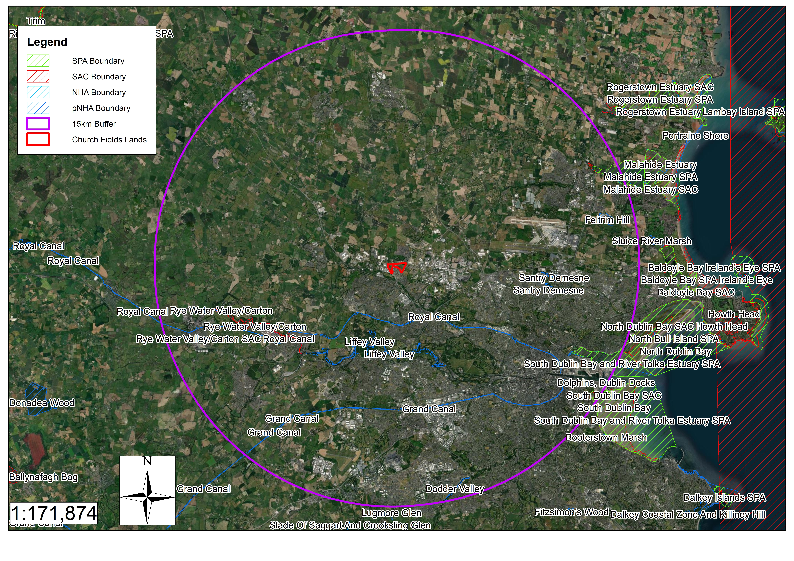
Figure 1.3. Site Designations within a 15km radius of the Church Fields Lands. SPA site boundary shown by green hatching, pNHA site boundary shown by blue hatching and SAC site boundary shown by red hatching.

3.2 Rare, Scarce and Threatened Flora
A review of the National Parks and Wildlife Service online database has no records of recent and historic records of Protected, Threatened and Scarce Vascular Plant Species from the 10km square (O04) in which the Church Fields Lands are located (O04).

3.3 Previous Ecological Surveys
The importance of the Church Fields Lands as a green open space for biodiversity has been highlighted in a number of previous studies including:
- Ecological Appraisal conducted by RPS for the Church Fields Link Road & Cycle Network.
- Preliminary Ecological Appraisal report prepared by Walsh/BSM for the Master Plan for the Church Fields Northern Lands.

Church Fields Link Road & Cycle Network
Part of the lands at Church Fields were the subject of an ecological appraisal for the Church Fields Link Road & Cycle Network completed by RPS Consulting Engineers in January 2020.

This study recorded the following habitats from the general study area.
- Buildings and artificial surfaces BL3
- Spoil and bare ground ED2
- Recolonising bare ground ED3
- Amenity grassland (improved) GA2
- Amenity grassland/neutral grassland mosaic GA2/GS1
- Scrub WS1
- Hedgerow WL1
- Treelines WL2
- (Mixed) Broadleaved woodland WD1
- Drainage ditches FW4
- Depositing/Lowland river FW2
- Arable crops BC1

The study described each of them (with the exception of the Pinkeen River, treelines and the area of mixed broadleaved woodland) as being of local (lower) ecological value. The Pinkeen River, treelines and the area of mixed broadleaved woodland were rated as being of local (higher) ecological value.

Their location is presented in the habitat map from that study on Figure 1.4 below.

The study also confirmed the presence of an active badger sett within close proximity to the scheme.

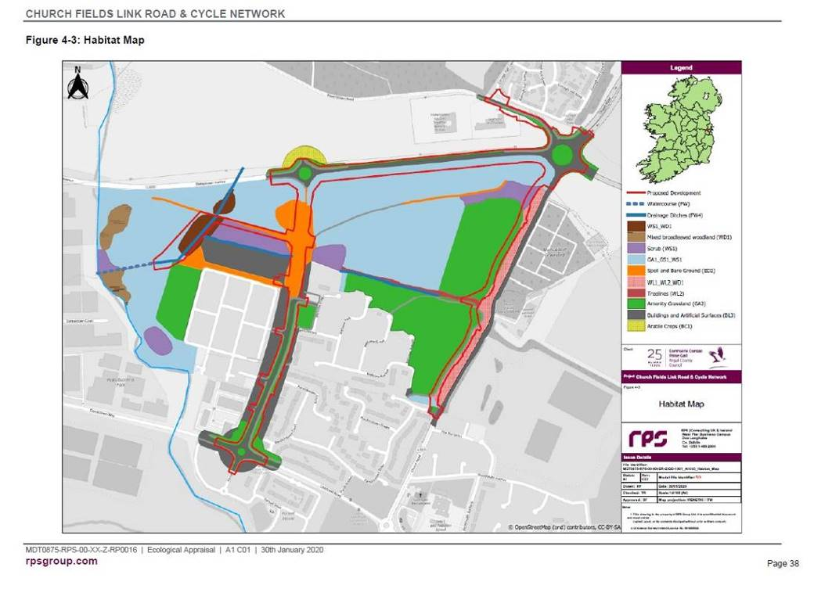
Figure 1.4. Habitat Map of the Church Fields Lands (RPS 2020).

The lands to the north of the proposed Wellview Park (the Church Fields Eastern Linear Park and the housing lands) were the subject of a preliminary ecological appraisal conducted as part of the master plan for this area which was completed by Brady Shipman Martin.

3.4 Changing Land Use
The lands at Church Fields have over the last twenty years been moving out of intensive agricultural use and slowly becoming developed through urbanisation, the construction of housing, roads, powerlines, drainage and other infrastructure including public open space.

Elements of the former demesne landscape associated with Tyrrelstown House such as planted shelterbelts, original field boundary hedgerows and the Pinkeen River Valley (a tributary of the River Tolka) remain.

This change in land use from one of intensive agriculture can be clearly seen when reviewing the various mapping and datasets available from the Ordnance Survey as presented below on Figures 1.5 to 1.9.

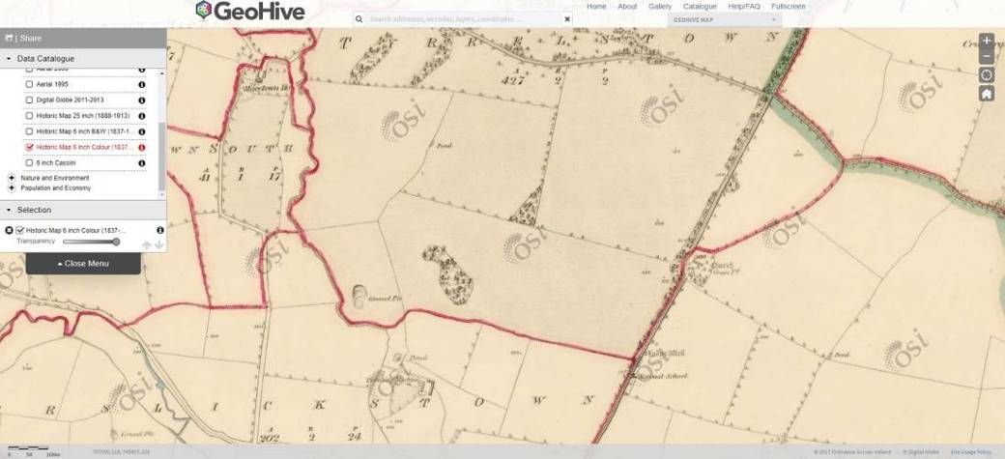
Figure 1.5. First Edition Ordnance Survey Mapping (1837) showing the Pinkeen River, an old gravel pit, a pond, field boundaries and shelterbelt planting along Church Road.

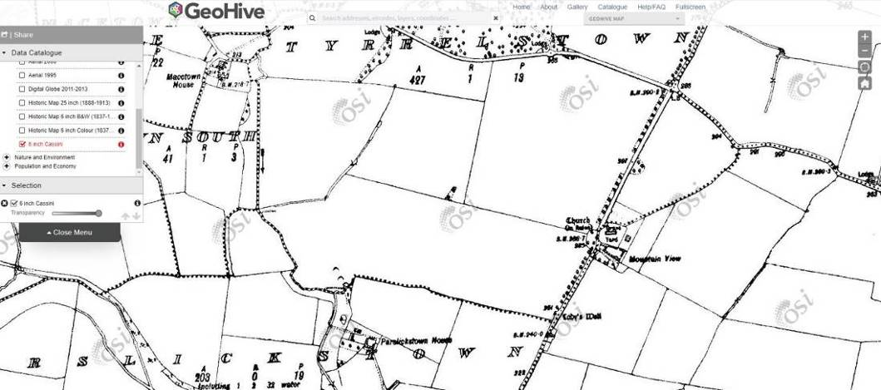
Figure 1.6. By the early 1900s the pond had been lost and the lands drained towards the Pinkeen River (illustrated by a red arrow).

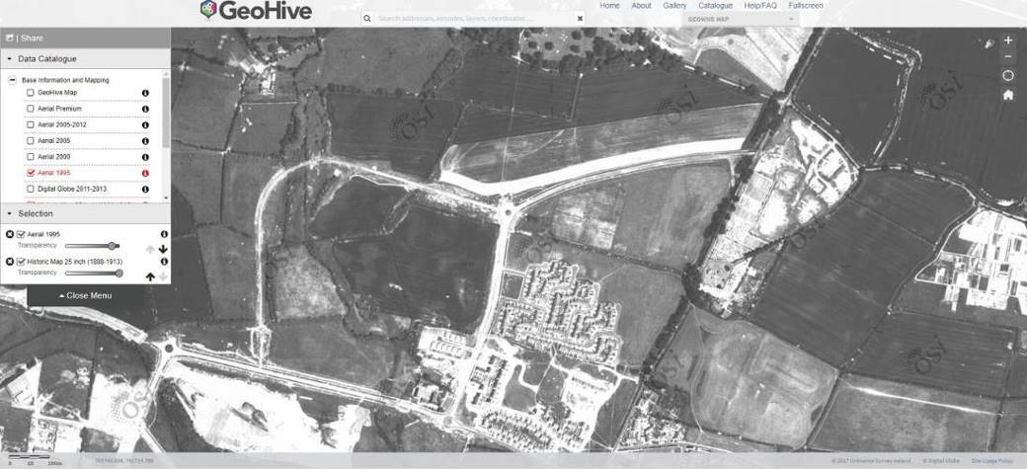
Figure 1.7. Intensive agricultural land use and increasing housing in the 1990s, with construction access roads developed bisecting the lands (Ordnance Survey Ireland aerial photography dated 1995). Wellview Park is indicated by the red arrow.

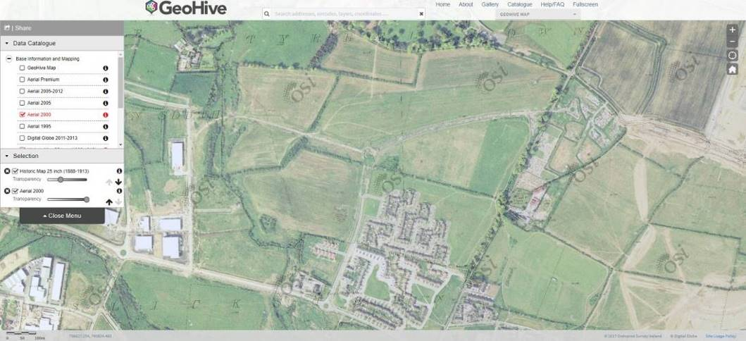
Figure 1.8. The lands continue to be farmed in the early 2000s (Ordnance Survey Ireland aerial photography dated 2000). Wellview Park is indicated by the red arrow.

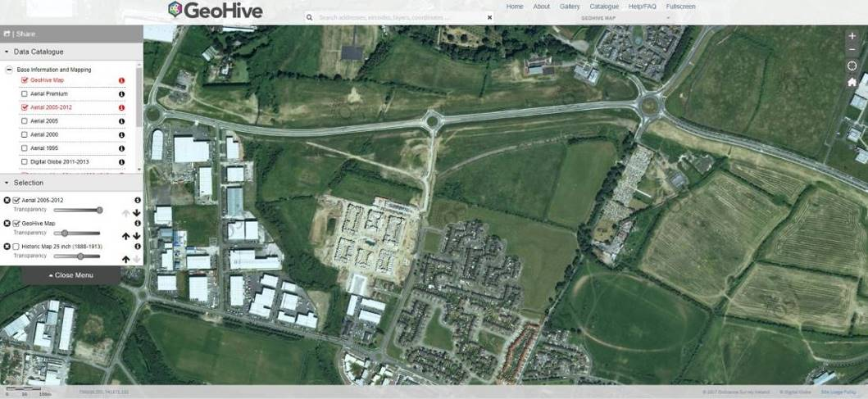
Figure 1.9. By 2012 the new Damastown Avenue had been constructed further bisecting the lands (Ordnance Survey Ireland aerial photography 2005 - 2012). Wellview Park is indicated by the red arrow.

3.5 Habitats
The abandonment of any management/intensive land use has allowed the natural succession of trees and scrub and the restoration of semi – species-rich natural grassland habitats on the northern parts of the Church Fields Lands.

These areas, the treelines, hedgerows, immature woodland, scrub and watercourses were mapped as ecologically sensitive areas within the Church Fields Lands as shown on Figure 1.10 below. The ecological value of these habitats is described in the ecological appraisal below.

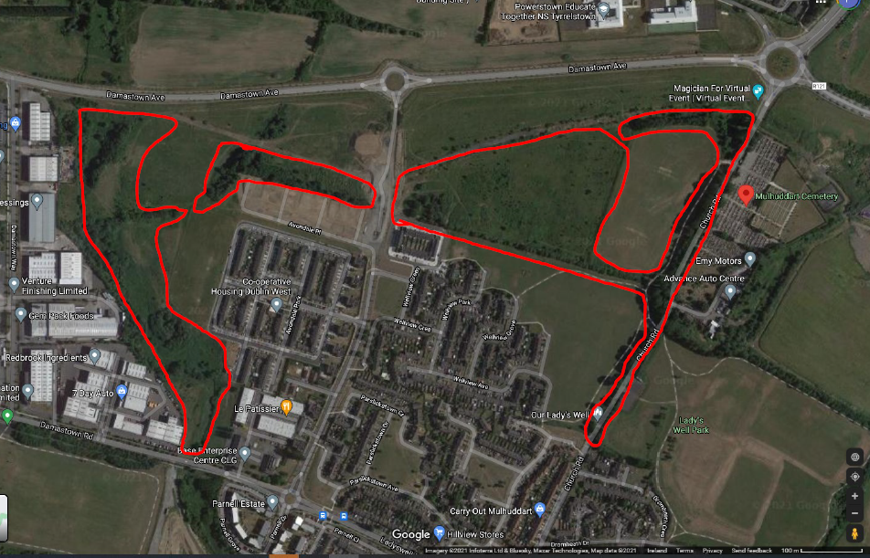
Figure 1.10. Ecologically sensitive areas identified on the Church Fields Lands include the Pinkeen River corridor, areas of extant copses, treelines and hedgerows, drainage ditches, areas of species rich semi-natural grassland and immature woodland and scrub.

Ecological Appraisal – Church Fields Lands
Although at first glance these lands appear abandoned, neglected and subject to ongoing anti-social behaviour they do in fact hold much in the way of interest for biodiversity in what are increasingly urbanised and sanitised surroundings. A diversity of habitat types is present on the Church Fields Lands – these are mapped on Figure 1.11.

The two areas of amenity grassland (GA2) in the eastern portion of the Church Fields Lands (the southern of these contains Wellview Park) are species poor on account of current management practices which allows the grass cuttings to be left on the sward following mowing. This favours the dominance of grass species at the expense of wildflowers. The grassland sward is dominated by a number of common grass species such as meadow grasses (Poa spp.), bents (Agrostis spp.) and in unmown verges cock’s-foot grass (Dactylis glomerata), crested dog’s-tail grass (Cynosurus cristatus) and false oat grass (Arrhenatherum elatius) were noted. Flowering species were limited to dandelion (Taraxacum officinale agg.) and white clover (Trifolium spp.). With appropriate management (primarily the cutting and removal of grass cuttings to reduce fertility on each mowing cycle) the diversity of the sward in these areas could be further improved. Wellview Park will be developed in the southern of these two fields.

The grassland areas in the northern and western parts of the Church Fields Lands are beginning to recover from years of intensive agricultural use and the associated application of fertilisers, herbicides and pesticides or have recolonised on disturbed ground which is low in nutrients. These areas contain species characteristic of semi-natural species-rich grasslands (GS1) and traditional hay meadows (GS2). Species such as cowslip (Primula veris), creeping cinquefoil (Potentilla reptans), vetches (Vicia cracca, Vicia sativa), various grasses (Festuca rubra, Festuca pratensis, Arrhenatherum elatius, Agrostis canina, Agrostis stolonifera, Agrostis capillaris, Poa annua, Poa pratensis, Cynosurus cristatus), bird’s foot trefoil (Lotus corniculatus), selfheal (Prunella vulgaris) and mosses are frequent in the areas akin to species rich grassland. Other typical species of these areas include germander speedwell (Veronica chamaedrys), common centaury (Centaurium erythraea), sweet vernal grass (Anthoxanthum odoratum), red bartsia (Odontites verna), ribwort plantain (Plantago lanceolata). These areas are typically maintained through the grazing actions of rabbits.

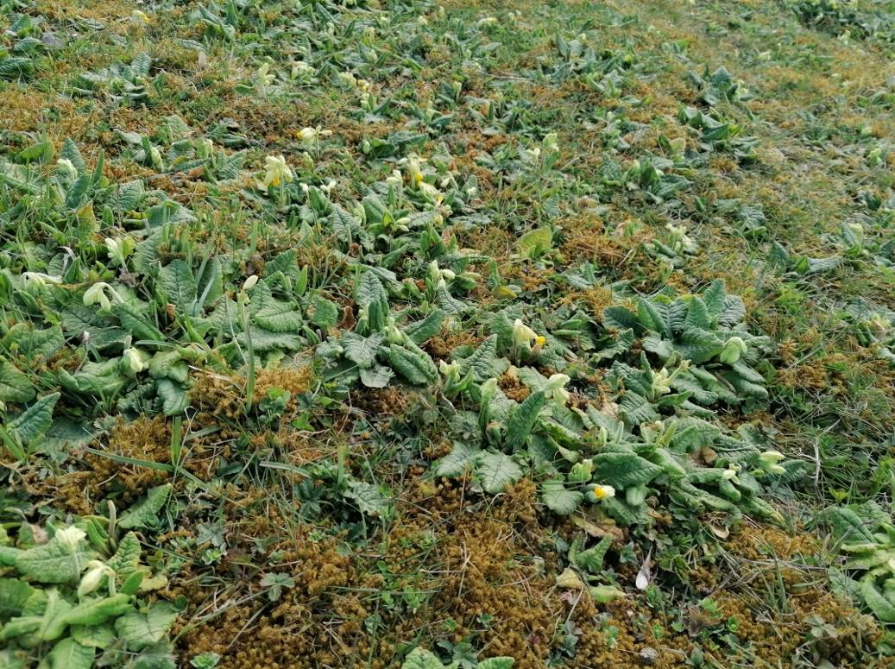
Plate 1. Cowslips abound in some parts of the Church Fields Lands.

In other areas which are less grazed areas of hay meadow/grassy verge grassland (GS2) has developed with typical species such as ribwort plantain (Plantago lanceolata), meadow vetchling (Lathyrus pratensis), hogweed (Heracleum sphondylium), white clover (Trifolium repens), creeping buttercup (Ranunculus repens), red clover (Trifolium pratense), nipplewort (Lapsana communis), creeping thistle (Cirsium arvense), spear thistle (Cirsium vulgare), burdock (Arctium minus), common bent (Agrostis canina), creeping bent (Agrostis stolonifera), cock’s-foot grass (Dactylis glomerata) and sweet vernal grass (Anthoxanthum odoratum). With appropriate management (primarily the cutting and removal of cuttings to reduce fertility at the end of the summer) the diversity of the sward in these areas could be further improved.

These areas of grassland are then becoming invaded by scattered scrub (WS1) or increasingly dominated by opportunistic species such as rosebay willowherb (Epilobium angustifolium), nettle (Urtica dioica), teasel (Dipsacus fullonum) and thistles (Cirsium arvensis, Cirsium vulgaris). All of these species provide nectar for pollinators, seeds for feeding flocks of wild birds, and cover for invertebrates to complete their lifecycles within.

The treeline (WL2)/hedgerow (WL1) and associated drainage ditches (FW4), which runs east west through the Church Fields Lands, forming the main spine of the Church Fields Eastern Linear Park, acts as an important corridor for wildlife and dates from the 1860s. This hedgerow is described in the arboricultural report as boundary 1, 2, 3, 4 and 5. This hedgerow and associated drainage ditch forms the northern boundary of Wellview Park. The overgrown and spreading nature of this original field boundary, particularly on the northern side contains the greatest diversity in terms of structure providing a rich natural resource for invertebrates, pollinators, birds and other fauna including bats, pygmy shrew, rabbits and other mammals. The hedgerow contains species such as ash (Fraxinus excelsior), sycamore (Acer pseudoplatanus), blackthorn (Prunus spinosa), field maple (Acer campestre), elder (Sambuccus nigra), bramble (Rubus fruticosus agg.), dog rose (Rosa canina) and mature ivy (Hedera helix). Some dead standing remains or young regenerating Wych elm (Ulmus glabra) also occurs. Scrub elements here include naturally regenerating blackthorn (Prunus spinosa) which in some locations is forming a dense thicket, bramble (Rubus fruticosus agg.), dog rose (Rosa canina), honeysuckle (Lonicera periclymenum) and gorse (Ulex europaeus). All of these species and features are of high ecological importance from the perspective of biodiversity and fauna. Adjoining this hedgerow are small copses of immature woodland (WN2) containing sycamore (Acer pseudoplatanus), ash (Fraxinus excelsior), elder (Sambucus nigra), bramble (Rubus fruticosus), ivy (Hedera helix), and hawthorn (Crataegus monogyna). These are described as Thicket Area 1 and Woodland Area 1 in the arboricultural report for the Church Fields Lands. A copse with a similar composition is found along the Macetown Stream – described as Thicket Area 2 and 3 in the arboricultural report.

A buffer zone with a boundary a minimum of 6 - 10m from the hedgerow is recommended in order to allow it to function ecologically in the short to medium term with additional planting to strengthen it to form a shelterbelt/linear woodland in the long term.

Fragmentation of this linear feature should be avoided and although north – south permeability from the Church Fields Eastern Linear Park to Wellview Park is required this should be provided where there are existing gaps in the hedgerow and kept to a maximum width of under 1.5m (i.e. suitable for pedestrians but not vehicles).

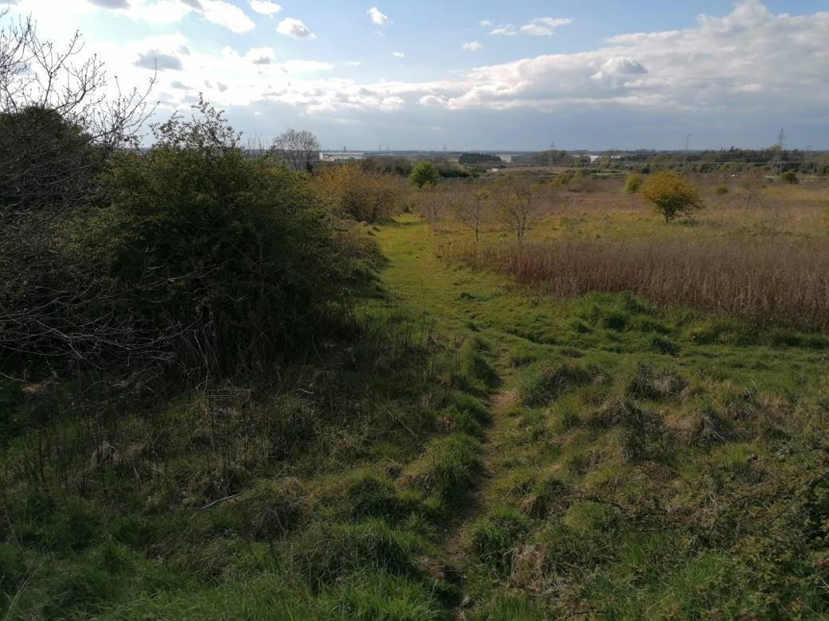
Plate 2. Spreading scrub from the hedgerow on the northern side of the hedgerow along the northern boundary of Wellview Park will be protected and enhanced with additional planting to create a long term linear woodland/shelterbelt in the Church Fields Eastern Linear Park.

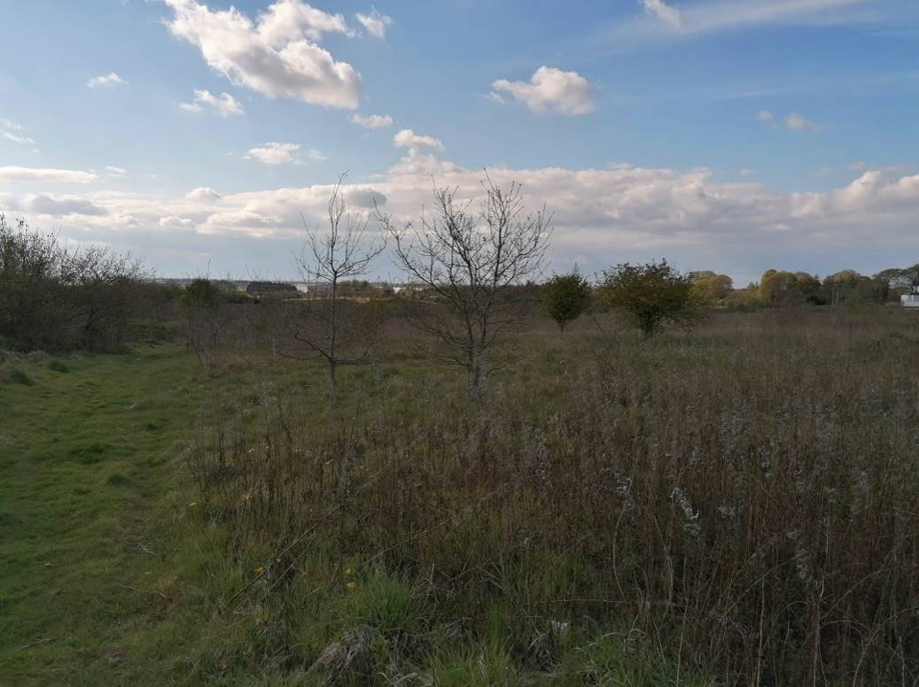
Plate 3. Naturally regenerated immature woodland and dry meadow grassland habitat north of the Church Fields Eastern Linear Park.

North of this is a significant area of naturally regenerated young woodland (WS2) comprising pedunculate oak (Quercus robur), crab apple (Malus sylvestris), hawthorn (Crataegus monogyna), blackthorn (Prunus spinosa), ash (Fraxinus excelsior), silver birch (Betula pendula), whitebeam (Sorbus aria), goat willow (Salix caprea) and the non-native buddleia (Buddleia davidii), interspersed with pockets of bramble thickets, gorse (Ulex europaeus) and other scrub features such as bramble, blackthorn (Prunus spinosa) and dog rose (Rosa canina).

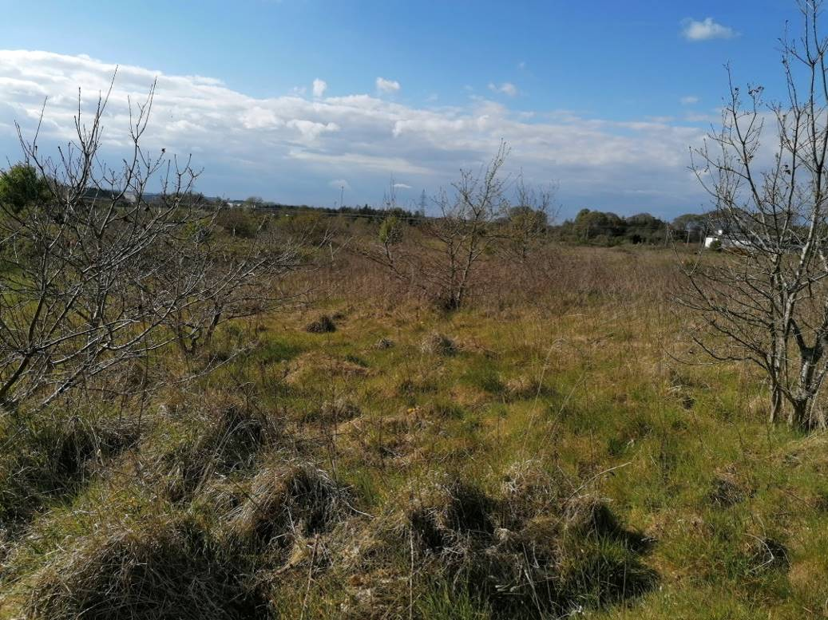
Plate 4. Naturally regenerated immature woodland and dry meadow grassland habitat north of the Church Fields Eastern Linear Park.

They are surrounded by areas of dry meadow/grassy verge grassland. With appropriate management and a light touch approach these features could form an ongoing reservoir of habitat for wildlife in the area as well as a real connection for locals with the natural world.

Notwithstanding the fact that the masterplan for the Church Fields Lands to the north of the Church Fields Eastern Linear Park are zoned for development these areas, which have been subject to natural ecological processes (or rewilding), support a considerable range of biodiversity.

This is particularly evident and in strong contrast to the existing Wellview Park, which in comparison contains relatively little habitat for wildlife beyond the hedgerow and treeline features. Grassland management here does not favour biodiversity as the grass cuttings are left in situ leaving a rank sward. There did seem to have been some delays in mowing which had allowed the dandelions and daisy to flower providing nectar resources for early spring pollinators. Winter heliotrope (Petasites fragrans), which is a non-native invasive species was recorded within this area.

Key tree species in the treeline (WL2) and narrow band of mixed broadleaved woodland (WD1) along Church Road include mature beech (Fagus sylvatica), sycamore (Acer pseudoplatanus) and ash (Fraxinus excelsior). Under storey trees include hawthorn and willow.

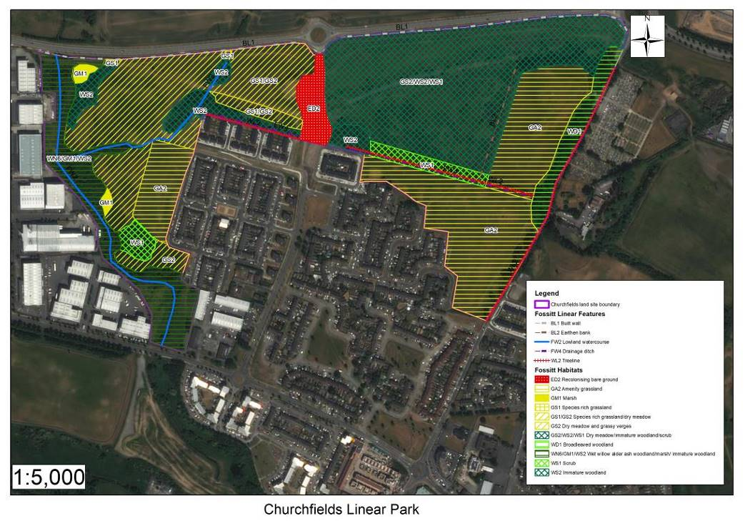
Figure 1.11. Habitat map of the Church Fields Lands.

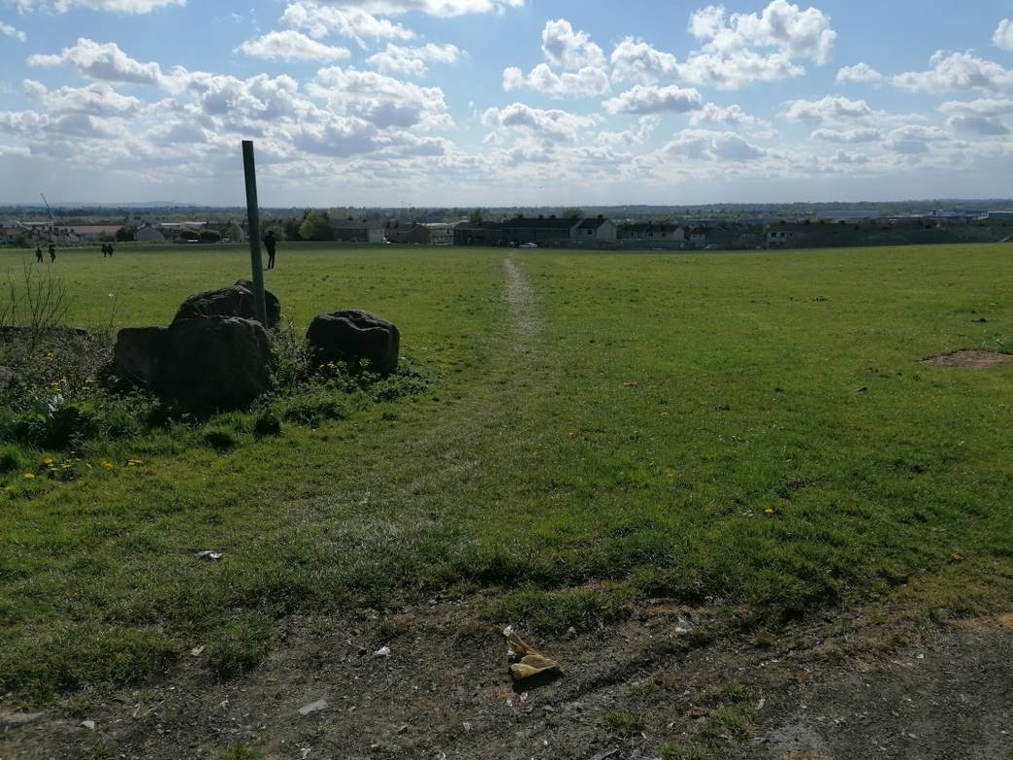
Plate 5. Wellview Park.

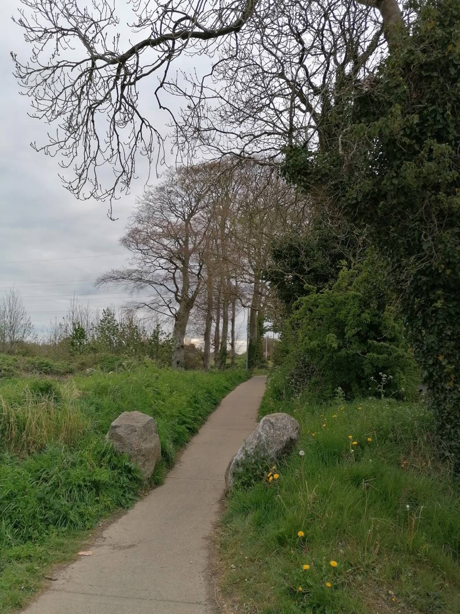
Plate 6. Treeline of mature beech and ash along Church road. These are a remnant of the former demesne landscape.
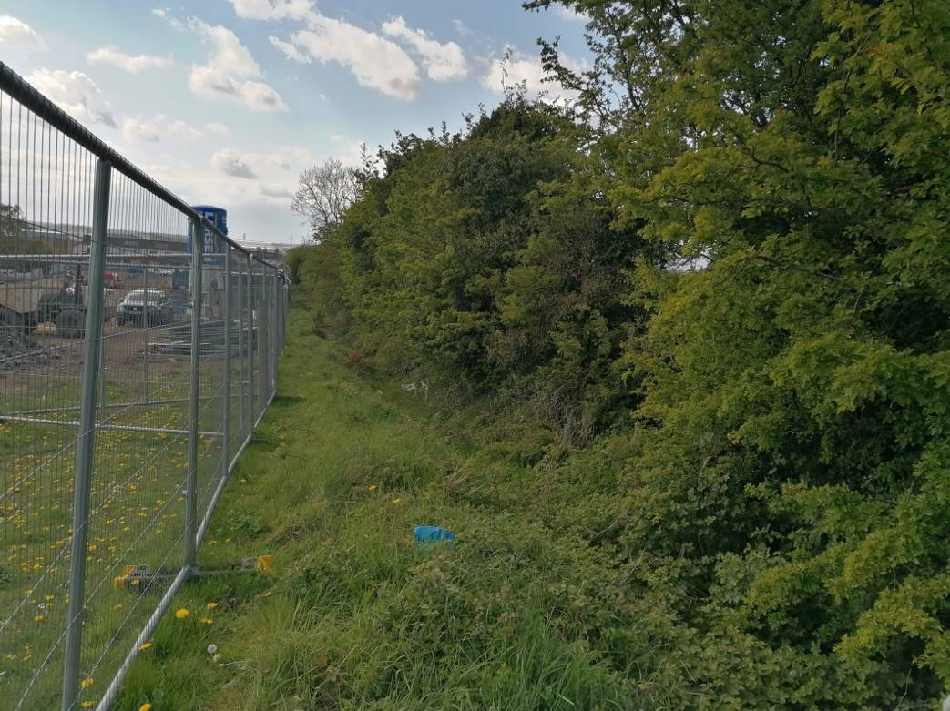
Plate 7. Housing under construction to the west of Wellview Park.

3.6 Invasive Species
Winter heliotrope (Petasites fragrans) was recorded on the margins of Wellview Park and can be very invasive. It is recommended that an invasive species management plan is prepared to control and eradicate this species and to ensure that it is nor spread during further site construction works.

3.7 Bats
The Bat Conservation Ireland Database of bat records was searched for records of bats from the environs of Mulhuddart and the Church Fields Lands. The database contains records of roosts, ad hoc observations and the results of surveys such as the BATLAS 2010 project and the All Ireland Daubenton’s Monitoring Project.

Species recorded within the 10km square in which the Church Fields Lands are located (O04) include:
- Common pipistrelle (Pipistrellus pipistrellus),
- Soprano pipistrelle (Pipistrellus pygmaeus),
- Leisler’s bat (Nyctalus leisleri), and
- an unidentified pipistrelle species (Pipistrellus sp.).

A bat survey was conducted by Faith Wilson on the lands of Hollystown Golf Course (which is located c.1.4km to the north of the Church Fields Lands) on 5th June 2018. Three species of bat were found to use these lands for hunting and foraging purposes although no roosts were confirmed. The most abundant of these were common pipistrelle and soprano pipistrelle both of which were recorded foraging along the perimeter treelines of the golf course, along internal scattered trees and the edges of immature woodland and over the drainage ditches and artificial ponds and wetlands within the golf course. The other species that was recorded on the site was Leisler’s bat, which was recorded hunting high over the site just shortly after dusk.

In 2019 additional bat surveys were conducted by Faith Wilson as part of a housing development on lands at Kilmartin (to the west of the golf course) adjoining the Hollystown Golf Course. The 2019 surveys, which were conducted on the 14th and 15th May 2019 recorded three species of bat, which were found to use these lands for hunting and foraging purposes although no roosts were confirmed. These were common pipistrelle and soprano pipistrelle which were found across the entire site, while Leisler’s bat were recorded hunting over the arable fields in the western portion of the site. This study noted that there are several mature trees within the proposed housing development lands at Kilmartin, particularly within the treelines that adjoin the golf course and the treeline adjoining the R121 opposite Hollywood Rath, which are suitable for roosting bats.

Three species of bats have been recorded during the surveys conducted by Brian Keeley from the Church Fields Lands in 2020 and 2021. These are:
- Common pipistrelle (Pipistrellus pipistrellus),
- Soprano pipistrelle (Pipistrellus pygmaeus),
- Leisler’s bat (Nyctalus leisleri).

As reported by Keely (2021):

‘None of the bats were seen to enter or leave any of the mature trees within the Church Fields Lands. However, soprano pipistrelle activity was noted around trees prior to sunrise in 2020 but the final destination of the bat was not discovered. There was activity of all three bat species close to the trees prior to sunrise in 2021 also but no bat entered any of the trees.

All three species will avail of trees with Leisler’s bat probably the most commonly encountered in trees of these species. There are several mature beech trees along the eastern edge of the Church Fields Lands that have high roost potential.

Leisler’s bat activity was relatively high within the site, over the grassland and towards the mature line of beech trees. The lands to the west of the soil berm were less used by bats and this area is relatively exposed in comparison to the eastern side of the site. Leisler’s bats were present after sunset and prior to sunrise and it is probable that roosts are present close to the site but no roosts were identified within the site ’.

The Pinkeen River wasn't very accessible at night so it wasn't covered over any distance; only the northern end. This would reduce the apparent value of it for bats.

The results of the survey are mapped on Figure 1.12 below.

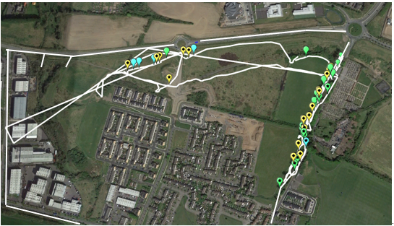
Figure 1.12. Bat activity from sunset onwards and prior to sunrise within the site July 2021.

Green paddle Common pipistrelle activity Starred = Prior to sunrise; Blue paddle Soprano pipistrelle activity Starred = Prior to sunrise; Yellow paddle Leisler’s bat activity; White line Transect of surveyors

The RPS study noted the following potential bat roosts within the Church Fields Lands:
‘The field study identified a group of semi-mature ash trees at the western end of the proposed development alongside attenuation pond #1 with high ivy coverage adjacent marked for removal. These were considered to have roosting features of low potential’.

The trees, treeline and scrub vegetation on the eastern boundary of Wellview Park along Church Road and the east –west hedgerow and associated drainage ditch on the northern boundary of Wellview Park are of high importance to bats as can be seen on Figure 1.12 above.

3.8 Other Mammals
The habitats in the Church Fields Lands provide a rich habitat for a range of mammal species, which while common and ubiquitous in the wider countryside rapidly disappear following urbanisation of the landscape. Species which were either directly observed (or their signs were noted) from the Church Fields Lands include:
- Red fox (Vulpes vulpes)
- Rabbit (Oryctolagus cuniculus)
- Brown Rat (Rattus norvegicus)
- House Mouse (Mus musculus)
- Field Mouse (Apodemus sylvaticus)
- Hedgehog (Erinaceous europaeus)

3.9 Amphibians
The drainage ditch along the northern boundary of Wellview Park and other ditches within the Church Fields Lands could potentially support breeding frogs (Rana temporaria).

3.12 Birds
A rich variety of bird species were recorded during the surveys which reflects the natural habitats present on the Church Fields Lands. These include blackbird (Turdus merula), wren (Troglodytes troglodytes), robin (Erithacus rubecula), dunnock (Prunella modularis), chaffinch (Fringilla coelebs), greenfinch (Carduelis chloris), song thrush (Turdus philomelos), and mistle thrush (Turdus viscivorus).

Other species recorded include; great tit (Parus major), coal tit (Parus ater), blue tit (Cyanistes caeruleus), long tailed tit (Aegithalos caudatus), goldcrest (Regulus regulus), rook (Corvus frugilegus), jackdaw (Corvus monedula), pied wagtail (Motacilla alba yarrellii), hooded crow (Corvus cornix) and magpie (Pica pica).

Both feral pigeon (Columba columba domest.) and woodpigeon (Columba palumbus) were also encountered and flocks of starlings (Sturnus vulgaris) were recorded in October 2021.

Summer visitors such as swifts (Apus apus), swallows (Hirundo rustica) and house martins (Delichon urbicum) are likely to feed over the lands.

Large flocks of linnet (Carduelis cannabina) and goldfinch (Carduelis carduelis) were observed foraging on the thistle and willowherb seed heads.

Observed birds of prey include sparrowhawk (Accipiter nisus) and buzzard (Buteo buteo) while kestrel (Falco tinnunculus) may also hunt over the Church Fields Lands.

Long eared owl (Asio otus) breed within the Church Fields Lands. Young birds were heard calling from the trees within the woodland in the Pinkeen River ecological corridor during the bat survey in July 2021.

3.13 Fisheries and Watercourses
The study lands at Church Fields are located within the Liffey and Dublin Bay Catchment (09), and within the Tolka Sub-Catchment (SC10). The Church Fields Lands are drained by the Tolka 030 (IE_EA_09T010800).

The main channel of the Pinkeen River flowing through the Church Fields Lands is known as the Powerstown (Dublin)_010 (IE_EA_09P210700), while the eastern arm of the Pinkeen River is known Macetown South (IE_EA_09T010800) as shown below on Figure 1.13. Both of these waterbodies have been deemed at risk of not achieving ‘Good’ water status under the current Water Framework Directive monitoring period 2013 - 2018. Q values taken downstream of here in the River Tolka at Mulhuddart Bridge are poor (i.e. Q2-3). This is unsurprising as raw sewage was seen discharging from the local sewer connections on the Church Fields Lands into the Macetown South stream and the Pinkeen River just beyond that.

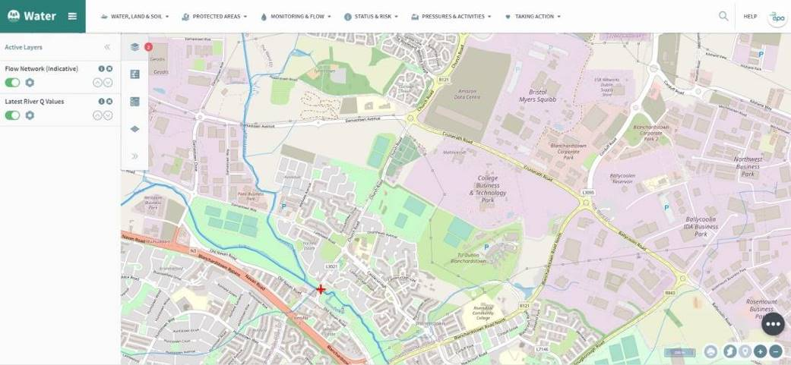
Figure 1.13. Watercourses within the study area (www.catchments.ie).

ASSESSMENT OF ECOLOGICAL SIGNIFICANCE

4.1 Church Fields Lands
The habitats and the species they support within the Church Fields Lands are of high local biodiversity importance within the general environs of Mulhuddart/Damastown. The Pinkeen River and associated wet willow alder ash woodland, marsh, scrub, immature woodland and grassland habitats form a very significant ecological corridor along the western part of the Church Fields Lands. The wet willow alder ash woodland here has potential affinities with the Annex I priority habitat type 91E0 Alluvial Woodland and would be of county importance. The hedgerow, drainage ditch and scrub which runs east west through the lands and the treeline, trees and scrub along the boundary with Church road all form important green corridors and linkages through the lands for wildlife.

4.2 Wellview Park
The habitats of high ecological importance within the context of Wellview Park include the boundary hedgerow and associated drainage ditch to the north and the treeline, trees and scrub in the shelterbelt along the eastern boundary of the Park.

With appropriate management and additional planting the biodiversity interest of the grassland within these lands could be improved.

DESIGN RECOMMENDATIONS

This survey and ecological study has identified the main features of importance from the perspective of biodiversity within the Church Fields Lands.

The following ecological enhancement proposals and recommendations for habitat protection and management were presented to the design team to inform the design for the development of Wellview Park. They were to:
- Retain a sense of calm, a green oasis and a green lung to the Church Fields Lands through the retention of habitats of ecological value
- Opportunity to improve the biodiversity value of the intensively managed amenity grassland in Wellview Park through appropriate mowing and grassland management
- Strengthen the ecological corridor along the east west spine of the northern part of Wellview Park (within the Church Fields Eastern Linear Park) to improve it’s biodiversity value through protection of the existing scrub habitat and planting of native hedgerow species
- Retention of ecological connectivity provided by the mature beech trees along the eastern edge of Wellview Park with additional planting to replace this shelterbelt over time as the trees come to the end of their lives
- Strengthen and protect the ecological corridor along the Pinkeen watercourse at the western end of the Church Fields Lands from the perspective of fauna
- Strengthen and protect the area of alluvial woodland, marsh, scrub and grassland habitats along the Pinkeen watercourse at the western end of the lands
- Ensure the protection of bats utilising the Church Fields Lands for foraging purposes and the protection of potential roosts in the mature beech trees on the eastern edge of Wellview Park
- Develop an appropriate wildlife friendly public lighting scheme for the Church Fields Eastern Linear Park

Any proposals for the development of the Church Fields Lands should be in line with the relevant Green Infrastructure Policy Objectives as set out in the Fingal County Development Plan. These include:

Objective GI01: Support the implementation of the Fingal Heritage Plan in relation to the provision of Green Infrastructure.

Objective GI02: Create an integrated and coherent green infrastructure for the County by requiring the retention of substantial networks of green space in urban, urban fringe and adjacent countryside areas to serve the needs of communities now and in the future including the need to adapt to climate change.

Objective GI03: Develop the green infrastructure network to ensure the conservation and enhancement of biodiversity, including the protection of European Sites, the provision of accessible parks, open spaces and recreational facilities (including allotments and community gardens), the sustainable management of water, the maintenance of landscape character including historic landscape character and the protection and enhancement of the architectural and archaeological heritage.

Objective GI04: Seek a net gain in green infrastructure through the protection and enhancement of existing assets, through the provision of new green infrastructure as an integral part of the planning process, and by taking forward priority projects including those indicated on the Development Plan green infrastructure maps during the lifetime of the Development Plan.

Objective GI06: Resist development that would fragment or prejudice the County’s strategic green infrastructure network.

Objective GI07: Ensure green infrastructure protection and provision promotes pedestrian access, cycling, and public transport in preference to the car, as appropriate.

Objective GI08: Integrate the provision of green infrastructure with infrastructure provision and replacement, including walking and cycling routes, as appropriate, while protecting biodiversity and other landscape resources.

Objective GI11: Ensure the Green Infrastructure Strategy for Fingal protects existing green infrastructure resources and plans for future green infrastructure provision which addresses the five main themes identified in this Plan, namely:
- Biodiversity,
- Parks, Open Space and Recreation,
- Sustainable Water Management,
- Archaeological and Architectural Heritage,
- Landscape.

Objective GI12: Ensure the Green Infrastructure Strategy for Fingal reflects a long-term perspective, including the need to adapt to climate change.

Objective GI24: Ensure biodiversity conservation and/or enhancement measures, as appropriate, are included in all proposals for large scale development such as road or drainage schemes, wind farms, housing estates, industrial parks or shopping centres.

Objective GI25: Integrate provision for biodiversity with public open space provision and sustainable water management measures (including SuDS) where possible and appropriate.

ECOLOGICAL IMPACTS – WELLVIEW PARK

A number of impacts on the local biodiversity, habitats and species associated with the Church Fields Lands arise from their development and future use as a public space for Wellview Park as shown on Figure 1.14 below.

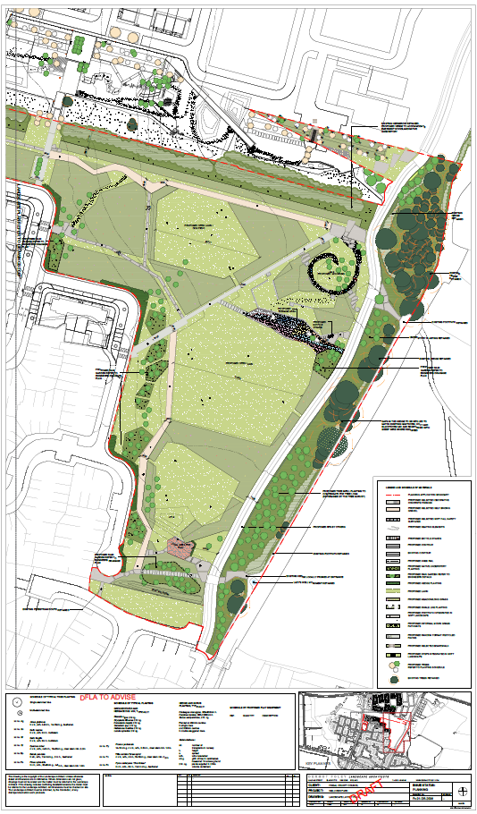
Figure 1.14. Proposed Site Layout for Wellview Park.

The main potential impacts arising from the proposed development of Wellview Park during the construction period are assessed as follows:
- Potential damage to the habitats within the site from the construction works.
- Potential for the spread of invasive species if biosecurity measures are not implemented.
- Potential impacts on bats potentially utilising the mature beech trees on the eastern boundary for roosting purposes.
- Potential for disturbance to bats from lighting including loss of hunting habitat and barriers to the movement of bats through the site.
- Potential for disturbance to bats from fragmentation of habitat.
- Potential loss of habitat in drainage ditches within the site.
- Potential loss of deadwood and other features of ecological value within retained hedgerows and below the eastern linear shelterbelt on the boundary of Wellview Park from health and safety concerns, tidying up and sanitisation of areas of natural vegetation.
- Potential impacts on the hedgerow and understorey species within the eastern linear shelterbelt on the boundary of Wellview Park from proposals to erect a fence along this boundary.

Potential impacts during the operational phase of Wellview Park may include the following:
- Potential disturbance to bats from lighting.
- Potential sanitisation of areas of ecological importance through removal of vegetation, trampling pressure, dumping of rubbish, garden waste and other items, etc.
- Disturbance to breeding birds through increased public use.
- Inappropriate mowing regime of grassland areas and park margins.

The following mitigation measures are recommended to avoid/reduce these impacts in the design of Wellview Park.

MITIGATION MEASURES

7.1 Mitigation by Avoidance
The principal mitigation that should be considered in any development is avoidance of impact. Direct impacts on the majority of the mature beech trees and understorey and hedgerow edge species along the eastern boundary and the hedgerow along the northern boundary of the site have been avoided in the proposed design for Wellview Park. It is proposed to retain all of these areas and strengthen them with additional planting of native species and to manage them appropriately in the future. This has ameliorated some of the potential impacts for both flora and fauna within the red line boundary of the site.

Before any construction related works begin on site these areas need to be clearly marked out on the ground and afforded suitable protection. This will be done by the ecological clerk of works with the project landscape architect and contractor.

7.2 Sediment Control
Sediment control practices are used on building sites to prevent sand, soil, cement and other building materials from reaching streams and ditches. Even a small amount of pollution from a site can cause significant environmental damage by killing aquatic life, silting up streams and blocking storm water pipes. Storm water can contain many pollutants which can enter our local drainage ditches, streams, rivers and marine systems, causing harm to native animals, plants, fish breeding habitats and recreational areas.

Soil erosion, sediment and litter from building sites can be major sources of storm water pollution, and can cause:
- significant harm to the environment
- weed infestation of waterways caused by sediment settling in watercourses and ditches and transporting nutrients
- loss of valuable topsoil
- significant public safety problems when washed onto roads and intersections
- blocked drains creating flooding and increased maintenance costs
- damage to recreational and commercial fishing downstream.

Sediment control usually requires little effort and results in:
- Cleaner waterways and healthier aquatic life.
- Improved site conditions.
- Improved wet weather working conditions.
- Reduced wet weather construction delays.
- Reduced losses from material stockpiles.
- Fewer mud and dust problems.

Good site management in relation to sediment control during the construction phase should prevent this from occurring and possible mitigation measures for consideration are outlined below.

Minimising site disturbance:
Prevention is better than cure. Careful design and an efficient construction sequence will minimise disturbance to the site. This will save money and reduce environmental impact.

Clear only those areas necessary for building work to occur. Preserve grassed areas and vegetation where possible. This helps filter sediment from storm water run off and stops rain turning exposed soil into mud. Delay removing vegetation or commencing earthworks until just before building activities start. Avoid building activities that involve soil disturbance during periods of expected heavy or lengthy rainfall.

Implement sediment control:
Install sediment control measures along the drainage ditch along the northern site boundary using techniques such as silt fencing before commencing any excavation or earth moving. Regularly maintain them until construction is complete and the site is stabilised.

7.3 Contractor Briefing
All site contractors will be briefed regarding the biodiversity value of the northern drainage ditch/ hedgerow/scrub and the retained trees, treelines, and scrub along Church Road to ensure that there are no accidental or unintentional actions conducted during the project construction that could lead to a reduction in water quality/damage to same. Such matters often arise through ignorance or by accident rather than as a result of an intentional action.

7.4 Protection Measures for Birds
Section 40 of the Wildlife Act 1976, as amended by Section 46 of the Wildlife (Amendment) Act 2000, restricts the cutting, grubbing, burning or destruction by other means of vegetation growing on uncultivated land or in hedges or ditches during the nesting and breeding season for birds and wildlife, from 1 March to 31 August.

No clearance of vegetation suitable for nesting birds within the site (shrubs, bramble tangles, etc.) will take place during this period.

Should such clearance be required than the area proposed for clearance should be inspected by an ecologist to ascertain if any nesting birds are present.

7.5 Measures for Birds
A variety of artificial nesting opportunities for birds (bird boxes) will be erected on the retained trees along the eastern boundary of Wellview Park.

7.6 Protection Measures for Bats

Bat Foraging Habitat
It is important that all trees, treelines, hedgerows and other vegetation (including bramble scrub) which is to be retained within the site boundary is retained in full as this provides foraging habitat for bats supporting a diversity of invertebrates. These trees and vegetation also help to maintain and create a corridor which allows bats (and other fauna) to forage and commute through the Church Fields Lands.

These areas of retained trees and vegetation must be fenced and protected during the construction phase to ensure that they are not damaged during the works. Protective fencing will be erected in advance of any construction works commencing in order to prevent damage to these retained habitats during construction in accordance with BS 5837:2012. This will be signed off on by a qualified ecologist to ensure it has been erected properly and the vegetation has been protected before any machinery/works are allowed on site. No ground clearance, earth moving, stock-piling or machinery movement will occur within these protected areas.

Potential Bat Roosts
A number of mature trees on the eastern boundary of the Church Fields Eastern Linear Park have been identified as having the potential to support roosting bats. The majority of these trees are to be retained in full and will be afforded protection during construction as set out above.

Should any of these trees require removal on the grounds of health and safety they will be further assessed by a licensed bat specialist prior to removal to check for the presence of bats. If any bats are encountered during the assessment a bat derogation licence for the works will be sought from NPWS. The results of the survey will determine how they should be felled. Tree felling of potential bat roosts will be conducted during the winter months of October and November to avoid both the bird breeding season and the maternity/hibernation periods for bats.

Reduction of light disturbance
The Wellview Park lands are currently unlit at night and provide an important dark habitat for hunting bats and other fauna.

Design recommendations from the BCT (2010) for wildlife-friendly lighting include:
- Do not "over" light. This is a major cause of obtrusive light and is a waste of energy. Use only the minimum amount of light needed for safety. There are published standards for most lighting tasks, adherence to which will help minimise upward reflected light.
- Eliminate any bare bulbs and any light pointing upwards. The spread of light should be kept near to or below the horizontal.
- Use narrow spectrum bulbs to lower the range of species affected by lighting.
- Use light sources that emit minimal ultra-violet light. Insects are attracted to light sources that emit ultra-violet radiation.
- Reduce light-spill so that light reaches only areas needing illumination. Shielding or cutting light can be achieved through the design of the luminaire or with accessories, such as hoods, cowls, louvers and shields to direct the light.
- Reduce the height of lighting columns. Light at a low level reduces ecological impact. However, higher mounting heights allow lower main beam angles, which can assist in reducing glare.
- For pedestrian lighting, use low level lighting that is directional as possible and below 3 lux at ground level.
- Limit the times that lights are on to provide some dark periods for wildlife.
- Use lighting design computer programs and professional lighting designers to predict where light spill will occur.
- In general any lighting used in the development should not overspill onto the adjoining trees and woodland thereby ensuring that a dark corridor for foraging and commuting bats and movement for other wildlife is maintained.

In addition:
- Luminaires will be dimmable LED (light emitting diode) fittings with High performance optics to provide high visual comfort.
- Luminaires will be selected to ensure that when installed there shall be zero direct upward light emitted to the sky (all output shall be at or below 90º to the horizontal to help prevent sky glow from light pollution of the night sky).
- Luminaires will be selected to ensure that there is no light spill from the proposed development onto the retained areas of linear vegetation and boundary features.
- The light emitted from these fittings shall have no photo biological risk and shall be categorised as “Exempt Group” in relation to emissions of Blue light, Infrared and Ultra Violet Radiation in accordance with EN 62741:2008.
- All luminaires shall have a Luminous intensity Classification of between G4 and G6 to IS EN 13201-2:2003(E) / BS 5489-1:2013.
- The recommendations of the Institution of Lighting Professionals and Bat Conservation Trust “Bats and Lighting in the UK” documentation and Bat Conversation Ireland Guidance Notes for planners, engineers, architects and developers December 2010 will be met.

These guidelines will be implemented in any project lighting design which links Wellview Park to the Church Fields Eastern Linear Park.

7.7 Measures for Bats - Erection of Bat Boxes
It is recommended that five no. Schwegler 2F bat boxes are erected on trees on site to provide roosting potential for bats. These will be sited by the contractor under the supervision of a suitably qualified ecologist.

7.8 Biosecurity
Should earth or other material be brought to site this material should be screened to confirm that no invasive species such as Japanese knotweed or other species as described on http://www.invasivespeciesireland.com/ are present. All machinery and plant entering the site should be cleaned to ensure that no fragments of Japanese knotweed or seeds of other invasive species are brought on to the site in line with the Birds and Natural Habitats Regulations 2011.

7.9 Planting Proposals
The landscaping proposals for the development (including the planting of native trees and shrubs to enhance the existing mature beech treelines on the eastern boundary of the park) were developed by Dermot Foley Landscape Architects in conjunction with the project ecologist.

Proposals for the establishment of a native hedgerow along the southern and western boundary of the park were also discussed. These planting proposals set out to strengthen the existing areas within the site for wildlife and biodiversity and to reinstate green infrastructure across the site post construction. They include the use of native and local plant species such as oak, hawthorn, blackthorn, holly, hazel, guelder rose and dog rose within the proposed hedgerow planting.

The species used will be native and of local origin where possible, certified stock is available from nurseries who supply stock for the Native Woodland Scheme.

7.10 Grassland Management/Creation
The presence of a diverse grassland flora in unmown areas within the wider Church Fields Lands has informed the project team as to how ecologically rich the existing amenity grassland areas within the site could become if managed appropriately.

The areas of amenity grassland in Wellview Park could be improved if managed as short rotation grassland whereby some areas are left unmown for 4 – 6 weeks to allow species such as dandelion, clovers, etc. flower and provide forage for pollinators. These areas should then be cut and the grass clippings removed to reduce fertility within the sward and improved the herbaceous/wildflower components of the grassland.

It is recommended that some other grassland areas in Wellview Park could be left uncut and where long grass can be maintained as a meadow for pollinators and other invertebrates during the summer months. These areas will then require annual cutting and removal of the meadow cuttings to ensure diversity within the sward.

Following construction areas of disturbed ground will be reseeded with an appropriate native grassland/wildflower mix to be specified by the project ecologist in conjunction with the landscape architect.

7.11 Invasive Species
It is recommended that the winter heliotrope (Petasites fragrans) in Wellview Park is removed and any regeneration of same controlled.

7.12 Tree Survey
The recommendations of the project arborist will be reviewed by the project ecologist to ensure that any pruning/tree health measures can be achieved without compromising the ecological integrity of retained trees, copses, areas of emerging woodland, scrub and treelines/hedgerows. Clearance of trees such as those required to create the new linkages for paths and services through the southern boundary hedgerow/treeline of the park will be done under supervision of the ecologist.

7.13 Ecological Clerk of Works
An ecological clerk of works will be appointed to oversee the construction of the park and the implementation of the mitigation measures and recommendations set out in this report and to sign off on same.

7.14 Screening for Appropriate Assessment
A report for Screening for Appropriate Assessment is being completed as part of the planning process.

7.15 Park Habitat Management Plan
A wildlife friendly habitat management plan needs to be developed with the contractor/local authority staff to ensure that the future management of the rounds remains friendly to wildlife.

7.16 Wetland/Pond Creation
As part of water attenuation measures in Wellview Park it is proposed to develop a wetland/pond area. With suitable design this could also provide habitat for wildlife.

PREDICTED IMPACT OF THE PROPOSED DEVELOPMENT

When assessing the ecological impacts and effects of the development of the proposed Wellview Park on the biodiversity and ecology of the Church Fields Lands, reference was made to the following characteristics as required:
- positive or negative
- extent
- magnitude
- duration
- frequency and timing
- reversibility.

The proposed development of Wellview Park on the Church Fields Lands has been assessed from the perspective of ecology and detailed mitigation measures have been presented to reduce impacts on species of European and national conservation interest using these lands.

The proposed development design for Wellview Park on the Church Fields Lands have taken into account the existing ecology and biodiversity present with a view to minimising the ecological effects of further developing these lands. The project team of landscape architects, engineers, project arborist and design team have worked to consider and to reduce the effects of this development on wildlife within the site.

Significant mitigation measures have been implemented through the development of the project layout and design to avoid and reduce direct impacts (for example on the boundary trees and treelines, retained areas of scrub and small copses of trees), to ameliorate impacts (through the timing of works, lighting design, etc.) and to ensure that the design protected these areas and to ensure the appropriate grassland management of the lands in the future.

The efficacy of these measures will be monitored at both construction stage and post construction to ensure they are delivering for biodiversity in response to the declaration of both a County and a National Biodiversity Crisis in Ireland.

No habitat designated for nature conservation purposes, or plant species protected under the Floral Protection Order 2015, will be impacted by the proposed development of Wellview Park on this part of the Church Fields Lands, which would be deemed of moderate importance for biodiversity within this part of the county.

The landscape architects design proposals include significant tree planting and the planting of native scrub, hedgerow and pollinator friendly planting within the development.

Given the implementation of the above mitigation measures the overall impacts on flora and fauna have been significantly reduced.

CONCLUSION

The proposed development of Wellview Park within the Church Fields Lands has been assessed from the perspective of ecology and detailed mitigation measures have been presented to reduce impacts on same within the lands.

The outcome of the baseline ecological surveys of these lands will also be used to inform future public park developments on these lands which will be subject to additional planning applications.

REFERENCES

Anon. (1996). Interpretation Manual of European Union Habitats. Version EUR 15, European Commission, Brussels.

Convention on the Conservation of European Wildlife and Natural Habitats (Bern Convention) 1982.

Convention on the Conservation of Migratory Species of Wild Animals (Bonn Convention) 1979.

Council of the European Communities (1992). Council Directive of 21 May 1992 on the conservation of natural habitats and of wild fauna and flora (92/43/EEC). O.J. L 206/35, 22 July 1992.

Council of the European Communities (1979). Council Directive of 02 April 1979 on the conservation of wild birds (79/409/EEC). O.J.L. 103, 25 April 1979.

Curtis, T. G. F., and H. N. Mc Gough (1988). The Irish Red Data Book I. Vascular Plants. Stationery Office, Dublin.

Flora (Protection) Order (2015). Government of Ireland.

Fossitt, J. (2000). A Guide to Habitats in Ireland. Heritage Council, Kilkenny.

Gilbert G, Stanbury A. and Lewis L.J. 2021. Birds of Conservation Concern in Ireland 2020 –2026. Irish Birds 43, 1-22.

Hayden, T. & R. Harrington (2000). Exploring Irish mammals. Dúchas. Town House, Dublin.

Kelly, F.L., Matson, R., Connor, L., Feeney, R., Morrissey, E., Wogerbauer, C. and Rocks, K. (2012). Water Framework Directive Fish Stock Survey of Rivers in the Eastern River Basin District. Inland Fisheries Ireland, Swords Business Campus, Swords, Co. Dublin, Ireland.

King, J.L., Marnell, F., Kingston, N., Rosell, R., Boylan, P., Caffrey, J.M., FitzPatrick, Ú., Gargan, P.G., Kelly, F.L., O’Grady, M.F., Poole, R., Roche, W.K. & Cassidy, D. (2011). Ireland Red List No. 5: Amphibians, Reptiles & Freshwater Fish. National Parks and Wildlife Service, Department of Arts, Heritage and the Gaeltacht, Dublin, Ireland.

McAney, K. (2006). A Conservation Plan for Irish Vesper Bats. Irish Wildlife Manuals, No. 20. National Parks and Wildlife Service, Department of Environment, Heritage and Local Government, Dublin, Ireland.

Marnell, F., Looney, D. & Lawton, C. (2019). Ireland Red List No. 12: Terrestrial Mammals. National Parks and Wildlife Service, Department of the Culture, Heritage and the Gaeltacht, Dublin, Ireland.

National Parks and Wildlife Service Online Database. Available online at www.npws.ie

Natura 2000 Sites - Site Synopsis. Available online at www.npws.ie

NRA, (2010). Guidelines on the Management of Noxious Weeds and Non-Native Invasive Plant Species on National Roads. Available online at www.nra.ie

Parnell, J. and T.G.F. Curtis (2012). Webb's An Irish Flora 8th Edition. Cork University Press.

Ramao, C. (2003). Interpretation Manual of the European Union Habitats Version Eur 25. European Commission DG Environment Nature and Biodiversity. Brussels.

Regan, E.C., Nelson, B., Aldwell, B., Bertrand, C., Bond, K., Harding, J., Nash, D., Nixon, D., & Wilson, C.J. (2010). Ireland Red List No. 4 Butterflies. National Parks and Wildlife Service, Department of the Environment, Heritage and Local Government, Ireland.

Scannell, M.J.P. and Synnott, D.M. (1987). Census Catalogue of the Flora of Ireland – Clár de Phlandaí na hÉireann. The Stationary Office, Dublin.

S.I. No. 477 of 2011. The European Communities (Birds and Natural Habitats) Regulations 2011. Irish Government, Government Publications Office, Molesworth Street, Dublin 2.

Stone, E.L., Jones, G. and S. Harris (2009). Street Lighting Disturbs Commuting Bats. Current Biology 19, 1–5 j.cub.2009.05.058

The Tree File Consulting Arborists (2021). Tree Survey and Report - Trees at Proposed Site at Churchfields, Ashgrove House, Mulhuddart, Dublin 15 October 2021.

Wildlife Act, 1976 including all other amendments 1976–2010 Number 39 of 1976 and Number 38 of 2000. Dublin: Office of the Attorney General. Wildlife (Amendment) Act (2000). Government of Ireland.

Wyse Jackson, M., FitzPatrick, Ú., Cole, E., Jebb, M., McFerran, D., Sheehy Skeffington, M. & Wright, M. (2016) Ireland Red List No. 10: Vascular Plants. National Parks and Wildlife Service, Department of Arts, Heritage, Regional, Rural and Gaeltacht Affairs, Dublin, Ireland.

