Habitats Directive Assessment

Screening of Part 8 Rejuvenation and upgrade of Wellview Park
and public realm at Wellview Green and Terrace
for
Appropriate Assessment in accordance with the requirements of Article 6(3) of the EU Habitats Directive

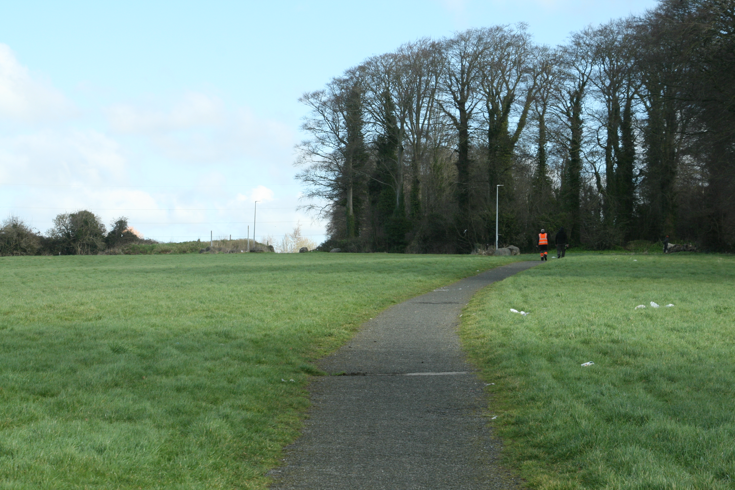

22nd March 2022

Final Report

Report prepared by

Faith Wilson BSc MCIEEM CEnv

Faith Wilson Ecological Consultant BSc MCIEEM CEnv
Kestrel Ridge, Tigroney West, Avoca, Co. Wicklow
Habitats Directive Assessment

Screening of Part 8 Rejuvenation and upgrade of Wellview Park
and public realm at Wellview Green and Terrace
for
Appropriate Assessment in accordance with the requirements of Article 6(3) of the EU Habitats Directive

TABLE OF CONTENTS

SECTION 1 INTRODUCTION 2
1.1. INTRODUCTION 2
1.2. LEGISLATIVE BACKGROUND 4
1.3. METHODOLOGY 5
1.4. GUIDANCE AND DATA SOURCES 6
1.5. STAGES OF APPROPRIATE ASSESSMENT 7
SECTION 2 SCREENING FOR APPROPRIATE ASSESSMENT 8
2.1 DESCRIPTION OF THE PLAN OR PROJECT 8
2.1.1 Description of the Proposed Rejuvenation and upgrade of Wellview Park and public realm at Wellview Green and Terrace. 8
2.1.2 Desk Study, Consultation and Field Survey 10
2.1.3 Description of the Receiving Environment at Wellview. 11
2.1.4 Assessment of Relevance Of Proposed Development To Natura 2000 Sites 30
SECTION 3 ASSESSMENT OF POTENTIAL IMPACTS 41
SECTION 4 CONCLUSIONS 47
SECTION 5 REFERENCES 48

Habitats Directive Assessment

Screening of Part 8 Rejuvenation and upgrade of Wellview Park
and public realm at Wellview Green and Terrace
for
Appropriate Assessment in accordance with the requirements of Article 6(3) of the EU Habitats Directive

SECTION 1 INTRODUCTION

INTRODUCTION

Faith Wilson Ecological Consultant has prepared a report for Screening for Appropriate Assessment for Part 8 Rejuvenation and upgrade of Wellview Park and public realm at Wellview Green and Terrace, in northwest County Dublin as shown on Figures 1.1 and 1.2 below.

Dermot Foley Landscape Architects were appointed by Fingal County Council to complete a five-stage design process for the delivery of an 11-hectare public park, commissioned by Fingal County Council, at Church Fields, Dublin 15 and this report feeds into that design process.

Faith was appointed by Dermot Foley Landscape Architects to advise on the ecological sensitivities of the lands at Church Fields, Dublin 15, to inform the design of their development as a public space and to provide an appropriate assessment screening report on the final design.

This appropriate assessment screening report is submitted as part of a Part 8 planning application for the Rejuvenation and upgrade of Wellview Park and public realm at Wellview Green and Terrace. The documentation pertains to the development of Wellview Park on a site of c.5.5 hectares within the Church Fields Lands. The documentation should be read in conjunction with other complementary documentation related specifically to the proposed linear park, as submitted by Dermot Foley Landscape Architects, Punch Consulting Engineers, BMA Planning, Fallon Design, Archaeology Plan and The Tree File. Wellview Park is one of a number of open spaces included in the Church Fields Lands. Wellview Park links into the previously approved Church Fields Eastern Linear Park. It is intended that the proposed linear park will ultimately to be extended to form a larger contiguous park of c. 11.8 hectares, stretching from Church Road in the east to the Pinkeen River in the west.

Church Fields is located one kilometre north of the village of Mulhuddart. The Church Fields are the subject of a master-planning exercise for the provision of housing, part of which includes the delivery of a series of parks which form part of a proposed residential development.
The Church Fields lands are shown on Figure 1.1 below. The current green open nature of the lands is evident in the aerial imagery for the area as shown on Figure 1.2 below.

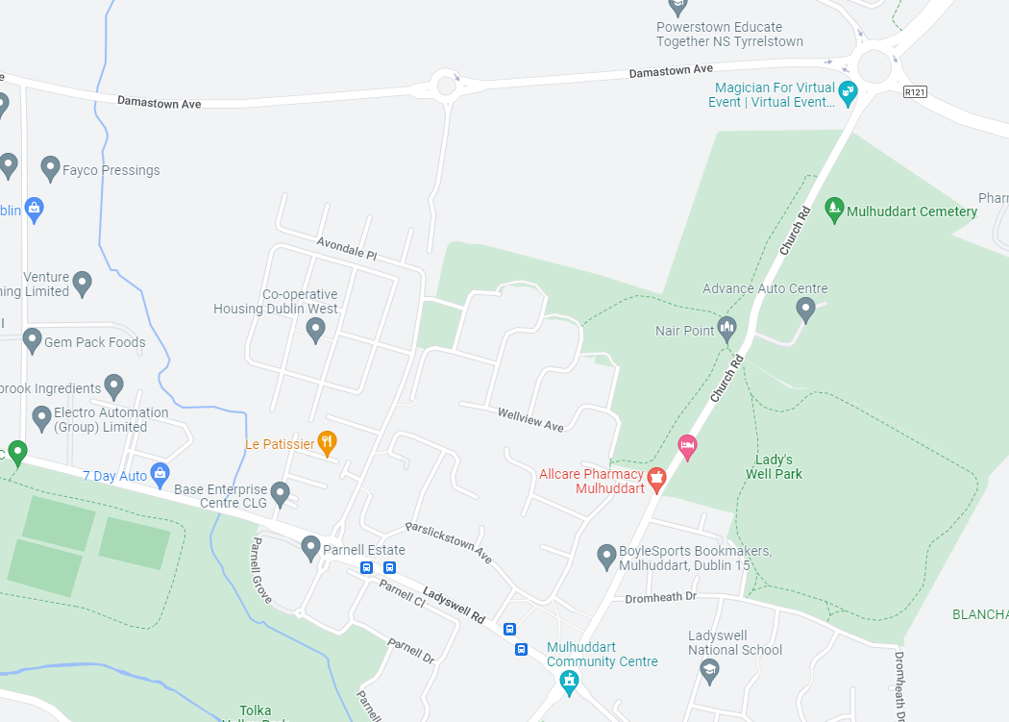
Figure 1.1 The Church Fields Lands north of Mulhuddart.

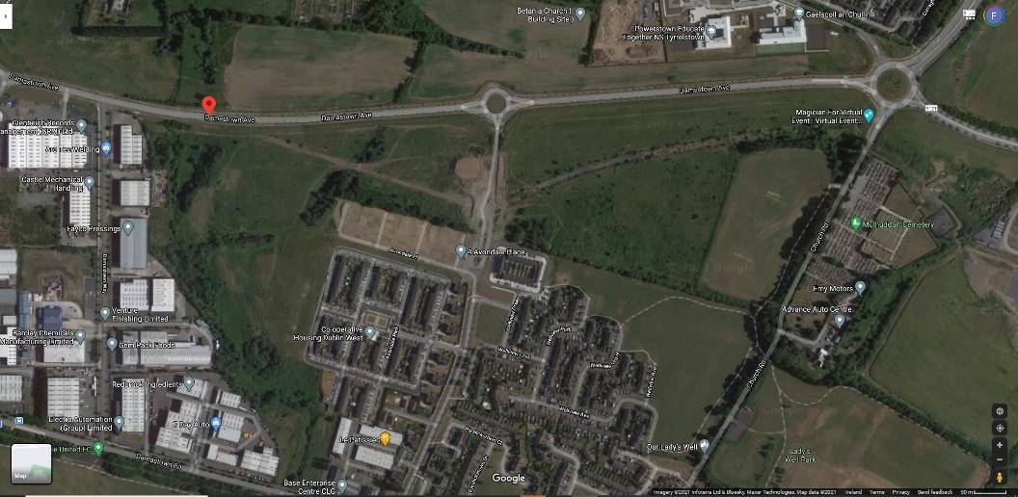
Figure 1.2 The location of Wellview Park (indicated by the red arrow). Source: Google Maps.

LEGISLATIVE BACKGROUND
The aim of the European Habitats Directive (Council Directive 92/43/EEC on the conservation of wild habitats and of wild fauna and flora) is to create a network of protected wildlife sites across Europe, which are to be maintained at a favourable conservation status.

Each member state must designate their most important natural areas as Special Areas of Conservation (SAC). The Directive specifies the scientific criteria on the basis of which SAC sites must be selected and very strictly curtails the grounds that can be used as justification for damaging a site. The network of sites is referred to as the NATURA 2000 network and includes SACs (Special Areas of Conservation) for protected habitats and species and SPAs (Special Protection Areas) for birds, which are designated under the European Birds Directive (Council Directive 79/409/EEC as amended by Directive 2009/147/EC).

It is a requirement of the Habitats Directive ((92/43/EEC) that the competent consenting authority (which in this instance is Fingal County Council, or An Bord Pleanála on appeal) must ensure that a proposal, which is likely to have a significant effect on an SAC or SPA, is authorised only to the extent that the authority is satisfied it will not adversely affect the integrity of the Natura 2000 site and that an appropriate assessment of the implications of the development for the conservation status of the site is undertaken.

The European Parliament, in a communication to the European Council in September 2000, states:

“The implementation of the European Habitats Directive and Birds Directive, both with respect to species conservation and with respect to the establishment of the Natura 2000 network, is one of the most important tools for achieving the objectives of the Convention on Biological Diversity in the European Union and member states (European Parliament 2000)".

Article 6 of the Habitats Directive provides a strict assessment procedure for any plan or project not directly connected with or necessary to the management of a designated European site but which has the potential to have implications for the site in view of the site’s conservation objectives.

Articles 6(3) and 6(4) of the Habitats Directive set out the decision-making tests for plans and projects likely to affect Natura 2000 sites (Annex 1.1).

Article 6(3) establishes the requirement for Appropriate Assessment (AA):

“Any plan or project not directly connected with or necessary to the management of the [Natura 2000] site but likely to have a significant effect thereon, either individually or in combination with other plans or projects, shall be subjected to appropriate assessment of its implications for the site in view of the site’s conservation objectives. In light of the conclusions of the assessment of the implications for the site and subject to the provisions of paragraph 4, the competent national authorities shall agree to the plan or project only after having ascertained that it will not adversely affect the integrity of the site concerned and, if appropriate, after having obtained the opinion of the general public.”

Article 6(4) states:

“If, in spite of a negative assessment of the implications for the [Natura 2000] site and in the absence of alternative solutions, a plan or project must nevertheless be carried out for imperative reasons of overriding public interest, including those of a social or economic nature, Member States shall take all compensatory measures necessary to ensure that the overall coherence of Natura 2000 is protected. It shall inform the Commission of the compensatory measures adopted. Where the site concerned hosts a priority natural habitat type and/or a priority species, the only considerations which may be raised are those relating to human health or public safety, to beneficial consequences of primary importance for the environment or, further to an opinion from the Commission, to other imperative reasons of overriding public interest.”

In Ireland, the requirements of Article 6(3) and (4) of the Habitats Directive have been broadly transposed into Irish law by the European Communities (Birds and Natural Habitats) Regulations 2011 (S.I. No. 477 of 2011), which has been amended by:
- S.I. No. 499 of 2013
- S.I. No. 355 of 2015
- S.I. No. 293 of 2021

This report has taken into consideration the relevant requirements of the Planning and Development Act, 2000 (as amended by the Planning and Development Act 2010).

METHODOLOGY

This report is based on desktop research and consultation and a series of visits to the property during April, July, August and October 2021 which were completed by this author.

This information was used to determine the potential for likely significant effects arising from the proposed Project on the European Sites of Conservation Interest.

If the outcome of the screening exercise is that there is no likelihood for significant effects, then any further stages in the Appropriate Assessment process are not required.

If, based upon the currently available information, there are aspects of the proposed development that could have a significant effect on any European sites, then further analysis in the form of a Natura Impact Statement (NIS) to inform the Appropriate Assessment is required (see Section 3).

The information presented in Section 2 of this report is therefore as follows:
- Description of the proposed development.
- Identification of relevant European sites within 15km of the proposed development.
- Description of the existing ecological environment/sensitive receptors at the site.
- Assessment of likely significant effects on the integrity of European sites.
- Appropriate Assessment Screening conclusions.

GUIDANCE AND DATA SOURCES
This report has been prepared with regard to the following guidance documents where relevant:

- Assessment of plans and projects in relation to Natura 2000 sites – Methodological guidance on the provisions of Article 6(3) and (4) of the Habitats Directive 92/43/EEC 2021/C 437/01. (Commission notice C/2021/6913. Dated 28.10.2021).

- Assessment of Plans and Projects Significantly Affecting Natura 2000 Sites: Methodological Guidance on the Provisions of Article 6(3) and (4) of the Habitats Directive 92/43/EEC (European Commission Environment Directorate General, 2001)

- Managing Natura 2000 Sites: The Provisions of Article 6 of the Habitats Directive 92/43/EEC (Commission Notice C(2018) 7621 final, Brussels, 21.11.2018)

- Managing Natura 2000 Sites: The Provisions of Article 6 of the Habitats Directive 92/43/EEC (EC Environment Directorate General, 2000)

- Appropriate Assessment under Article 6 of the Habitats Directive: Guidance for Planning Authorities Circular NPW 1/10 & PSSP 2/10

- Appropriate Assessment of Plans and Projects in Ireland – Guidance for Planning Authorities. (Department of Environment, Heritage and Local Government, 2010 revision)

- Guidelines for Good Practice, Appropriate Assessment of Plans under Article 6(3) Habitats Directive (International Workshop on Assessment of Plans under the Habitats Directive, 2011)

- Guidance Document on Article 6(4) of the Habitats Directive 92/43/EEC. Clarification of the Concepts of Alternative Solutions, Imperative Reasons of Over-riding Public Interest, Compensatory Measures, Overall Coherence. Opinion of the European Commission (European Commission, January 2007)

STAGES OF APPROPRIATE ASSESSMENT

The competent authority is required to carry out appropriate assessment, as required by Article 6(3) and 6(4) of the Habitats Directive, as follows:

• Stage 1: Screening for Appropriate Assessment
The first step to establishing if an appropriate assessment is required is referred to as 'screening' and its purpose is to determine, in view of best scientific knowledge, on the basis of a preliminary assessment and objective criteria if the plan or project, alone or in combination with other plans or projects, could have a significant effect on a Natura 2000 site in view of the sites conservation objectives. The process identifies any likely impacts upon a Natura 2000 Site, either alone or in combination with other projects or plans, and considers whether these impacts are likely to be significant.

• Stage 2: Appropriate Assessment
This is required if it cannot be excluded, on the basis of objective information, that the development, individually or in combination with other plans or projects, will have a significant effect on a Natura 2000 site.

The appropriate assessment must include a final determination by the competent authority as to whether or not a proposed development would adversely affect the integrity of a Natura 2000 site. In order to reach a final determination, the consenting authority must undertake examination, analysis and evaluation, followed by findings, conclusions and a final determination. The appropriate assessment must contain complete, precise and definitive findings and conclusions, and may not have lacunae or gaps.

Additionally, where there are deemed to be adverse impacts, an assessment of the potential mitigation of those impacts is considered.

• Stage 3: Assessment of Alternative Solutions
This stage examines alternative means of achieving the objectives of the project or plan that aim to avoid adverse impacts on the integrity of the Natura 2000 site.
• Stage 4: Assessment where no alternative solutions exist and where adverse impacts remain
This stage is the main derogation process outlined in Article 6(4) which examines whether there are imperative reasons of overriding public interest (IROPI) for allowing a plan or project, which will have adverse effects on the integrity of a Natura 2000 site, to proceed.

SECTION 2 SCREENING FOR APPROPRIATE ASSESSMENT

2.1 DESCRIPTION OF THE PLAN OR PROJECT

2.1.1 Description of the Proposed Rejuvenation and upgrade of Wellview Park and public realm at Wellview Green and Terrace.

The proposed development consists of the Rejuvenation and upgrade of the existing Wellview Park, situated at Church Road, Dublin 15 as well as two existing areas of public realm at Wellview Green and Terrace, totalling approximately 5.5ha.

The proposed development includes: landscape and external works; pedestrian access points to existing footpath on west side of Church Road; paving and associated drainage works; regrading of existing grassland areas; planting; public lighting; play areas, signage, street furniture and associated fixtures and fittings; including all ancillary site development.

The site area is crossed by a north-south cycle and pedestrian route as part of the wider proposed Church Fields Link Road and Cycle Network (planning register reference Part XI/011/19).

The layout for Wellview Park is shown on Figure 2.1.1 below and for the two existing areas of public realm at Avondale Place and Wellview Green, Dublin 15 on Figure 2.1.2 below.
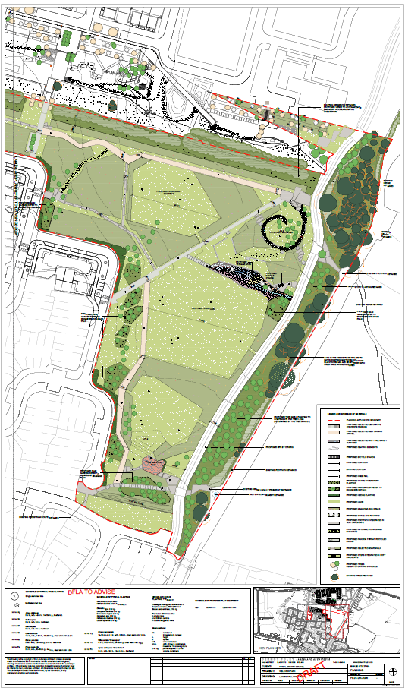
Figure 2.1.1. Proposed Site Layout for Wellview Park.
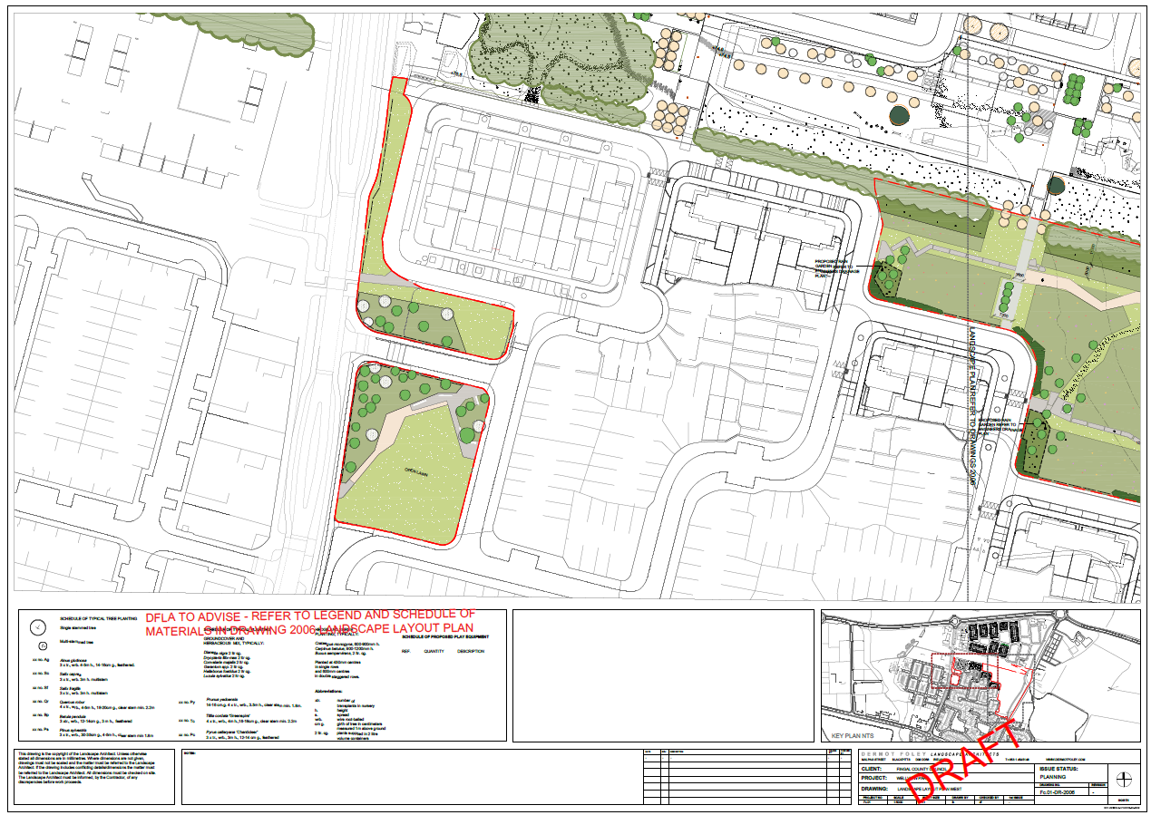
Figure 2.1.2. Proposed Site Layout for existing areas of public realm at Avondale Place and Wellview Green.

2.1.2 Desk Study, Consultation and Field Survey

A desk study was carried out to collate the available information on the ecological environment of the Church Fields lands and wider environs in 2021. The National Parks and Wildlife Service (NPWS) of the Department of Housing, Local Government and Heritage (DHLGH) database of designated conservation areas and NPWS records of rare and protected plant species were checked with regard to the location of the proposed park.

Information on protected species of fauna and flora listed for protection under Annex II of the EU Habitats Directive (92/43/EEC), Annex I of the Birds Directive (79/409/EEC) and the Wildlife Act 1976 (as amended) was also sought from NPWS, publications and other sources. Recent, high resolution, colour aerial photographs were also used to identify and map potential habitats.

The site was visited on several dates during April, July, August and October 2021.

Consultations regarding the ecology and nature conservation of the Church Fields lands were made with:

- FCC Biodiversity Office – Hans Visser
- FCC Biodiversity Office – Gemma Carr
- Matthew Hague Senior Ecologist with BSM; Housing Phase 3 & 4 masterplan
- Brian Keely Licensed Bat Specialist with Wildlife Surveys Ireland; bat surveys previously conducted for the Housing Phase 3 & 4 masterplan.

Previous ecological surveys and assessments of the area also included an ecological appraisal completed by RPS Consulting Engineers in January 2020 for the proposed Church Fields Link Road & Cycle Network and a preliminary ecological appraisal of the lands to the north of the proposed Church Fields Eastern Linear Park which was conducted as part of the master plan for this area by Brady Shipman Martin. Both of these documents were also reviewed.

2.1.3 Description of the Receiving Environment at Wellview.

The importance of the Church Fields lands as a green open space for biodiversity has been highlighted in a number of previous studies including:
- Ecological Appraisal conducted by RPS for the Church Fields Link Road & Cycle Network
- Preliminary Ecological Appraisal report prepared by Walsh/BSM for the Master Plan for the Church Fields Northern Lands

Church Fields Link Road & Cycle Network
Part of the lands at Church Fields were the subject of an ecological appraisal for the Church Fields Link Road & Cycle Network completed by RPS Consulting Engineers in January 2020. This study recorded the following habitats from the general study area.

- Buildings and artificial surfaces BL3
- Spoil and bare ground ED2
- Recolonising bare ground ED3
- Amenity grassland (improved) GA2
- Amenity grassland/neutral grassland mosaic GA2/GS1
- Scrub WS1
- Hedgerow WL1
- Treelines WL2
- (Mixed) Broadleaved woodland WD1
- Drainage ditches FW4
- Depositing/Lowland river FW2
- Arable crops BC1

The study described each of them (with the exception of the Pinkeen River, treelines and the area of mixed broadleaved woodland) as being of local (lower) ecological value. The Pinkeen River, treelines and the area of mixed broadleaved woodland were rated as being of local (higher) ecological value.

Their location is presented in the habitat map from that study on Figure 2.1.3 below. The study also confirmed the presence of an active badger sett within close proximity to the scheme.

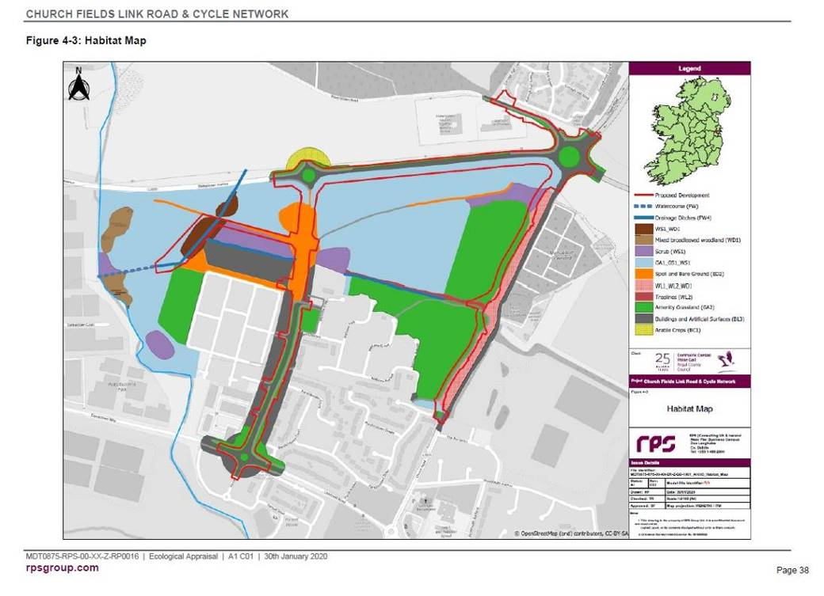
Figure 2.1.3 Habitat Map of the Church Fields lands (RPS 2020).

The lands to the north of the proposed Wellview Park (the Church Fields Eastern Linear Park and the housing lands) were the subject of a preliminary ecological appraisal conducted as part of the master plan for this area which was completed by Brady Shipman Martin.

Changing Land Use
The lands at Church Fields have over the last twenty years been moving out of intensive agricultural use and slowly becoming developed through urbanisation, the construction of housing, roads, powerlines, drainage and other infrastructure including public open space.

Elements of the former demesne landscape associated with Tyrrelstown House such as planted shelterbelts, original field boundary hedgerows and the Pinkeen River Valley (a tributary of the River Tolka) remain.

This change in land use from one of intensive agriculture can be clearly seen when reviewing the various mapping and datasets available from the Ordnance Survey as presented below on Figures 2.1.4 to 2.1.1.8.

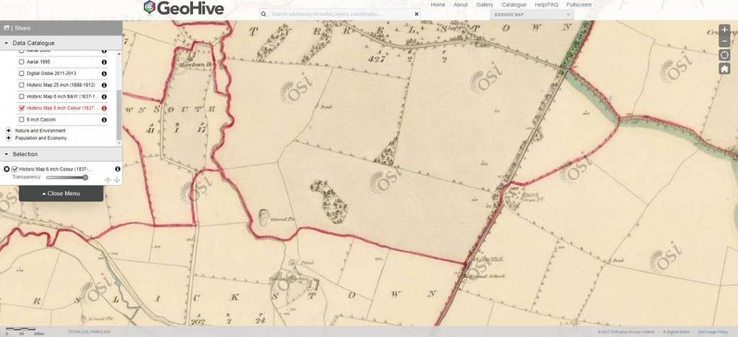
Figure 2.1.4. First Edition Ordnance Survey Mapping (1837) showing the Pinkeen River, an old gravel pit, a pond, field boundaries and shelterbelt planting along Church Road.

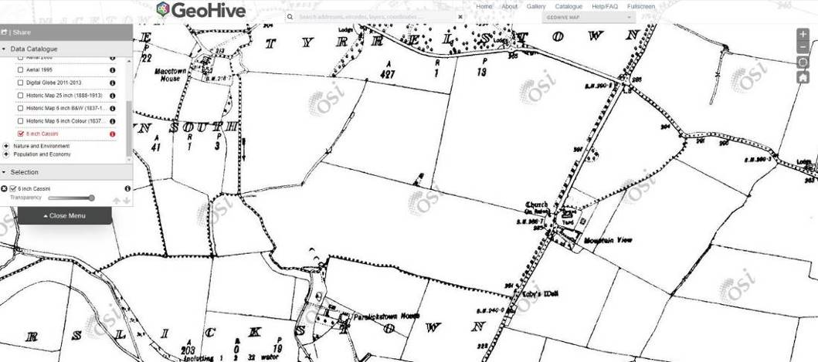
Figure 2.1.5. By the early 1900s the pond had been lost and the lands drained towards the Pinkeen River (illustrated by a red arrow).

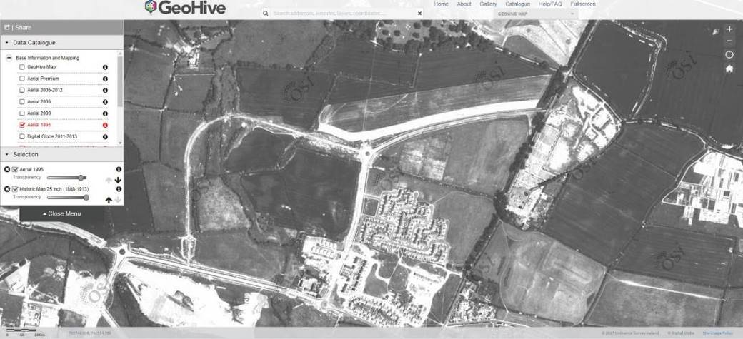
Figure 2.1.6. Intensive agricultural land use and increasing housing in the 1990s, with construction access roads developed bisecting the lands (Ordnance Survey Ireland aerial photography dated 1995). Wellview Park is indicated by the red arrow.

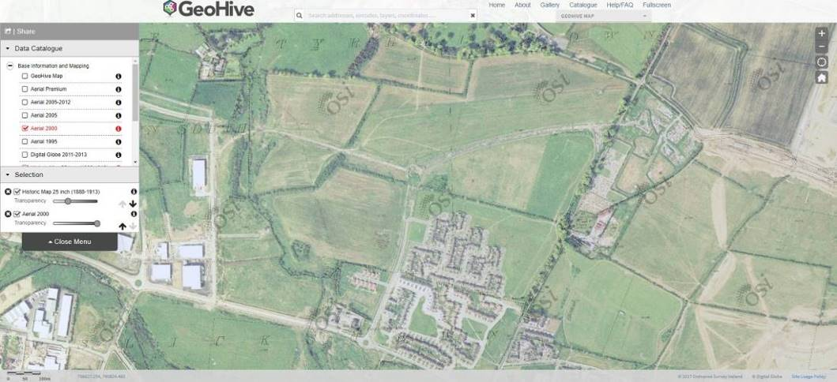
Figure 2.1.7. The lands continue to be farmed in the early 2000s (Ordnance Survey Ireland aerial photography dated 2000). Wellview Park is indicated by the red arrow.

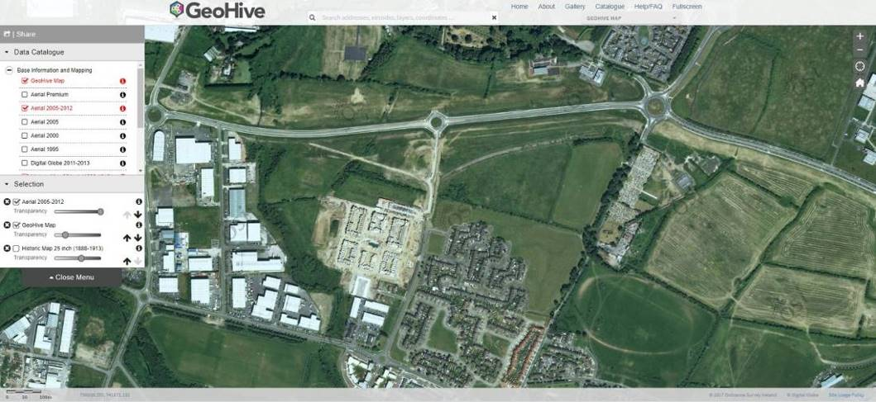
Figure 2.1.8. By 2012 the new Damastown Avenue had been constructed further bisecting the lands (Ordnance Survey Ireland aerial photography 2005 - 2012). Wellview Park is indicated by the red arrow.

Habitats

The abandonment of any management/intensive land use has allowed the natural succession of trees and scrub and the restoration of semi – species-rich natural grassland habitats on the northern parts of the Church Fields lands.

These areas, the treelines, hedgerows, immature woodland, scrub and watercourses were mapped as ecologically sensitive areas within the Church Fields lands as shown on Figure 2.1.9 below. The ecological value of these habitats is described in the preliminary ecological appraisal below.

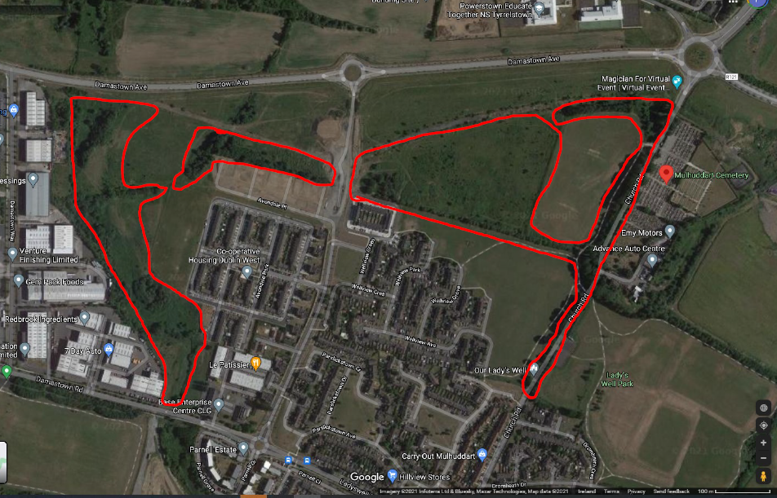
Figure 2.1.9. Ecologically sensitive areas identified on the Church Fields Lands include the Pinkeen River corridor, areas of extant copses, treelines and hedgerows, drainage ditches, areas of species rich semi-natural grassland and immature woodland and scrub.

Preliminary Ecological Assessment – Church Field Lands
Although at first glance these lands appear abandoned, neglected and subject to ongoing anti-social behaviour they do in fact hold much in the way of interest for biodiversity in what are increasingly urbanised and sanitised surroundings. A diversity of habitat types is present on the Church Fields lands – these are mapped on Figure 2.1.10.

The two areas of amenity grassland (GA2) in the eastern portion of the Church Fields lands (the southern of these contains Wellview Park) are species poor on account of current management practices which allows the grass cuttings to be left on the sward following mowing. This favours the dominance of grass species at the expense of wildflowers. The grassland sward is dominated by a number of common grass species such as meadow grasses (Poa spp.), bents (Agrostis spp.) and in unmown verges cock’s-foot grass (Dactylis glomerata), crested dog’s-tail grass (Cynosurus cristatus) and false oat grass (Arrhenatherum elatius) were noted. Flowering species were limited to dandelion (Taraxacum officinale agg.) and white clover (Trifolium spp.). With appropriate management (primarily the cutting and removal of grass cuttings to reduce fertility on each mowing cycle) the diversity of the sward in these areas could be further improved. Wellview Park will be developed in the southern of these two fields.

The grassland areas in the northern and western parts of the Church Fields lands are beginning to recover from years of intensive agricultural use and the associated application of fertilisers, herbicides and pesticides or have recolonised on disturbed ground which is low in nutrients. These areas contain species characteristic of semi-natural species-rich grasslands (GS1) and traditional hay meadows (GS2). Species such as cowslip (Primula veris), creeping cinquefoil (Potentilla reptans), vetches (Vicia cracca, Vicia sativa), various grasses (Festuca rubra, Festuca pratensis, Arrhenatherum elatius, Agrostis canina, Agrostis stolonifera, Agrostis capillaris, Poa annua, Poa pratensis, Cynosurus cristatus), bird’s foot trefoil (Lotus corniculatus), selfheal (Prunella vulgaris) and mosses are frequent in the areas akin to species rich grassland. Other typical species of these areas include germander speedwell (Veronica chamaedrys), common centaury (Centaurium erythraea), sweet vernal grass (Anthoxanthum odoratum), red bartsia (Odontites verna), ribwort plantain (Plantago lanceolata). These areas are typically maintained through the grazing actions of rabbits.

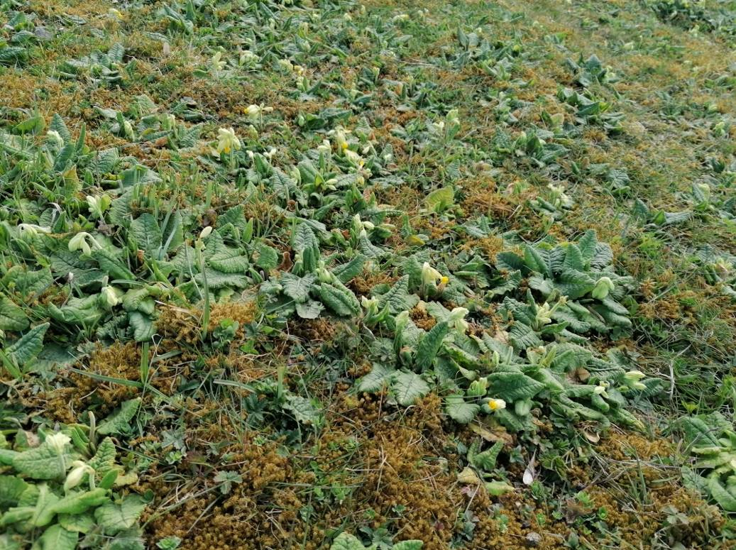
Plate 1. Cowslips abound in some parts of the Church Fields lands.

In other areas which are less grazed areas of hay meadow/grassy verge grassland (GS2) has developed with typical species such as ribwort plantain (Plantago lanceolata), meadow vetchling (Lathyrus pratensis), hogweed (Heracleum sphondylium), white clover (Trifolium repens), creeping buttercup (Ranunculus repens), red clover (Trifolium pratense), nipplewort (Lapsana communis), creeping thistle (Cirsium arvense), spear thistle (Cirsium vulgare), burdock (Arctium minus), common bent (Agrostis canina), creeping bent (Agrostis stolonifera), cock’s-foot grass (Dactylis glomerata) and sweet vernal grass (Anthoxanthum odoratum). With appropriate management (primarily the cutting and removal of cuttings to reduce fertility at the end of the summer) the diversity of the sward in these areas could be further improved.

These areas of grassland are then becoming invaded by scattered scrub (WS1) or increasingly dominated by opportunistic species such as rosebay willowherb (Epilobium angustifolium), nettle (Urtica dioica), teasel (Dipsacus fullonum) and thistles (Cirsium arvensis, Cirsium vulgaris). All of these species provide nectar for pollinators, seeds for feeding flocks of wild birds, and cover for invertebrates to complete their lifecycles within.

The treeline (WL2)/hedgerow (WL1) and associated drainage ditches (FW4), which runs east west through the Church Fields lands, forming the main spine of the Church Fields Eastern Linear Park, acts as an important corridor for wildlife and dates from the 1860s. This hedgerow is described in the arboricultural report as boundary 1, 2, 3, 4 and 5. This hedgerow and associated drainage ditch forms the northern boundary of Wellview Park. The overgrown and spreading nature of this original field boundary, particularly on the northern side contains the greatest diversity in terms of structure providing a rich natural resource for invertebrates, pollinators, birds and other fauna including bats, pygmy shrew, rabbits and other mammals. The hedgerow contains species such as ash (Fraxinus excelsior), sycamore (Acer pseudoplatanus), blackthorn (Prunus spinosa), field maple (Acer campestre), elder (Sambuccus nigra), bramble (Rubus fruticosus agg.), dog rose (Rosa canina) and mature ivy (Hedera helix). Some dead standing remains or young regenerating Wych elm (Ulmus glabra) also occurs. Scrub elements here include naturally regenerating blackthorn (Prunus spinosa) which in some locations is forming a dense thicket, bramble (Rubus fruticosus agg.), dog rose (Rosa canina), honeysuckle (Lonicera periclymenum) and gorse (Ulex europaeus). All of these species and features are of high ecological importance from the perspective of biodiversity and fauna. Adjoining this hedgerow are small copses of immature woodland (WN2) containing sycamore (Acer pseudoplatanus), ash (Fraxinus excelsior), elder (Sambucus nigra), bramble (Rubus fruticosus), ivy (Hedera helix), and hawthorn (Crataegus monogyna). These are described as Thicket Area 1 and Woodland Area 1 in the arboricultural report for the Church Fields lands. A copse with a similar composition is found along the Macetown Stream – described as Thicket Area 2 and 3 in the arboricultural report.

A buffer zone with a boundary a minimum of 6 - 10m from the hedgerow is recommended in order to allow it to function ecologically in the short to medium term with additional planting to strengthen it to form a shelterbelt/linear woodland in the long term.

Fragmentation of this linear feature should be avoided and although north – south permeability from the Church Fields Eastern Linear Park to Wellview Park is required this should be provided where there are existing gaps in the hedgerow and kept to a maximum width of under 1.5m (i.e. suitable for pedestrians but not vehicles).

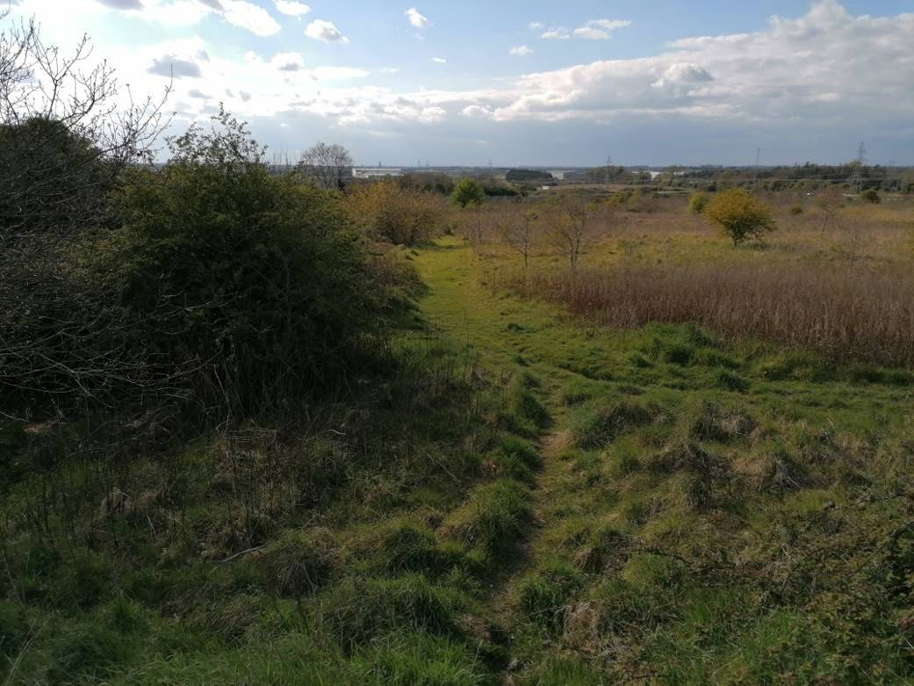
Plate 2. Spreading scrub from the hedgerow on the northern side of the hedgerow along the northern boundary of Wellview Park will be protected and enhanced with additional planting to create a long term linear woodland/shelterbelt in the Church Fields Eastern Linear Park.

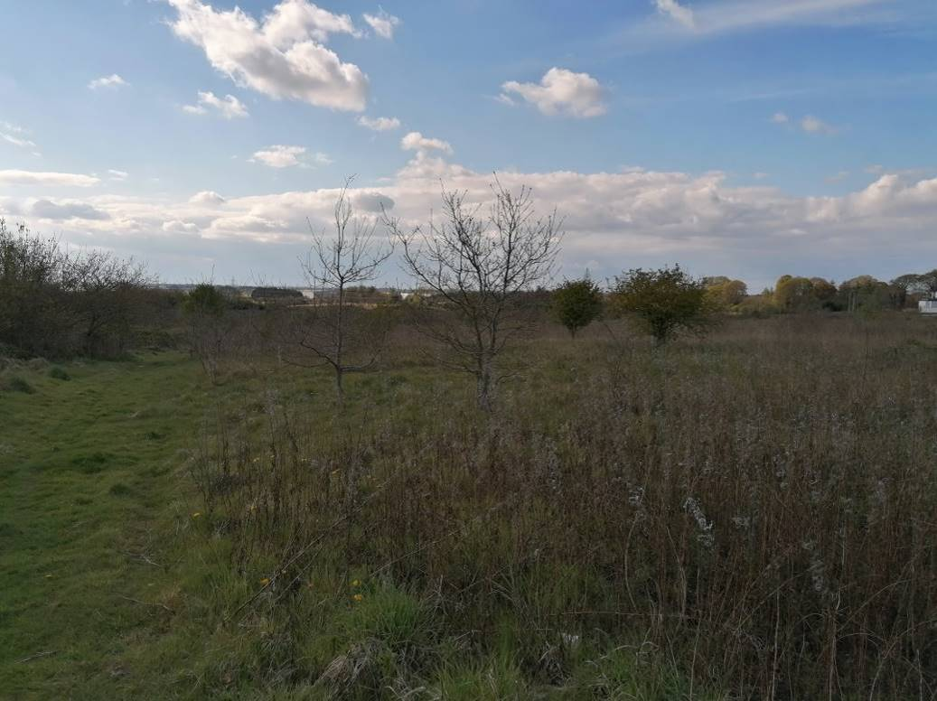
Plate 3. Naturally regenerated immature woodland and dry meadow grassland habitat north of the Church Fields Eastern Linear Park.

North of this is a significant area of naturally regenerated young woodland (WS2) comprising pedunculate oak (Quercus robur), crab apple (Malus sylvestris), hawthorn (Crataegus monogyna), blackthorn (Prunus spinosa), ash (Fraxinus excelsior), silver birch (Betula pendula), whitebeam (Sorbus aria), goat willow (Salix caprea) and the non-native buddleia (Buddleia davidii), interspersed with pockets of bramble thickets, gorse (Ulex europaeus) and other scrub features such as bramble, blackthorn (Prunus spinosa) and dog rose (Rosa canina).

They are surrounded by areas of dry meadow/grassy verge grassland. With appropriate management and a light touch approach these features could form an ongoing reservoir of habitat for wildlife in the area as well as a real connection for locals with the natural world.

Notwithstanding the fact that the masterplan for the Church Fields lands to the north of the Church Fields Eastern Linear Park are zoned for development these areas, which have been subject to natural ecological processes (or rewilding), support a considerable range of biodiversity.

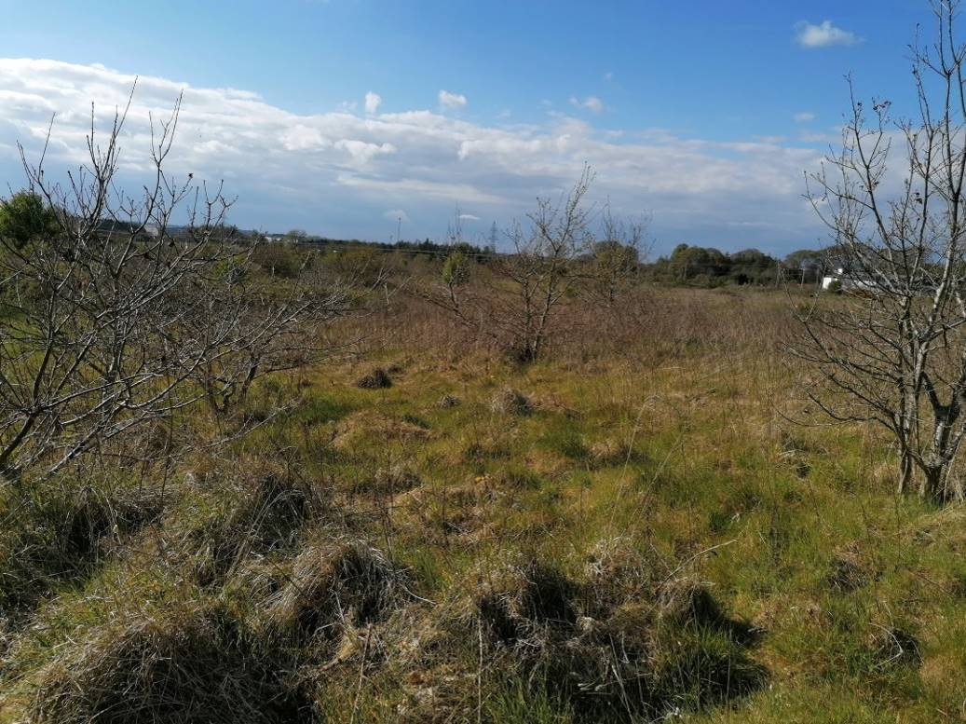
Plate 4. Naturally regenerated immature woodland and dry meadow grassland habitat north of the Church Fields Eastern Linear Park.

This is particularly evident and in strong contrast to the existing Wellview Park, which in comparison contains relatively little habitat for wildlife beyond the hedgerow and treeline features. Grassland management here does not favour biodiversity as the grass cuttings are left in situ leaving a rank sward. There did seem to have been some delays in mowing which had allowed the dandelions and daisy to flower providing nectar resources for early spring pollinators. Winter heliotrope (Petasites fragrans), which is a non-native invasive species was recorded within this area.

Key tree species in the treeline (WL2) and narrow band of mixed broadleaved woodland (WD1) along Church Road include mature beech (Fagus sylvatica), sycamore (Acer pseudoplatanus) and ash (Fraxinus excelsior). Under storey trees include hawthorn and willow.

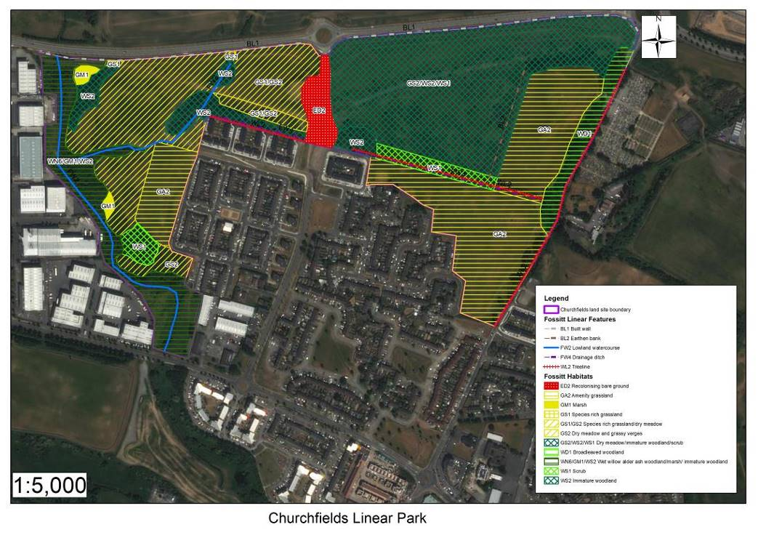
Figure 2.1.10. Habitat map of the Church Fields lands.

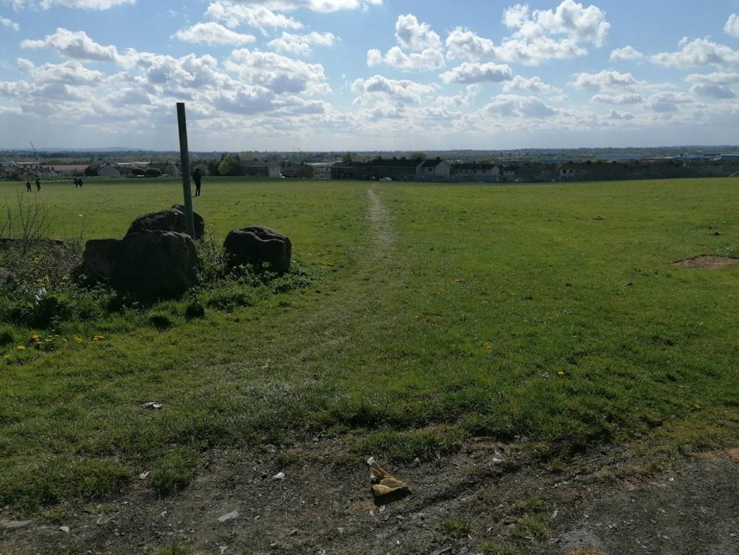
Plate 5. Wellview Park.
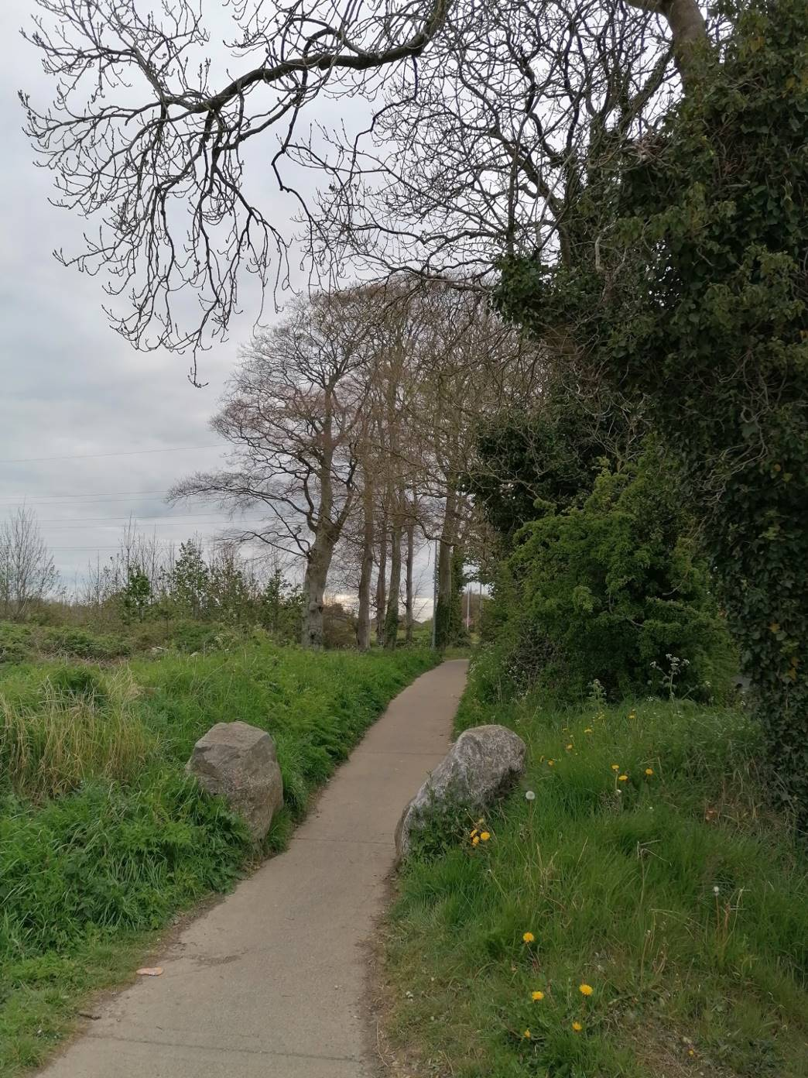
Plate 6. Treeline of mature beech and ash along Church Road. These are a remnant of the former demesne landscape.
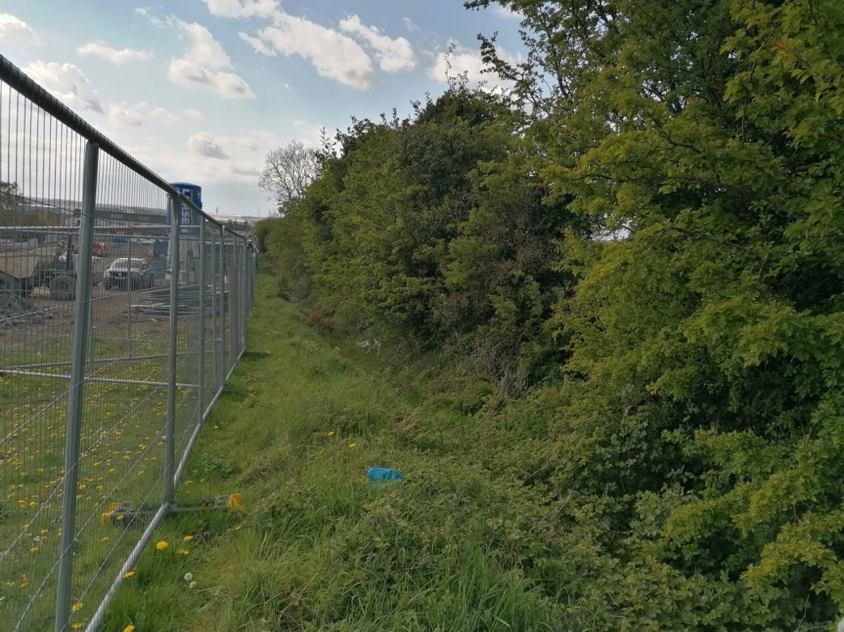
Plate 7. Housing under construction to the west of Wellview Park.

Invasive Species

Winter heliotrope (Petasites fragrans) was recorded on the margins of Wellview Park and can be very invasive. It is recommended that an invasive species management plan is prepared to control and eradicate this species and to ensure that it is nor spread during further site construction works.

Bats

The Bat Conservation Ireland Database of bat records was searched for records of bats from the environs of Mulhuddart and the Church Fields lands. The database contains records of roosts, ad hoc observations and the results of surveys such as the BATLAS 2010 project and the All Ireland Daubenton’s Monitoring Project.

Species recorded within the 10km square in which the Church Fields lands are located (O04) include:
- Common pipistrelle (Pipistrellus pipistrellus),
- Soprano pipistrelle (Pipistrellus pygmaeus),
- Leisler’s bat (Nyctalus leisleri), and
- an unidentified pipistrelle species (Pipistrellus sp.).

A bat survey was conducted by Faith Wilson on the lands of Hollystown Golf Course (which is located c.1.4km to the north of the Church Fields lands) on 5th June 2018. Three species of bat were found to use these lands for hunting and foraging purposes although no roosts were confirmed. The most abundant of these were common pipistrelle and soprano pipistrelle both of which were recorded foraging along the perimeter treelines of the golf course, along internal scattered trees and the edges of immature woodland and over the drainage ditches and artificial ponds and wetlands within the golf course. The other species that was recorded on the site was Leisler’s bat, which was recorded hunting high over the site just shortly after dusk

In 2019 additional bat surveys were conducted by Faith Wilson as part of a housing development on lands at Kilmartin (to the west of the golf course) adjoining the Hollystown Golf Course. The 2019 surveys, which were conducted on the 14th and 15th May 2019 recorded three species of bat, which were found to use these lands for hunting and foraging purposes although no roosts were confirmed. These were common pipistrelle and soprano pipistrelle which were found across the entire site, while Leisler’s bat were recorded hunting over the arable fields in the western portion of the site. This study noted that there are several mature trees within the proposed housing development lands at Kilmartin, particularly within the treelines that adjoin the golf course and the treeline adjoining the R121 opposite Hollywood Rath, which are suitable for roosting bats.

Three species of bats have been recorded during the surveys conducted by Brian Keeley from the Church Fields lands in 2020 and 2021. These are:
- Common pipistrelle (Pipistrellus pipistrellus),
- Soprano pipistrelle (Pipistrellus pygmaeus),
- Leisler’s bat (Nyctalus leisleri).

As reported by Keely (2021):
‘None of the bats were seen to enter or leave any of the mature trees within the Church Fields lands. However, soprano pipistrelle activity was noted around trees prior to sunrise in 2020 but the final destination of the bat was not discovered. There was activity of all three bat species close to the trees prior to sunrise in 2021 also but no bat entered any of the trees.

All three species will avail of trees with Leisler’s bat probably the most commonly encountered in trees of these species. There are several mature beech trees along the eastern edge of the Church Fields lands that have high roost potential.

Leisler’s bat activity was relatively high within the site, over the grassland and towards the mature line of beech trees. The lands to the west of the soil berm were less used by bats and this area is relatively exposed in comparison to the eastern side of the site. Leisler’s bats were present after sunset and prior to sunrise and it is probable that roosts are present close to the site but no roosts were identified within the site.’

The Pinkeen River wasn't very accessible at night, so only the northern end was covered. This would reduce the apparent value of it for bats. The results of the survey are mapped on Figure 2.1.11 below.

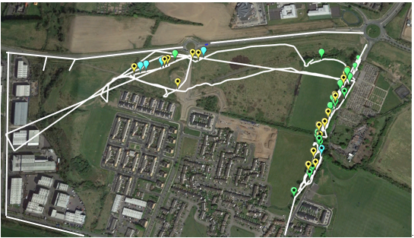
Figure 2.1.11. Bat activity from sunset onwards and prior to sunrise within the site July 2021.

Green paddle Common pipistrelle activity Starred = Prior to sunrise; Blue paddle Soprano pipistrelle activity Starred = Prior to sunrise; Yellow paddle Leisler’s bat activity; White line Transect of surveyors

The RPS study noted the following potential bat roosts within the Church Fields lands:
‘The field study identified a group of semi-mature ash trees at the western end of the proposed development alongside attenuation pond #1 with high ivy coverage adjacent marked for removal. These were considered to have roosting features of low potential’.

The trees, treeline and scrub vegetation on the eastern boundary of Wellview Park along Church Road and the east –west hedgerow and associated drainage ditch on the northern boundary of Wellview Park are of high importance to bats as can be seen on Figure 2.1.11 above.

Other Mammals
The habitats in the Church Fields lands provide a rich habitat for a range of mammal species, which while common and ubiquitous in the wider countryside rapidly disappear following urbanisation of the landscape. Species which were either directly observed (or their signs were noted) from the Church Fields lands include:
- Red fox (Vulpes vulpes)
- Rabbit (Oryctolagus cuniculus)
- Brown Rat (Rattus norvegicus)
- House Mouse (Mus musculus)
- Field Mouse (Apodemus sylvaticus)
- Hedgehog (Erinaceous europaeus)

Amphibians
The drainage ditch along the northern boundary of Wellview Park and other ditches within the Church Fields lands could potentially support breeding frogs (Rana temporaria).

Birds
A rich variety of bird species were recorded during the surveys which reflects the natural habitats present on the Church Fields lands. These include blackbird (Turdus merula), wren (Troglodytes troglodytes), robin (Erithacus rubecula), dunnock (Prunella modularis), chaffinch (Fringilla coelebs), greenfinch (Carduelis chloris), song thrush (Turdus philomelos), and mistle thrush (Turdus viscivorus).

Other species recorded include; great tit (Parus major), coal tit (Parus ater), blue tit (Cyanistes caeruleus), long tailed tit (Aegithalos caudatus), goldcrest (Regulus regulus), rook (Corvus frugilegus), jackdaw (Corvus monedula), pied wagtail (Motacilla alba yarrellii), hooded crow (Corvus cornix) and magpie (Pica pica).

Both feral pigeon (Columba columba domest.) and woodpigeon (Columba palumbus) were also encountered and flocks of starlings (Sturnus vulgaris) were recorded in October 2021.

Summer visitors such as swifts (Apus apus), swallows (Hirundo rustica) and house martins (Delichon urbicum) are likely to feed over the lands.

Large flocks of linnet (Carduelis cannabina) and goldfinch (Carduelis carduelis) were observed foraging on the thistle and willowherb seed heads.

Observed birds of prey include sparrowhawk (Accipiter nisus) and buzzard (Buteo buteo) while kestrel (Falco tinnunculus) may also hunt over the Church Fields lands.

Long eared owl (Asio otus) breed within the Church Fields lands. Young birds were heard calling from the trees within the woodland in the Pinkeen River ecological corridor during the bat survey in July 2021.

Fisheries and Watercourses
The Church Fields lands are located within the Tolka River catchment. The Office of Public Works, working closely with three County Councils (Dublin, Meath and Fingal) carried out a flood relief scheme on the Tolka. Following advice and consultation with Inland Fisheries Ireland the works included either the removal or modification of a significant number of man-made weirs to “open up” this system to migratory fish. This allowed sea trout to run the system upstream to its headwaters in Dunboyne for the first time, in at least, 150 years, and more recently salmon have returned to spawn in this river after an absence of over 100 years. Any works on the Church Fields lands will therefore need to be cognisant of the salmonid status of the River Tolka and sensitivities regarding same.

The study lands at Church Fields are located within the Liffey and Dublin Bay Catchment (09), and within the Tolka Sub-Catchment (SC10). The Church Fields lands are drained by the Tolka 030 (IE_EA_09T010800).

The main channel of the Pinkeen River flowing through the Church Fields lands is known as the Powerstown (Dublin)_010 (IE_EA_09P210700), while the eastern arm of the Pinkeen River is known Macetown South (IE_EA_09T010800) as shown below on Figure 2.1.12. Both of these waterbodies have been deemed at risk of not achieving ‘Good’ water status under the last Water Framework Directive monitoring period 2013 – 2018 and are considered to be at risk of not achieving their WFD objectives by 2027, due to bad biological status and concentrations of phosphate and ammonia. The WFD cycle 2 report for the Tolka_SC_010 subcatchment states that “Evidence of enrichment and heavy siltation were identified within Tolka_030 with a [IE] licensed facility highlighted as a significant pressure”.

Q values taken downstream of here in the River Tolka at Mulhuddart Bridge are poor (i.e. Q2-3). This is unsurprising as raw sewage was seen discharging from the local sewer connections on the Church Fields lands into the Macetown South stream and the Pinkeen River just beyond that.

The Pinkeen enters the River Tolka at Mulhuddart Village. Between here and Drumcondra, the Tolka is of poor status or unassigned status (WFD 2013 – 2018) and at risk of not achieving WFD objectives / good status. Between Drumcondra and Fairview, the Tolka becomes an estuary (WFD code IE_EA_090_0200) of moderate status (WFD 2013 – 2018) and at risk of not achieving WFD objectives / good status. The WFD cycle 2 report for the Tolka_SC_010 subcatchment identifies urban wastewater (and more specifically, combined sewer overflows) as a significant pressure affecting the Tolka Estuary. The estuary is identified as a ‘nutrient sensitive area’, on account of the presence of a Designated Site, the South Dublin Bay and River Tolka Estuary SPA.

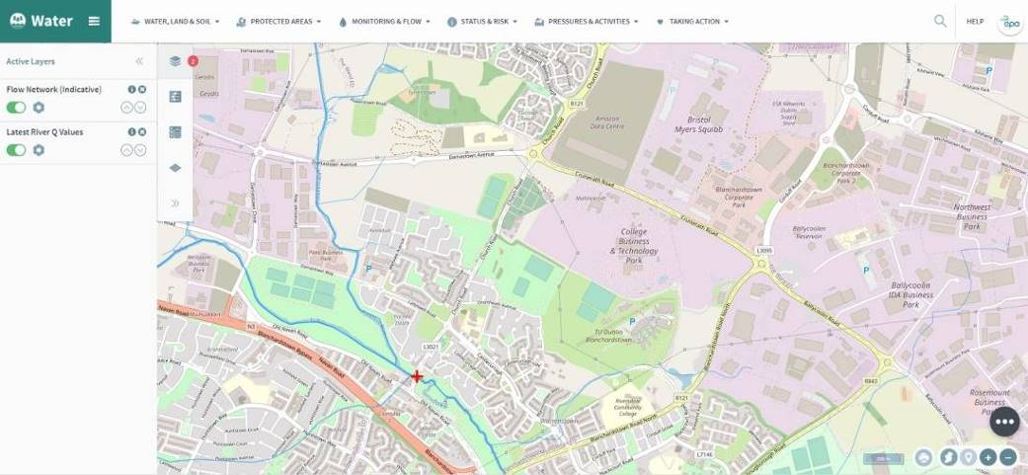
Figure 2.1.12. Watercourses within the study area (www.catchments.ie).

Ecological Assessment

Church Field Lands
The habitats and the species they support within the Church Fields lands are of high local biodiversity importance within the general environs of Mulhuddart/Damastown. The Pinkeen River and associated wet willow alder ash woodland, marsh, scrub, immature woodland and grassland habitats form a very significant ecological corridor along the western part of the Church Fields lands. The wet willow alder ash woodland here has potential affinities with the Annex I priority habitat type 91E0 Alluvial Woodland and would be of county importance. The hedgerow, drainage ditch and scrub which runs east west through the lands and the treeline, trees and scrub along the boundary with Church road all form important green corridors and linkages through the lands for wildlife.

Wellview Park
The habitats of high ecological importance within the context of Wellview Park include the boundary hedgerow and associated drainage ditch to the north and the treeline, trees and scrub in the shelterbelt along the eastern boundary of the park. With appropriate management the biodiversity interest of the grassland within these lands could be improved.

2.1.4 Assessment of Relevance Of Proposed Development To Natura 2000 Sites

In line with the European Commission Methodological Guidance (EC (2001)) and the DoEHLG Guidance (DoEHLG (2010)) a review of all Natura 2000 sites that could be potentially affected by the proposed development of the Wellview Park was made using the NPWS online map viewer.

These included any Natura 2000 sites within or adjacent to the lands, and any Natura 2000 sites within the likely zone of impact of the proposed development (a 15km radius), including those downstream.

In addition to the identified Natura 2000 sites consideration was also given to relevant species listed under Annexes I and II and IV of the Birds and Habitats Directives respectively.

Special Areas of Conservation (SACs) and Special Protection Areas (SPAs) are habitats of international significance that have been identified by NPWS and submitted for designation to the EU. The obligations imposed in relation to SACs and SPAs (or “European Sites”) are set out in the Planning Acts and the European Communities (Birds and Natural Habitats) Regulations 2011 (S.I. No. 477 of 2011). The main implication of this designation is that any project likely to have a significant adverse impact on the integrity of a “non priority” site of international importance for nature conservation may only be carried out for “imperative reasons of overriding public interest, including those of a social or economic nature”.

The lands at Church Fields are not currently designated for nature conservation purposes. Best practice recommends assessing Natura 2000 sites located within 15km of a proposed plan or project. This assessment confirmed that there are seven Natura 2000 designations located within 15km of the proposed development of Wellview Park. These are:
- Malahide Estuary SAC (site code 000205),
- Malahide Estuary SPA (site code 004025),
- South Dublin Bay SAC (site code 000210),
- South Dublin Bay and River Tolka Estuary SPA (site code 004024),
- North Dublin Bay SAC (site code 000206),
- North Bull Island SPA, Malahide Estuary SPA (site code 004006) and
- Rye Water Valley/Carton SAC (site code 001398).

The latter is the closest European site to the proposed park (approximately 7.4km away to the south-west).

Of these, South Dublin Bay SAC, South Dublin Bay and River Tolka Estuary SPA, North Bull Island SPA and North Dublin Bay SAC are located downstream of the Church Fields lands where the River Tolka discharges into Dublin Bay and are hydrologically connected to the lands.

In addition to the seven European sites within 15km, the following sites are, also potentially located within the Zone of Influence of the proposed development:
- Rogerstown Estuary SAC (site code: 000208), c. 16.5 km north east
- Baldoyle Bay SAC (000199), c. 16.7 km east
- Baldoyle Bay SPA (004016), c. 16.8 km east
- Baldoyle Bay SPA (004016), c. 16.8 km east
- Glenasmole Valley SAC (001209), c. 17.1 km south west
- Rogerstown Estuary SPA (004015), c. 17.2 km north east
- Howth Head SAC (000202), c. 20.2 km east
- Rockabill to Dalkey Island SAC (003000), c. 20.9 km east
- Ireland’s Eye SPA (004117), c. 21.4 km east
- Howth Head SPA (004113), c. 22.7 km east

The lands proposed for development as a public park are not located within any nationally designated site. There are eleven proposed National Heritage Areas (pNHAs) and no Natural Heritage Areas (NHAs) of relevance to the proposed park.

The closest of these is the Royal Canal pNHA (002103), located 3.2km south from the proposed park and Liffey Valley pNHA (000128) located 4.3km south-west of the proposed park.

Only the following pNHAs (Dolphins, Dublin Docks (000201); North Dublin Bay; South Dublin Bay) are hydrologically connected to the proposed park via the River Tolka which discharges into Dublin Bay.

The locations of these sites are shown on Figure 2.1.13 below.

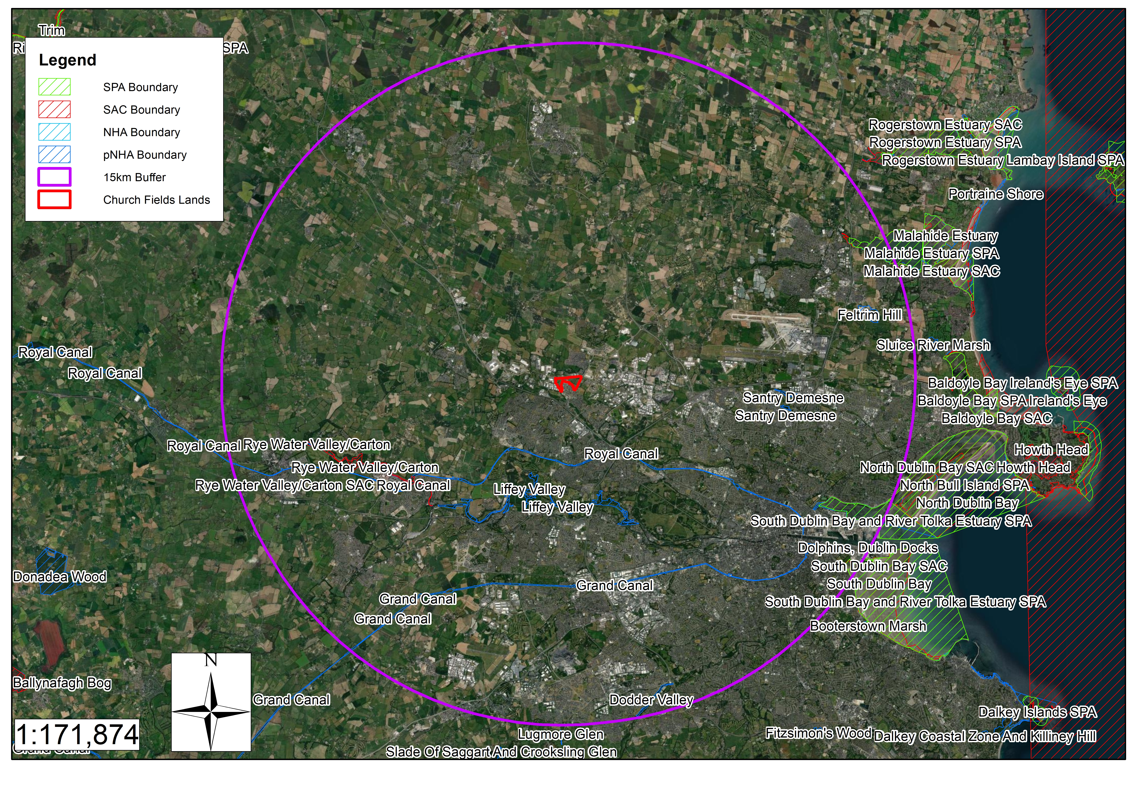
Figure 2.1.13. Site Designations within a 15km radius of the Church Fields lands. SPA site boundary shown by green hatching, pNHA site boundary shown by blue hatching and SAC site boundary shown by red hatching.

In addition to the identified Natura 2000 sites consideration was also given to relevant species listed under Annexes I and II and IV of the Birds and Habitats Directives respectively.

Natura 2000 Site Conservation Objectives:

Detailed site management plans are available for many of the Natura 2000 sites identified as outlined in the reference list, and generic conservation objectives are identified for those remaining. The conservation objectives for each of the Natura 2000 sites outlined above are summarised below in Table 2.1. This screening report has examined the generic and detailed conservation objectives for each Natura 2000 site and the attributes and targets for each conservation objective and has not identified any potential risk of significant impact on any of these targets.

Hydrological Links to Natura 2000 sites:

There are no Natura 2000 sites located either within or directly adjacent to the lands at Wellview.

The lands at Wellview are located within the Liffey and Dublin Bay catchment (Catchment 09) and within the Tolka sub-catchment (SC_010).

The Pinkeen River joins the River Tolka at Clonsilla. The water quality of the River Tolka is still classified as a river with ‘bad’ status under the Water Framework Directive. Water quality in the River Tolka remains poor (Q3).

The River Tolka enters Dublin Bay and there is therefore a distant hydrological connection between the Wellview Park lands and the South Dublin Bay/Tolka Estuary SPA and the Dublin Bay SAC/North Bull Island SPA via the Tolka River.

Table 2.1. Natura 2000 sites within 15km of the location of the proposed park at Wellview.

Site Code | Site Name and Designation | Approximate distance from Wellview | Conservation Interest  Priority Habitats are indicated with an asterisk | General Conservation Objectives | Potential for Likely Significant Effects
001398 | Rye Water Valley/Carton SAC | 7.4km SW | - Petrifying springs with tufa formation (Cratoneurion) [7220]  - Vertigo angustior (Narrow-mouthed Whorl Snail) [1014]  - Vertigo moulinsiana (Desmoulin's Whorl Snail) [1016] | Source: NPWS (2021) Conservation Objectives: Rye Water Valley/Carton SAC 001398. Version 1. National Parks and Wildlife Service, Department of Housing, Local Government and Heritage.  Accessed 16th March 2022.  To maintain the favourable conservation condition of the Annex I habitats for which the SAC has been selected:  - Petrifying springs with tufa formation (Cratoneurion) [7220]  - Vertigo angustior (Narrow-mouthed Whorl Snail) [1014]  - Vertigo moulinsiana (Desmoulin's Whorl Snail) [1016] | No, as no pathway for likely significant effects.
004024 | South Dublin Bay and River Tolka Estuary | 12.5km SE | - Light-bellied Brent Goose (Branta bernicla hrota) [A046]  - Oystercatcher (Haematopus ostralegus) [A130]  - Ringed Plover (Charadrius hiaticula) [A137]  - Grey Plover (Pluvialis squatarola) [A141]  - Knot (Calidris canutus) [A143]  - Sanderling (Calidris alba) [A144]  - Dunlin (Calidris alpina) [A149]  - Bar-tailed Godwit (Limosa lapponica) [A157]  - Redshank (Tringa totanus) [A162]  - Black-headed Gull (Chroicocephalus ridibundus) [A179]  - Roseate Tern (Sterna dougallii) [A192]  - Common Tern (Sterna hirundo) [A193]  - Arctic Tern (Sterna paradisaea) [A194]  - Wetland and Waterbirds [A999] | Source: NPWS (2015) Conservation Objectives: South Dublin Bay and River Tolka Estuary SPA 004024. Version 1. National Parks and Wildlife Service, Department of Arts, Heritage and the Gaeltacht.  Accessed 16th March 2022.  To maintain the favourable conservation condition of the bird species listed as Special Conservation Interests for this SPA:  - Light-bellied Brent Goose (Branta bernicla hrota) [A046]  - Oystercatcher (Haematopus ostralegus) [A130]  - Ringed Plover (Charadrius hiaticula) [A137]  - Grey Plover (Pluvialis squatarola) [A141]  - Knot (Calidris canutus) [A143]  - Sanderling (Calidris alba) [A144]  - Dunlin (Calidris alpina) [A149]  - Bar-tailed Godwit (Limosa lapponica) [A157]  - Redshank (Tringa totanus) [A162]  - Black-headed Gull (Chroicocephalus ridibundus) [A179]  - Roseate Tern (Sterna dougallii) [A192]  - Common Tern (Sterna hirundo) [A193]  - Arctic Tern (Sterna paradisaea) [A194]  - Wetland and Waterbirds [A999] | Although surface water from the project will ultimately discharge to the River Tolka, thereby creating a potential source receptor pathway from this site to the Dublin Bay Natura 2000 sites likely significant effects are ruled out on account of distance and the implementation of SUDS measures.
000205 | Malahide Estuary SAC | 13.5km NE | - (1140) Mudflats and sandflats not covered by seawater at low tide  - (1310) Salicornia and other annuals colonizing mud and sand  - (1320) Spartina swards (Spartinion maritimae)  - (1330) Atlantic salt meadows (Glauco-Puccinellietalia maritimae)  - (1410) Mediterranean salt meadows (Juncetalia maritimi)  - (2130) Fixed coastal dunes with herbaceous vegetation (grey dunes)*  - (2120) Shifting dunes along the shoreline with Ammophila arenaria (white dunes) | Source: NPWS (2013) Conservation Objectives: Malahide Estuary SAC 000205. Version 1. National Parks and Wildlife Service, Department of Arts, Heritage and the Gaeltacht.  Accessed 16th March 2022.  To maintain the favourable conservation condition of the Annex I habitats for which the SAC has been selected:  - (1140) Mudflats and sandflats not covered by seawater at low tide  - (1310) Salicornia and other annuals colonizing mud and sand  - (1320) Spartina swards (Spartinion maritimae)  - (1330) Atlantic salt meadows (Glauco-Puccinellietalia maritimae)  - (1410) Mediterranean salt meadows (Juncetalia maritimi)  - (2130) Fixed coastal dunes with herbaceous vegetation (grey dunes)*  - (2120) Shifting dunes along the shoreline with Ammophila arenaria (white dunes) | No, as no pathway for likely significant effects.
004025 | Malahide Estuary SPA | 13.5km NE | - Great Crested Grebe (Podiceps cristatus) [A005]  - Light-bellied Brent Goose (Branta bernicla hrota) [A046]  - Shelduck (Tadorna tadorna) [A048]  - Pintail (Anas acuta) [A054]  - Goldeneye (Bucephala clangula) [A067]  - Red-breasted Merganser (Mergus serrator) [A069]  - Oystercatcher (Haematopus ostralegus) [A130]  - Golden Plover (Pluvialis apricaria) [A140]  - Grey Plover (Pluvialis squatarola) [A141]  - Knot (Calidris canutus) [A143]  - Dunlin (Calidris alpina) [A149]  - Black-tailed Godwit (Limosa limosa) [A156]  - Bar-tailed Godwit (Limosa lapponica) [A157]  - Redshank (Tringa totanus) [A162]  - Wetland and Waterbirds [A999] | This site overlaps substantially with the Malahide Estuary SAC. It encompasses estuary, saltmarsh and shallow subtidal areas at the mouth of the estuary. The site is of high importance for wintering waterfowl, providing both feeding and roosting areas for a range of species. It supports internationally important populations of Light-bellied Brent Goose and Blacktailed Godwit, and nationally important populations of an additional 12 species: Great Crested Grebe, Shelduck, Pintail, Goldeneye, Red-breasted Merganser, Oystercatcher, Golden Plover, Grey Plover, Knot, Dunlin, Bar-tailed Godwit and Redshank | No, as no pathway for likely significant effects.
000210 | South Dublin Bay SAC | 14.5km SE | - Mudflats and sandflats not covered by seawater at low tide [1140]  - Annual vegetation of drift lines [1210]  - Salicornia and other annuals colonising mud and sand [1310]  - Embryonic shifting dunes [2110] | Source: NPWS (2013) Conservation Objectives: South Dublin Bay SAC 000210. Version 1. National Parks and Wildlife Service, Department of Arts, Heritage and the Gaeltacht.  Accessed 16th March 2022.  To maintain the favourable conservation condition of the Annex I habitats for which the SAC has been selected:  - Mudflats and sandflats not covered by seawater at low tide [1140]  - Annual vegetation of drift lines [1210]  - Salicornia and other annuals colonising mud and sand [1310]  - Embryonic shifting dunes [2110] | Although surface water from the project will ultimately discharge to the River Tolka, thereby creating a potential source receptor pathway from this site to the Dublin Bay Natura 2000 sites likely significant effects are ruled out on account of distance and the implementation of SUDS measures.
000206 | North Dublin Bay SAC | 15km SE | - Mudflats and sandflats not covered by seawater at low tide [1140]  - Annual vegetation of drift lines [1210]  - Salicornia and other annuals colonising mud and sand [1310]  - Atlantic salt meadows (Glauco-Puccinellietalia maritimae) [1330]  - Mediterranean salt meadows (Juncetalia maritimi) [1410]  - Embryonic shifting dunes [2110]  - Shifting dunes along the shoreline with Ammophila arenaria (white dunes) [2120]  - Fixed coastal dunes with herbaceous vegetation (grey dunes) [2130]  - Humid dune slacks [2190]  - Petalophyllum ralfsii (Petalwort) [1395] | Source: NPWS (2013) Conservation Objectives: North Dublin Bay SAC 000206. Version 1. National Parks and Wildlife Service, Department of Arts, Heritage and the Gaeltacht.  Accessed 16th March 2022.  To maintain the favourable conservation condition of the Annex I habitats for which the SAC has been selected:  - Mudflats and sandflats not covered by seawater at low tide [1140]  - Annual vegetation of drift lines [1210]  - Salicornia and other annuals colonising mud and sand [1310]  - Atlantic salt meadows (Glauco-Puccinellietalia maritimae) [1330]  - Mediterranean salt meadows (Juncetalia maritimi) [1410]  - Embryonic shifting dunes [2110]  - Shifting dunes along the shoreline with Ammophila arenaria (white dunes) [2120]  - Fixed coastal dunes with herbaceous vegetation (grey dunes) [2130]  - Humid dune slacks [2190]  - Petalophyllum ralfsii (Petalwort) [1395] | Although surface water from the project will ultimately discharge to the River Tolka, thereby creating a potential source receptor pathway from this site to the Dublin Bay Natura 2000 sites likely significant effects are ruled out on account of distance and the implementation of SUDS measures.
004006 | North Bull Island SPA | 15km SE | - Light-bellied Brent Goose (Branta bernicla hrota) [A046]  - Shelduck (Tadorna tadorna) [A048]  - Teal (Anas crecca) [A052]  - Pintail (Anas acuta) [A054]  - Shoveler (Anas clypeata) [A056]  - Oystercatcher (Haematopus ostralegus) [A130]  - Golden Plover (Pluvialis apricaria) [A140]  - Grey Plover (Pluvialis squatarola) [A141]  - Knot (Calidris canutus) [A143]  - Sanderling (Calidris alba) [A144]  - Dunlin (Calidris alpina) [A149]  - Black-tailed Godwit (Limosa limosa) [A156]  - Bar-tailed Godwit (Limosa lapponica) [A157]  - Curlew (Numenius arquata) [A160]  - Redshank (Tringa totanus) [A162]  - Turnstone (Arenaria interpres) [A169]  - Black-headed Gull (Chroicocephalus ridibundus) [A179]  - Wetland and Waterbirds [A999] | This site takes in the North Bull Island sand spit and most of the inner part of north Dublin Bay, extending from the Ball Wall to Howth Head. The site is an excellent example of an estuarine complex, and is one of the top sites in Ireland for wintering waterfowl. It contains a variety of habitats, including saltmarsh and intertidal lagoons. It is of international importance on the basis that it regularly supports in excess of 20,000 waterfowl. It supports internationally important populations of three species: Light-bellied Brent Goose, Black-tailed Godwit and Bar-tailed Godwit; and nationally important populations of a further 14 species: Shelduck, Teal, Pintail, Shoveler, Oystercatcher, Grey Plover, Golden Plover, Knot, Sanderling, Dunlin, Curlew, Redshank, Turnstone and Black-headed Gull | Although surface water from the project will ultimately discharge to the River Tolka, thereby creating a potential source receptor pathway from this site to the Dublin Bay Natura 2000 sites likely significant effects are ruled out on account of distance and the implementation of SUDS measures.

Based on the above preliminary screening in Table 2.1 all sites can be excluded from further assessment at this preliminary stage based on the lack of direct or indirect pathways for likely significant effects.

SECTION 3 ASSESSMENT OF POTENTIAL IMPACTS
The proposed development consists of the refurbishment of the existing Wellview Park, situated at Church Road, Dublin 15 as well as two existing areas of public realm at Avondale Place and Wellview Green, Dublin 15, totalling approximately 5.5ha as set out in Section 2.1.1 above.

The proposed works are outlined in a series of landscape architectural drawings prepared by Dermot Foley Landscape Architects and engineering drawings prepared by PUNCH Consulting Engineers, supplied as part of the planning documentation.

The proposed development will involve typical construction activities associated with park developments of this nature and scale. These include;
- site preparation,
- clearance of vegetation and topsoil,
- ground works,
- construction of footpaths, utilities and services installations,
- landscaping and finishes.

As this is a greenfield site, no demolition works will be required. An on-site construction compound will be provided for materials storage areas and facilities for site personnel, situated within the lands made available (LMA) to the contractor.

Brief description of the project or plan | The proposed development consists of the refurbishment of the existing Wellview Park, situated at Church Road, Dublin 15 as well as two existing areas of public realm at Avondale Place and Wellview Green, Dublin 15, totalling approximately 5.5ha.  The proposed development includes: landscape and external works; pedestrian access points to existing footpath on west side of Church Road; paving and associated drainage works; regrading of existing grassland areas; planting; public lighting; play areas, signage, street furniture and associated fixtures and fittings; including all ancillary site development.  The site area is proposed to be crossed by a north-south cycle and pedestrian route as part of the wider proposed Church Fields Link Road and Cycle Network subject to a separate planning grant (planning register reference Part XI/011/19).
Brief description of the Natura 2000 sites | There are no Natura 2000 sites either within or directly adjacent to the proposed development at Wellview.  There are 7 Natura 2000 sites occurring within a 15km radius as described above in Table 2.1.
Describe the individual elements of the project (either alone or in combination with other plans or projects) likely to give rise to impacts on the Natura 2000 sites | None.
Describe any likely direct, indirect or secondary impacts of the project (either alone or in combination with other plans or projects) on the Natura 2000 site by virtue of:  - size and scale;  - land-take;  - distance from the Natura 2000 site or key features of the site;  - resource requirements (water abstraction etc.);  - emissions (disposal to land, water or air); excavation requirements;  - transportation requirements;  - duration of construction, operation, decommissioning, etc.;  - other | The lands proposed for development of a park at Wellview are not within or directly adjacent to any Natura 2000 site, therefore there will be no direct impacts arising from the project on any Natura 2000 site by virtue of size and scale; land-take; distance from the Natura 2000 site or key features of the site; resource requirements (water abstraction etc.); emissions (disposal to land, water or air); excavation requirements; transportation requirements; or duration of construction, operation, decommissioning, etc.  The sole identified source receptor pathway from this site to the Dublin Bay Natura 2000 sites is via surface water which will ultimately discharge to the River Tolka, thereby creating a potential impact. Likely significant effects from same are ruled out on account of distance and the implementation of SUDS measures (see below).
Describe any likely changes to the site arising as a result of:  - reduction of habitat area  - disturbance to key species;  - habitat or species fragmentation;  - reduction in species density;  - changes in key indicators of conservation value (water quality etc.);  - climate change | There are no significant changes expected to any Natura 2000 site relating to disturbance to key species, habitat or species fragmentation, reduction in species density, changes to key indicators of conservation value, or to climate change arising from the proposed refurbishment of the existing Wellview Park, situated at Church Road, Dublin 15 and the two existing areas of public realm at Avondale Place and Wellview Green.  Water Quality  This assessment relies on the information contained within the ‘Part 8 Refurbishment of Wellview Park and Avondale Place Engineering Planning Report’ prepared by PUNCH Consulting Engineers where SUDS measures and surface water treatment is discussed.  It is proposed that all drainage is to discharge to groundwater infiltration via rain gardens and gravel base below.  Attenuated surface water run-off from the park will be discharged to ground water via rain gardens in accordance with the GDSDS, and will be attenuated using SuDS such that there is no possibility of significant ecological effects.  Even in the event of an accidental discharge or significant dust deposition to an adjacent drainage ditch during the construction phase, considering the substantial distance from any Designated Site and the high dilution factor in the receiving watercourses, there is no possibility of significant impacts on any such site via this pathway.  During the operational phase the SUDS measures (rain gardens) will ensure that any waters discharging from the site are free of silt, sediments or other pollutants.  Given the distance to the watercourse from the site of the proposed park at Wellview significant impacts are not likely to occur during either the construction or operational phase.
Describe any likely impacts on the Natura 2000 site as a whole in terms of:  - interference with the key relationships that define the structure of the site  - interference with key relationships that define the function of the site | There will be no impacts to Natura 2000 sites relating to interference of key relationships that define the structure and function of the sites from the proposed refurbishment of the existing Wellview Park, situated at Church Road, Dublin 15 and the two existing areas of public realm at Avondale Place and Wellview Green.
Provide indicators of significance as a result of the identification of effects set out above in terms of:  - Loss  - Fragmentation  - Disruption  - Disturbance  - Change to key elements of the site (e.g. water quality etc.) | There will be no impacts to Natura 2000 sites relating to loss, fragmentation, disruption or disturbance from the proposed refurbishment of the existing Wellview Park, situated at Church Road, Dublin 15 and the two existing areas of public realm at Avondale Place and Wellview Green.
Describe from the above those elements of the project or plan, or combination of elements, where the above impacts are likely to be significant or where the scale or magnitude of impacts is not known. | There will be no direct, indirect, or cumulative impacts from the proposed refurbishment of the existing Wellview Park, situated at Church Road, Dublin 15 and the two existing areas of public realm at Avondale Place and Wellview Green.

Cumulative/In Combination Impacts

The EC Habitats Directive, the Planning Acts and the Habitats Regulations 2011 require that the impacts on Natura 2000 sites from the plan or project in question are assessed and that they are assessed in combination with other plans and projects that could affect the same Natura 2000 sites. The Appropriate Assessment Screening Process identified other plans and projects that could act in combination with the proposed refurbishment of the existing Wellview Park, situated at Church Road, Dublin 15 and the two existing areas of public realm at Avondale Place and Wellview Green to pose likely significant effects on European sites within the study area and its environs. These included:
- The Fingal County Development Plan 2017 - 2023. Fingal County Council.
- There are a number of a number of current planning applications in the area. These include the following:
  - FCC reg. ref. FW19A/0177 (Applicant: ESB Engineering & Major Projects)
  - ABP reg. ref. VA06F.306834 (Amazon Data Services Ireland Ltd. (ADSIL))
  - FCC reg. ref. PARTXI/006/18 (Fingal County Council – Architect’s Department)
  - FCC reg. ref. PARTXI/010/19 (Fingal County Council – Architect’s Department)
  - Part XI Church Fields Housing and Eastern Linear Park Development AA Screening Report Brady Shipman Martin
- Projects in the vicinity of the proposed development are predominantly comprised of other small-scale residential developments and developments / upgrade works associated with industrial and ICT activities in the neighbouring areas. Considering the nature and scale of the proposed development, the localised and insignificant nature of the environmental effects predicted to occur as a result of the proposed development, and the nature of existing, permitted and proposed development in its environs, it is considered that significant in-combination effects on European sites are not likely to occur.
- Furthermore, the zoning, policies and objectives set out in the Fingal Development Plan 2017 – 2023 are intended to protect the environment while encouraging development in appropriate areas.

All of these plans and/or projects have been screened for Appropriate Assessment or undergone an Appropriate Assessment themselves and it is therefore assumed that if a plan has been adopted or a project given planning permission following an AA that it cannot pose likely significant adverse effects on a Natura 2000 site.

In addition the proposed refurbishment of the existing Wellview Park, situated at Church Road, Dublin 15 and the two existing areas of public realm at Avondale Place and Wellview Green, in combination or cumulatively with the above plans and projects, is not likely to have a significant effect on any of the Natura 2000 sites identified.

Table 3.1. Likely direct, indirect or secondary impacts of the proposed refurbishment of the existing Wellview Park, situated at Church Road, Dublin 15 and the two existing areas of public realm at Avondale Place and Wellview Green, (either alone or in combination with other plans or projects) on Natura 2000 sites within a 15km radius of the site by virtue of:

Site Code,  Site Name and Designation | 00205 Malahide Estuary SAC | 004025 Malahide Estuary SPA | 000210 South Dublin Bay SAC | 004024 South Dublin Bay/River Tolka Estuary | 000206 North Dublin Bay SAC | 004006 North Bull Island SPA | 001398 Rye Water Valley SAC
Land-take within Natura 2000 site | None | None | None | None | None | None | None
Potential for impacts on Natura 2000 site from resource requirements (water abstraction, etc.) | None | None | None | None | None | None | None
Potential for impacts on Natura 2000 site from emissions (disposal to land, water or air) | None | None | None | None | None | None | None
Potential for impacts on Natura 2000 site from excavation requirements | None | None | None | None | None | None | None
Potential for impacts on Natura 2000 site from transportation requirements | None | None | None | None | None | None | None
Potential for reduction of habitat in any Natura 2000 site | None | None | None | None | None | None | None
Potential for disturbance to key species within any Natura 2000 site | None | None | None | None | None | None | None
Potential for habitat or species fragmentation within any Natura 2000 site | None | None | None | None | None | None | None
Potential for reduction in density of key species within any Natura 2000 site | None | None | None | None | None | None | None
Potential for changes in key indicators of conservation value (water quality, etc.) within any Natura 2000 site | None | None | None | None | None | None | None
Potential for likely impacts on key relationships that define the structure of any Natura 2000 site | None | None | None | None | None | None | None
Potential for likely impacts on key relationships that define the function of any Natura 2000 site | None | None | None | None | None | None | None

SECTION 4 CONCLUSIONS

This report for screening for appropriate assessment has been prepared following the Department of the Environment, Heritage and Local Government guidance ‘Appropriate Assessment of Plans and Projects in Ireland. Guidance for Planning Authorities’ (DoEHLG, 2010).

The assessment considers the potential adverse effects on the qualifying interests of European sites arising from the proposed rejuvenation and upgrade of Wellview Park and public realm at Wellview Green and Terrace, to determine whether or not significant negative impacts on Natura 2000 sites are likely to arise.

The assessment considers whether the works, alone or in combination with other projects or plans, will have adverse effects on the integrity of a European Site, and determines if any specific mitigation measures are necessary to avoid, reduce or offset negative effects on the identified European Sites.

This report has concluded that the proposed rejuvenation and upgrade of Wellview Park and public realm at Wellview Green and Terrace, individually or in combination with other plans or projects, will not adversely affect the integrity of any Natura 2000 site in view of the sites conservation objectives, and that no reasonable scientific doubt remains as to the absence of such adverse effects.

Based on the information provided above, and by applying the precautionary principle, it was determined that it was possible to rule out likely significant impacts on any European site and therefore it was not deemed necessary to undertake any further stage of the Appropriate Assessment process.

The proposed rejuvenation and upgrade of Wellview Park and public realm at Wellview Green and Terrace within the Church Fields lands has been also assessed from the perspective of the local ecological environment and detailed mitigation measures have been presented to reduce impacts on biodiversity within the lands as set out within the ecological impact assessment report.

It is considered that this report provides sufficient relevant information to allow the Competent Authority (Fingal County Council) to carry out an AA Screening, and reach a determination that the proposed development will not have any likely significant effects on European sites under Article 6 of the Habitats Directive, in light of their conservation objectives.

SECTION 5 REFERENCES

Anon. (1996). Interpretation Manual of European Union Habitats. Version EUR 15, European Commission, Brussels.

Anon. (2010). Appropriate Assessment of plans and projects in Ireland: Guidance for planning authorities. National Parks and Wildlife Service, Dept Environment, Heritage and Local Government.

Convention on the Conservation of European Wildlife and Natural Habitats (Bern Convention) 1982.

Convention on the Conservation of Migratory Species of Wild Animals (Bonn Convention) 1979.

Council of the European Communities (1992). Council Directive of 21 May 1992 on the conservation of natural habitats and of wild fauna and flora (92/43/EEC). O.J. L 206/35, 22 July 1992.

Council of the European Communities (1979). Council Directive of 02 April 1979 on the conservation of wild birds (79/409/EEC). O.J.L. 103, 25 April 1979.

European Commission (2001). Assessment of plans and projects significantly affecting Natura 200 sites- methodological guidance on the provisions of Article 6(3) and 6 (4) of the Habitats Directive 92/43/EEC.

European Commission (2021). Assessment of plans and projects in relation to Natura 2000 sites – Methodological guidance on the provisions of Article 6(3) and (4) of the Habitats Directive 92/43/EEC 2021/C 437/01. (Commission notice C/2021/6913. Dated 28.10.2021).

European Commission (2002). Managing Natura 2000 sites - the provisions of Article 6 of the Habitats Directive 92/43/EEC.

European Commission (2018). Managing Natura 2000 Sites: The Provisions of Article 6 of the Habitats Directive 92/43/EEC (Commission Notice C (2018) 7621 final, Brussels, 21.11.2018).

Flora Protection Order (2015). Government of Ireland.

Fossitt, J. (2000). A Guide to Habitats in Ireland. Heritage Council, Kilkenny.

Gilbert G, Stanbury A and Lewis L.J. 2021. Birds of Conservation Concern in Ireland 2020 –2026. Irish Birds 43, 1-22.

Hayden, T. & R. Harrington (2000). Exploring Irish mammals. Dúchas. Town House, Dublin.

Inland Fisheries Ireland (2020). Planning For Watercourses In The Urban Environment. A Guide to the Protection of Watercourses through the use of Buffer Zones, Sustainable Drainage Systems, Instream Rehabilitation, Climate / Flood Risk and Recreational Planning *Including one-off developments. A Guideline Developed by Inland Fisheries Ireland.

Kelly, F.L., Matson, R., Connor, L., Feeney, R., Morrissey, E., Wogerbauer, C. & Rocks, K. (2012). Water Framework Directive Fish Stock Survey of Rivers in the Eastern River Basin District. Inland Fisheries Ireland, Swords Business Campus, Swords, Co. Dublin, Ireland.

King, J.L., Marnell, F., Kingston, N., Rosell, R., Boylan, P., Caffrey, J.M., FitzPatrick, Ú., Gargan, P.G., Kelly, F.L., O’Grady, M.F., Poole, R., Roche, W.K. & Cassidy, D. (2011). Ireland Red List No. 5: Amphibians, Reptiles & Freshwater Fish. National Parks and Wildlife Service, Department of Arts, Heritage and the Gaeltacht, Dublin, Ireland.

Marnell, F., Looney, D. & Lawton, C. (2019). Ireland Red List No. 12: Terrestrial Mammals. National Parks and Wildlife Service, Department of the Culture, Heritage and the Gaeltacht, Dublin, Ireland.

National Parks and Wildlife Service Online Database. Available online at www.npws.ie

Ramao, C. (2003). Interpretation Manual of the European Union Habitats Version Eur 25. European Commission DG Environment Nature and Biodiversity. Brussels.

Regan, E.C., Nelson, B., Aldwell, B., Bertrand, C., Bond, K., Harding, J., Nash, D., Nixon, D., & Wilson, C.J. (2010). Ireland Red List No. 4 Butterflies. National Parks and Wildlife Service, Department of the Environment, Heritage and Local Government, Ireland.

Scannell, M.J.P. and Synnott, D.M. (1987). Census Catalogue of the Flora of Ireland – Clár de Phlandaí na hÉireann. The Stationary Office, Dublin.

Natura 2000 Sites - Site Synopsis. Available online at www.npws.ie

Parnell, J. & Curtis, T.G.F. (2012). Webb’s An Irish Flora 8th Edition. Cork University Press.

S.I. No. 477 of 2011. The European Communities (Birds and Natural Habitats) Regulations 2011. Irish Government, Government Publications Office, Molesworth Street, Dublin 2.

S.I. No. 293 of 2021. The European Communities (Birds and Natural Habitats) Regulations 2011-2021. Irish Government, Government Publications Office, Molesworth Street, Dublin 2.

The Tree File Consulting Arborists (2021). Tree survey and Report – Trees at Proposed Site at Churchfields, Ashgrove House, Mulhuddart, Dublin 15 October 2021.

Wildlife Act, 1976 including all other amendments 1976–2010 Number 39 of 1976 and Number 38 of 2000. Dublin: Office of the Attorney General. Wildlife (Amendment) Act (2000). Government of Ireland.

Wyse Jackson, M., FitzPatrick, Ú., Cole, E., Jebb, M., McFerran, D., Sheehy Skeffington, M. & Wright, M. (2016) Ireland Red List No. 10: Vascular Plants. National Parks and Wildlife Service, Department of Arts, Heritage, Regional, Rural and Gaeltacht Affairs, Dublin, Ireland.

